

ADAPTIVE LEARNING INTELLIGENCE PLATFORM USING EDUCATIONAL DOCUMENT ANALYSIS AND PERSONALIZED LEARNING ANALYTICS
A document-grounded study platform: syllabus and notes analysis, source-cited retrieval-augmented answers, auto-generated quizzes and a priority-ranked study roadmap
A project report submitted in partial fulfilment of the requirements for the award of the degree of
BACHELOR OF TECHNOLOGY
in
COMPUTER SCIENCE AND ENGINEERING
Submitted by
A Dhanush | 23K91A0501
Ale Vijayalaxmi | 23K91A0508
Burri Mallikarjun | 23K91A0549
Atragada Nagatrimurthulu | 23K91A0517
Batch A1 (CSE-A)
Under the esteemed guidance of
Raghavendra
[DESIGNATION]
DEPARTMENT OF COMPUTER SCIENCE AND ENGINEERING
TKR COLLEGE OF ENGINEERING & TECHNOLOGY (AN AUTONOMOUS INSTITUTION)
[COLLEGE ADDRESS]
Academic year [ACADEMIC YEAR]

CERTIFICATE
This is to certify that the project report entitled "Adaptive Learning Intelligence Platform Using Educational Document Analysis and Personalized Learning Analytics" is a bonafide record of the work carried out by A Dhanush (23K91A0501), Ale Vijayalaxmi (23K91A0508), Burri Mallikarjun (23K91A0549), Atragada Nagatrimurthulu (23K91A0517), in partial fulfilment of the requirements for the award of the degree of Bachelor of Technology in Computer Science and Engineering, during the academic year [ACADEMIC YEAR], under my supervision.

Project Guide | Head of the Department | Principal
Raghavendra | [HOD NAME] | [PRINCIPAL NAME]
[DESIGNATION] | Department of Computer Science and Engineering | TKR College of Engineering & Technology

External Examiner: [NAME AND SIGNATURE]
Place: [PLACE]
Date: [DATE]

DECLARATION
The undersigned hereby declare that the project report entitled "Adaptive Learning Intelligence Platform Using Educational Document Analysis and Personalized Learning Analytics", submitted to the Department of Computer Science and Engineering, TKR College of Engineering & Technology, in partial fulfilment of the requirements for the award of the degree of Bachelor of Technology in Computer Science and Engineering, is a record of original work carried out under the guidance of Raghavendra, [DESIGNATION]. The results embodied in this report have not been submitted to any other university or institution for the award of any degree or diploma.

A Dhanush 23K91A0501
Ale Vijayalaxmi 23K91A0508
Burri Mallikarjun 23K91A0549
Atragada Nagatrimurthulu 23K91A0517

Place: [PLACE]
Date: [DATE]

ACKNOWLEDGEMENT
The project team expresses its sincere gratitude to the project guide, Raghavendra, [DESIGNATION], for valuable guidance, encouragement and constructive suggestions throughout this project.
The team thanks [HOD NAME], Head of the Department of Computer Science and Engineering, for providing the facilities and support needed to complete this work, and [PRINCIPAL NAME], Principal, TKR College of Engineering & Technology, for the encouragement given.
Thanks are due to the project coordinators and all faculty and staff members of the department for their help, and to families and friends for their constant support.
The team also acknowledges the authors of the base paper and the supporting papers, the contributors to the English Wikipedia articles used to build the evaluation corpus, and the developers of the open-source software used in this project (scikit-learn, NumPy, pypdf, python-docx, Flask, FastAPI, React and Vite).

A Dhanush
Ale Vijayalaxmi
Burri Mallikarjun
Atragada Nagatrimurthulu

ABSTRACT
Students handle scattered PDFs, syllabi, lecture notes and question banks across six to eight subjects every semester, yet learning portals store these files without understanding what is inside them, and general chatbots answer from public data rather than the prescribed syllabus. This project presents the Adaptive Learning Intelligence Platform, a web application in which a student uploads study material, the system extracts subjects, units and topics into a searchable repository, answers questions from that repository with the source passage shown, generates fill-in-the-blank quizzes, and turns quiz accuracy per topic into a priority-ranked roadmap and a dashboard. It follows the retrieve-then-answer idea of the SAC-RAG base paper, but retrieval is lexical (TF-IDF cosine similarity), answers are extractive and run offline, and an optional Claude mode exists that was not measured.
The platform was measured on a corpus of 100,444 words from 36 Wikipedia articles arranged as six subjects, with 72 hand-written questions. The shipped retriever places the answer sentence in the top four chunks for 79.2% of questions (Hit@1 40.3%); BM25 reaches 83.3% and a BM25 plus dense hybrid 88.9%. Extractive sentence selection removes 87.5% of the retrieved words but lowers answer-key recall from 0.861 to 0.667, and 9 of 12 off-topic questions still receive an answer because no relevance threshold exists. A question is answered in about 30 ms. 84 automated tests and a 24-check smoke test pass. Learned embeddings, question-type routing, LLM compression, revision scheduling and coverage analytics are not implemented, and are the main future steps.
Keywords: adaptive learning, educational document analysis, retrieval-augmented generation (RAG), learning analytics, AI tutoring, personalised roadmaps, academic intelligence.

TABLE OF CONTENTS
CERTIFICATE i
DECLARATION ii
ACKNOWLEDGEMENT iii
ABSTRACT iv
TABLE OF CONTENTS v
LIST OF FIGURES viii
LIST OF TABLES ix
LIST OF ABBREVIATIONS x
CHAPTER 1: INTRODUCTION 1
1.1 Domain and Background 1
1.2 Motivation 1
1.3 Problem Statement 2
1.4 Need for the Proposed System 3
1.5 Objectives 3
1.6 Scope of the Project 3
1.7 Contributions 4
1.8 Limitations and Assumptions 4
1.9 Organisation of the Report 5
CHAPTER 2: LITERATURE SURVEY 6
2.1 Overview 6
2.2 Analysis of the Base Paper: SAC-RAG 6
2.3 Analysis of the Supporting Papers 8
2.4 Related Work 9
2.5 Datasets and Algorithms Used in This Project 10
2.6 Strengths and Limitations of the Surveyed Approaches 10
2.7 Research Gap 11
CHAPTER 3: FEASIBILITY STUDY 13
3.1 Technical Feasibility 13
3.2 Economic Feasibility 14
3.3 Operational Feasibility 14
3.4 Schedule Feasibility 14
3.5 Legal, Ethical and Data Feasibility 15
3.6 Risk Analysis 15
3.7 Advantages and Constraints 15
CHAPTER 4: SYSTEM REQUIREMENTS AND ANALYSIS 17
4.1 Existing System and its Limitations 17
4.2 Proposed System and its Advantages 17
4.3 Functional Requirements 18
4.4 Non-functional Requirements 19
4.5 Data Requirements 19
4.6 Hardware Requirements 19
4.7 Software Requirements 20
4.8 User Roles 20
4.9 Constraints and Assumptions 20
4.10 Analysis Summary 20
CHAPTER 5: SYSTEM DESIGN 22
5.1 Design goals 22
5.2 System architecture 22
5.3 High-level workflow 23
5.4 Data flow diagrams 23
5.5 UML diagrams 25
5.6 Database design 27
5.7 Module design 28
5.8 Algorithm design 29
5.9 API design 31
5.10 User interface design 31
CHAPTER 6: METHODOLOGY AND SOFTWARE IMPLEMENTATION 33
6.1 Overall methodology 33
6.2 Dataset 33
6.3 Pre-processing 35
6.4 Algorithm choice and justification 35
6.5 Mathematical formulation 36
6.6 Experiment configuration 38
6.7 Application architecture 39
6.8 API design 40
6.9 Security and error handling 40
6.10 Installation and execution 41
CHAPTER 7: SYSTEM TESTING 43
7.1 Testing strategy 43
7.2 Unit testing 44
7.3 Integration testing 44
7.4 Functional testing 45
7.5 Validation and edge cases 45
7.6 Security testing 46
7.7 End-to-end smoke test and browser run 46
7.8 Performance testing 47
7.9 Behaviours observed rather than asserted 48
7.10 User acceptance 48
7.11 The limits of the testing done 49
CHAPTER 8: RESULTS AND OUTPUT SCREENS 50
8.1 Experimental setup and protocol 50
8.2 Output screens 50
8.3 Retrieval quality 52
8.4 Context compression and answer quality 54
8.5 Answering only from the notes: abstention 55
8.6 Document analysis 56
8.7 Quiz generation and the roadmap 57
8.8 Performance 58
8.9 Test results 59
8.10 Comparison with the base paper 59
8.11 Sample inputs and outputs 60
8.12 Success and failure analysis 60
8.13 Limitations of the evaluation 61
8.14 Objectives against outcomes 62
CHAPTER 9: CONCLUSION 63
9.1 Summary 63
9.2 Objectives achieved 63
9.3 Key findings 63
9.4 Practical applications 64
9.5 Known limitations and lessons 65
CHAPTER 10: FUTURE SCOPE 66
10.1 Improvements to retrieval and answering 66
10.2 Improvements to document analysis 66
10.3 Improvements to quizzes, roadmap and dashboard 67
10.4 Scalability, security and deployment 67
10.5 Further research and evaluation 67
10.6 Suggested order 68
REFERENCES 69
APPENDIX A: IMPORTANT CODE 71
A.1 Chunking (`utils/text_extraction.py`, lines 58-74) 71
A.2 Index and retrieval (`utils/rag_engine.py`, lines 26-57) 71
A.3 Extractive answer and generation (`utils/rag_engine.py`, lines 59-101) 72
A.4 The ask and roadmap endpoints (`backend/main.py`, lines 297-321 and 400-430) 72
APPENDIX B: INSTALLATION AND USER GUIDE 74
B.1 Requirements 74
B.2 Installation and start 74
B.3 Using the screens 75
B.4 Running the tests, measurements and screenshots 75
B.5 Troubleshooting 75
APPENDIX C: ADDITIONAL SCREENS 76

LIST OF FIGURES
Figure 1: System architecture of the Adaptive Learning Intelligence Platform: browser, FastAPI service, SQLite and the file store. 22
Figure 2: High-level workflow: ingest and analyse, ask, then practise and adapt. 23
Figure 3: Level 0 data flow diagram (context diagram). 23
Figure 4: Level 1 data flow diagram with five processes and five data stores. 24
Figure 5: Level 2 data flow diagram of process 2.0, analyse documents. 24
Figure 6: Level 2 data flow diagram of process 3.0, answer questions. 25
Figure 7: UML class diagram of the service modules and the five entities. 25
Figure 8: Sequence diagram of uploading a study document. 26
Figure 9: Sequence diagram of asking a question. 26
Figure 10: Use case diagram: one actor, eleven use cases and one optional external actor. 27
Figure 11: Entity-relationship diagram of the SQLite database. 28
Figure 12: Flowchart of the core algorithm: retrieval and answer generation. 29
Figure 13: Flowcharts of quiz generation (left) and the roadmap priority rule (right). 30
Figure 14: Dashboard with counters, subject accuracy and recent documents. 32
Figure 15: Ask your notes: answer, offline-mode badge and sources. 32
Figure 16: Retrieval quality of the seven retrievers evaluated on the same 672 chunks and 72 questions. 39
Figure 17: Median and 95th-percentile response time of the API endpoints (logarithmic scale). 48
Figure 18: Upload after processing the sample notes: "12 topics detected, 4 chunks indexed" and the topic chips. 51
Figure 19: Documents: five documents with subject, detected topics, chunk counts (114, 104, 112, 101, 4), quiz and delete buttons. 51
Figure 20: Dashboard: 5 documents, 4 questions, 40 quiz questions; accuracy per subject (Data Structures 85 %, Algorithms 80 %, Operating Systems 60 %, Database Systems 30 %). 51
Figure 21: Roadmap: 30 topics (High 9, Medium 2, Low 19); the first rows are generic keywords such as "elements", "used" and "using". 51
Figure 22: Ask screen: "What is a deadlock?" answered from 02_Operating_Systems.txt (passage 8, match 0.46), with the badge "Offline mode: key sentences from your notes", recent questions and expandable sources. 52
Figure 23: Quiz in progress: fill-in-the-blank questions with four options. 52
Figure 24: Quiz result: 80 % (4 of 5) with the correct term and topic per question. 52
Figure 25: Hit@1, Hit@4 and MRR@10 of the seven retrievers on the same chunks and questions. 53
Figure 26: Hit@1 and Hit@4 by question type for the shipped retriever, BM25 and BM25 plus dense. 54
Figure 27: Hit@k for k = 1 to 10; the dotted line marks the default of four chunks. 54
Figure 28: Answer-key recall in the full retrieved chunks and in the extractive answer, and the percentage of words removed, against the number of chunks retrieved. 55
Figure 29: Left: top-1 cosine score of the 72 in-scope and 12 off-topic questions. Right: effect of a refusal threshold on the top-1 score. 56
Figure 30: Left: manual review of 30 questions. Right: automatic checks over 900 questions. 57
Figure 31: Retrieval and index-rebuild time against the number of chunks (log scale). 58
Figure 32: Median (bars) and 95th percentile (dots) of the API endpoints. 58
Figure 33: Landing page, light theme. 76
Figure 34: Landing page, dark theme. 76
Figure 35: Login screen. 76
Figure 36: Registration screen with the form filled. 76
Figure 37: Upload screen with the sample notes chosen, before pressing Upload & process. 76
Figure 38: Quiz screen: a button to start a quiz on each document. 76
Figure 39: Dashboard in the dark theme. 77
Figure 40: Dashboard on a 360 x 780 phone. 77
Figure 41: Ask screen on a phone. 77
Figure 42: Roadmap on a 768 x 1024 tablet. 77
Figure 43: Roadmap on a phone, dark theme. 77

LIST OF TABLES
Table 1: Abbreviations used in this report x
Table 2: Objectives and their status 3
Table 3: SAC-RAG components and their status in the Adaptive Learning Intelligence Platform 7
Table 4: Comparison of the surveyed work 9
Table 5: Algorithms used and measured 10
Table 6: Approach families compared 10
Table 7: Technical feasibility by component 13
Table 8: Cost items 14
Table 9: Plan of work (indicative weeks) 14
Table 10: Risks and mitigation 15
Table 11: Advantages and constraints of the proposed system 15
Table 12: Limitations of the existing situation 17
Table 13: Advantages over the existing situation 18
Table 14: Functional requirements 18
Table 15: Non-functional requirements 19
Table 16: Software 20
Table 17: Traceability of the batch objectives 20
Table 18: Tables and columns of the database 27
Table 19: Module breakdown 29
Table 20: Endpoints of backend/main.py 31
Table 21: Pages of the React application 31
Table 22: Evaluation corpus 34
Table 23: Pre-processing steps 35
Table 24: Algorithm decisions 35
Table 25: Experiment protocol 38
Table 26: API endpoints 40
Table 27: Input validation and errors 40
Table 28: Software environment used for this work 41
Table 29: Test layers and results 43
Table 30: Unit test cases (tests/test_text_extraction.py, test_rag_engine.py, test_quiz_generator.py) 44
Table 31: Integration test cases (tests/test_api.py) 44
Table 32: Functional test cases 45
Table 33: Security test cases 46
Table 34: HTTP response time (milliseconds) 47
Table 35: Retrieval time against index size (in-process, 72 queries) 47
Table 36: Acceptance walk-through against the objectives 49
Table 37: Retrieval quality, 72 questions, 672 chunks (the shipped retriever is the first row) 53
Table 38: Effect of the chunk size (words / overlap) on the shipped TF-IDF retriever 54
Table 39: Words passed on and answer-key recall against the number of retrieved chunks (72 questions) 55
Table 40: Effect of a refusal threshold on the top-1 score 56
Table 41: Units found in a five-unit syllabus, by heading style 56
Table 42: Three of the 30 reviewed questions (the blank is shown as _____) 57
Table 43: In-process retrieval time against index size (72 queries, milliseconds) 58
Table 44: HTTP API latency on 127.0.0.1, 30 calls each (milliseconds) 58
Table 45: SAC-RAG [1] and this project 59
Table 46: Sample questions and the engine's answers 60
Table 47: Four real failures of the shipped retriever 61
Table 48: The six objectives of the batch against what was measured 62
Table 49: Objectives and their status 63
Table 50: Settings in .env and the demo account 74
Table 51: User guide 75
Table 52: Common problems 75

LIST OF ABBREVIATIONS
Table 1: Abbreviations used in this report
Abbreviation | Expansion
AI | Artificial Intelligence
API | Application Programming Interface
BM25 | Best Matching 25 (probabilistic ranking function)
CORS | Cross-Origin Resource Sharing
CPU | Central Processing Unit
DFD | Data Flow Diagram
DOCX | Office Open XML Word document
EM | Exact Match
ER | Entity-Relationship
FK / PK | Foreign Key / Primary Key
HTTP | Hypertext Transfer Protocol
JSON | JavaScript Object Notation
LLM | Large Language Model
LSA | Latent Semantic Analysis
MRR | Mean Reciprocal Rank
PDF | Portable Document Format
RAG | Retrieval-Augmented Generation
REST | Representational State Transfer
SAC-RAG | Semantic Adaptive Compress RAG
SPA | Single-Page Application
SQL | Structured Query Language
SVD | Singular Value Decomposition
TF-IDF | Term Frequency - Inverse Document Frequency
UI | User Interface
UML | Unified Modeling Language

CHAPTER 1: INTRODUCTION
This chapter introduces the domain, the motivation, the problem, the objectives, the scope that was actually delivered, the contributions and the limitations that govern every result reported later. It closes with a map of the report.

1.1 Domain and Background
The project belongs to learning analytics and AI-assisted tutoring. A student of an engineering programme handles, in every semester, scattered PDFs, syllabi, lecture notes and question banks for six to eight subjects. Conventional e-learning portals store these files but do not look inside them: the units, topics and learning objectives stay locked in the documents, and the portal can neither answer a question from them nor say which topics deserve revision.
Large Language Models (LLMs) explain concepts well but hallucinate when they are not grounded in a trusted source, and a general chatbot answers from public data rather than from the syllabus the student is studying. Retrieval-Augmented Generation (RAG) retrieves the relevant passage first and generates the answer only from it [4]. Retrieval can be lexical, using term statistics such as TF-IDF [7] or BM25 [6], or dense, using learned embeddings [5], [9]. A second line of work compresses the retrieved context so that an answer stays within the model's context window and is not distracted by redundant text [10], [12].
The base paper, SAC-RAG by Zhang et al. [1], combines both ideas for open-domain question answering: an LLM classifies each question as factual, definitional or reasoning, a different retrieval strategy is applied to each type, and an LLM compresses the retrieved passages into evidence snippets before the answer is generated. On three multi-hop datasets the authors report that compression cuts token consumption by 38-58% at the cost of one to two points of exact match. The paper does not treat document ingestion, quizzes or learner analytics. The Adaptive Learning Intelligence Platform (ALIP) takes the retrieve-then-answer idea of [1] and builds around it the parts a student needs: ingestion of the student's own files, source-cited answers, quizzes and a study roadmap. SAC-RAG's question classifier, type-specific retrieval and LLM compression are not implemented here, and the retriever is lexical, not semantic; Chapters 2 and 8 return to this difference.

1.2 Motivation
Four observations motivate the work. They come from the batch problem statement and from the literature on AI in education [2], [3].
• Study material is stored but not understood. Nothing extracts the units and topics that PDFs and notes contain, so there is no structured view of the syllabus.
• Answers are not grounded in the student's syllabus. An examination candidate needs answers that come from the prescribed notes and point back to the passage used.
• Recommendations ignore performance. Knowledge-tracing work such as TutorLLM [2] combines a learning state with retrieval, but needs interaction logs and a trained model that a single student does not have.
• No single view of progress. A student cannot see what has been studied, what remains and how well each topic is understood.
A system that answers from the student's own files and records performance per topic addresses all four with data the student already has: the documents, the questions asked and the quizzes taken. The retrieval and answering parts run on an ordinary laptop with no paid service.

1.3 Problem Statement
The batch problem statement lists four weaknesses of current learning platforms:
• Learning platforms store academic files but never extract the units, topics or learning objectives inside them.
• Recommendations are identical for every learner and ignore prior performance and study behaviour.
• General-purpose chatbots answer from public internet data rather than the student's own prescribed syllabus.
• Students have no single view of what has been studied, what remains, and how well each topic is understood.
Written as a task for software, the problem addressed by this project is:
Given the documents a student uploads (syllabi, notes, question banks, timetables), extract their subjects, units and topics into a searchable knowledge repository; answer the student's questions using only that repository and show the passage each answer came from; generate practice questions from the same material; and turn the quiz results into a priority-ranked study roadmap and a dashboard, through a web application that runs on an ordinary PC.
Research gap. The surveyed RAG work in education (Chapter 2) applies RAG to question answering, to assessment, to tutoring in one subject, or studies context compression on benchmarks. None of the surveyed systems combines document ingestion, syllabus-grounded tutoring and progress analytics for a student's own curriculum.

1.4 Need for the Proposed System
The batch documents summarise the need in one sentence: a platform that ingests a student's own academic documents, answers strictly from them with citations, and adapts the study plan to measured topic mastery. Three properties follow. Answers must be traceable: each lists the file, the passage number and a match score. The system must work offline and at no cost: the default answerer is extractive and needs no network. And it must feel interactive: a question is answered in about 30 ms (median over 30 calls with 672 chunks indexed) and a quiz is generated in about 23 ms (Chapter 8).

1.5 Objectives
The six objectives are those of the batch document 6.OBJECTIVES&PROBLEM STATEMENT. The table states how each was addressed and whether it was met; "Partly" and "Not met" are used where the work fell short, and Chapter 8 gives the evidence.
Table 2: Objectives and their status
No. | Objective | How it was addressed | Status
O1 | Build a document ingestion module that parses syllabi, lecture notes and question banks and extracts subjects, units and topics. | PDF, DOCX and TXT are parsed and chunked. Headings of the form "Subject:", "Course:", "Unit N:" and "Chapter N:" are found (100% of the 36 unit headings of the test corpus), plus up to 12 TF-IDF topics. "UNIT-I", "Module 1" and Word tables are not handled. | Partly
O2 | Store the extracted content as vector embeddings so the material can be searched semantically rather than by keyword. | Chunks are indexed with TF-IDF (unigrams and bigrams), a sparse lexical representation, not a learned embedding. A dense model was measured only as an experiment (Hit@4 0.778 against 0.792 for the shipped retriever). | Not met
O3 | Implement a RAG question-answering engine that answers strictly from the uploaded material and cites the source. | Every answer word occurs in the retrieved chunks, and each answer lists file, passage and score. Hit@4 is 0.792. There is no relevance threshold: 9 of 12 off-topic questions still received an answer. The optional Claude mode was not measured. | Met for extractive mode
O4 | Apply semantic context compression so retrieval stays accurate without exceeding the model context window. | Extractive sentence selection removes 87.5% of the words, but answer-key recall falls from 0.861 to 0.667. SAC-RAG's classifier-driven retrieval and LLM compression are not implemented. | Partly
O5 | Generate personalised study roadmaps and revision schedules from topic coverage and performance. | Quiz accuracy per topic is bucketed High (below 50), Medium (below 80) and Low. There is no revision schedule or coverage model; topics are single TF-IDF keywords. | Partly
O6 | Present curriculum coverage, study velocity and engagement metrics on an interactive dashboard. | The dashboard shows documents, questions, quiz attempts, a subject-wise accuracy chart and recent documents. Coverage and study velocity over time are absent. | Partly

1.6 Scope of the Project
In scope. (i) Upload of PDF, DOCX and TXT material up to 16 MB; (ii) text extraction, chunking, subject and topic detection and a per-user knowledge repository; (iii) retrieval and cited extractive answering, with an optional LLM mode; (iv) generated fill-in-the-blank quizzes with server-side grading; (v) a priority-ranked roadmap and a dashboard; (vi) registration and login with hashed passwords; (vii) two interfaces over one Python core, a React application on a FastAPI service and the original Flask application; (viii) tests, measurements and documentation.
Out of scope. Learned embeddings and a vector database, question-type classification, LLM-based compression, revision scheduling, knowledge-tracing models, coverage and study-velocity analytics, optical character recognition for scanned PDFs, teacher or administrator roles, and any study with real students.

1.7 Contributions
1. An end-to-end, offline-capable study platform that joins document ingestion, source-cited answering, quizzes and a priority roadmap in one application with a React front end, a 14-endpoint FastAPI service and the original Flask interface.
2. A document-to-knowledge-repository pipeline that extracts text from three formats, chunks it with overlap, detects subject and unit headings and ranks topics by TF-IDF.
3. A grounded answering path whose extractive answers contain only words of the retrieved chunks and name the source file, passage and match score.
4. A measured evaluation of the retrieval and compression steps. A six-subject corpus of 100,444 words and 72 hand-written questions compares the shipped TF-IDF retriever with BM25 and a dense reference, measures what extractive compression costs (87.5% fewer words for a drop of 19.4 points of answer-key recall) and shows where the system fails.
5. Reproducible tooling. A pytest suite of 84 tests, a 24-check API smoke test, and scripts that rebuild the corpus, experiments, figures, diagrams and screenshots.

1.8 Limitations and Assumptions
• Retrieval is lexical. The shipped retriever reaches Hit@1 0.403 and Hit@4 0.792; BM25 reaches 0.500 and 0.833, and BM25 with a dense model 0.556 and 0.889.
• No relevance threshold. The engine refuses only when no query term occurs in any chunk, so off-topic questions can receive an irrelevant extract.
• Quizzes are cloze questions on keywords. The answer term stays visible in the stem in 18.2% of generated questions, and only 17 of 30 questions in a manual review were acceptable.
• Narrow heading detection, local-demo security. Only Arabic-numeral headings are recognised; the session cookie is not Secure; two uploads with the same file name share one file on disk.
• Evaluation data is not student data. The measurements use Wikipedia articles arranged as course notes and 72 questions written for this work; no real syllabi, no study with students and no measurement of the Claude mode were possible.
Assumptions: each student uploads text-based English documents; subject names are typed at upload; a quiz answer is correct only when the chosen option equals the blanked term; topic accuracy is computed over all quiz questions sharing a topic keyword; and the measurement machine was shared with other work, so timings are medians of repeated runs.

1.9 Organisation of the Report
Chapter 2 surveys the base paper and related work. Chapter 3 assesses feasibility and Chapter 4 states the requirements. Chapter 5 gives the design (architecture, data flow diagrams, UML, database, modules, interface) and Chapter 6 the methodology and implementation (data, algorithms, formulation, API, security, installation). Chapter 7 reports testing. Chapter 8 presents the output screens, the retrieval and compression results, the comparison with the base paper and the failure analysis. Chapters 9 and 10 give the conclusion and the future scope. The references and three appendices (important code, installation and user guide, additional screens) follow.

CHAPTER 2: LITERATURE SURVEY

2.1 Overview
This chapter reviews the work on which the Adaptive Learning Intelligence Platform builds and against which it is judged. It analyses the batch base paper, SAC-RAG [1], in detail, then the two supporting papers kept in the batch folder: TutorLLM [2], which joins knowledge tracing with RAG, and an LLM-powered RAG assessment system for higher education [3]. Related work is grouped by theme, the datasets and algorithms of this project are described, and the chapter ends with the research gap. A number is quoted from a paper only when it was read in the paper itself; statements about works that [1] cites (Adaptive-RAG, LLMLingua, RECOMP, Self-RAG) repeat the description given in [1] and are marked as such, and for the four further titles of the batch survey only the title and venue are used.

2.2 Analysis of the Base Paper: SAC-RAG
The batch documents name as base paper "SAC-RAG: Semantic Adaptive Context Compression for Retrieval-Augmented Generation" by Zhang, Yu, Huo and Su of Shenyang Ligong University, published in IEEE Access, volume 14, 2026 [1]. It studies how to make RAG both more accurate and cheaper for multi-hop question answering.

Problem addressed
Standard RAG applies one retrieval strategy to every question and passes all retrieved passages to the generator. The authors identify two weaknesses: different question types need different retrieval, and redundant retrieved text raises token consumption and can lower answer quality, a "lost-in-retrieval" effect related to the observation that models use information in the middle of long contexts poorly [12]. Earlier work optimises either retrieval (Adaptive-RAG [11], Self-RAG [14]) or compression (LLMLingua [10], RECOMP [15]), but not both in one framework [1].

Method
SAC-RAG has five stages: question classification, type-specific retrieval, context compression, answer generation and evaluation. An LLM with a few-shot prompt classifies each question as Fact, Definition or Reasoning. The retrieval strategy then depends on the type:
• Fact questions use hybrid retrieval. The score of a candidate document is S = lambda x BM25(q, d) + (1 - lambda) x cos(e_q, e_d), where BM25 uses k1 = 1.5 and b = 0.75 and the dense vectors come from the text-embedding-3-small model (1,536 dimensions, stored in Milvus). Candidates are merged, de-duplicated and re-ranked with the bge-reranker-base cross-encoder, keeping the top 10.
• Definition questions use dense retrieval only, taking the top 8 documents.
• Reasoning questions are decomposed by an LLM into sub-questions, each retrieved in parallel (top 10 each), then merged and re-ranked.
All retrieved sets then pass through one LLM compression module that extracts evidence snippets, and the generator answers from the compressed context. Compression uses one prompt for every type; the type-specific retrieval changes what the compressor receives, so its effect differs by type [1].

Evaluation and reported results
Four settings are compared on HotpotQA, 2WikiMultiHopQA and MuSiQue, with 1,000 questions per dataset, gpt-5-mini at temperature 0 and four metrics (Exact Match, F1, Recall@10 and average tokens): Naive RAG, Compress RAG, Adaptive RAG and SAC-RAG (both). Compression against Naive raises EM by 1.2, 2.4 and 2.9 points and lowers tokens by 9-36% (H1). Adaptive retrieval against Naive raises EM by 5.1, 3.3 and 4.2 points and Recall@10 by 2.5-9.3 points; on HotpotQA EM rises from 0.560 to 0.611 and Recall@10 from 0.787 to 0.880 (H2). SAC-RAG against Compress adds 2.3, 0.4 and 0.0 points of EM (H3). Against Adaptive RAG, SAC-RAG cuts token consumption by 38-58% at a cost of one to two points of EM; its average of 1,087-1,918 tokens compares with 2,407-3,111 [1].
The classifier agrees with manual labels on 92.0% of 300 sampled questions; 21 of its 24 errors label a reasoning question as factual. On reasoning questions of HotpotQA compression raises EM from 0.455 to 0.577, while on MuSiQue, where retrieval recall is low (0.42-0.48), it slightly lowers it. The system-level comparison with Vanilla RAG, IterDRAG, ReSearch and AirRAG uses different backbone models, which the authors acknowledge [1].

What the paper leaves open
• Cost in latency. The extra LLM calls raise the time per question from about 9.6 s (Naive RAG) to 27.8 s on HotpotQA [1].
• Benchmarks, not learners. The paper does not consider a student's own documents, document ingestion, or any learner-facing feature.
• Dependence on LLMs and paid services. Classification, decomposition and compression need an LLM, and retrieval needs a vector database and a reranker, none of which a student laptop offers.
Table 3: SAC-RAG components and their status in the Adaptive Learning Intelligence Platform
SAC-RAG component [1] | In ALIP | Status
LLM question classifier (Fact / Definition / Reasoning) | None. All questions take the same path. Question type is used only to analyse results (Chapter 8). | Not implemented
Hybrid BM25 + dense retrieval with reranking; dense-only retrieval; sub-question decomposition | TF-IDF with unigrams and bigrams, cosine similarity, top 4. BM25 and BGE-small were measured as experiments only. | Not implemented; reference only
LLM context compression and answer generation | Extractive selection of the four best sentences; an optional Claude call restricted to the context (not measured). | Partly (extractive)
Evaluation with EM, F1, Recall@10 and tokens | Hit@k, MRR, answer-key recall and words removed, on a 72-question notes corpus. | Own protocol

This project adopts the retrieve-then-answer pipeline of [1] and its idea that retrieved context should be reduced before it reaches the answer, and measures the reduction. It does not reproduce the paper's adaptive retrieval or its learned compression.

2.3 Analysis of the Supporting Papers

TutorLLM: knowledge tracing and RAG for personalised learning
Li et al. [2] observe that LLMs hallucinate and lack personalisation, while educational recommenders based on knowledge tracing (KT) personalise but cannot answer free-form questions. TutorLLM combines a KT model (MLFBK) that tracks the student's learning state, a scraper that collects the text of the online course page being studied, and a GPT-4 RAG module that uses both to answer and to recommend study material. It was implemented as a Chrome plug-in and evaluated in a two-week crossover study with 30 undergraduates in an online linear algebra course; the paper reports a 10% improvement in user satisfaction (System Usability Scale) and a 5% increase in quiz scores compared with a general LLM alone [2]. Knowledge tracing models the acquisition of a skill from a student's sequence of answers [17]. TutorLLM is closest in aim to this project but differs in means: it relies on interaction logs and a trained KT network, whereas the present platform records only per-topic quiz outcomes and turns them into three priority bands.

LLM-powered assessment RAG for higher education
Vatankhah Barenji, Salimi and Khoshgoftar [3] build an agentic assessment system on RAG for large university courses. A language model retrieves rubric criteria, exemplar essays and instructor feedback from a vector store to produce grades and formative comments. On 701 student essays the authors report 94-99% agreement with human evaluators, a Pearson correlation of 0.89 with instructor scores and a mean absolute error of 2.94 percentage points [3]. It shows that grounding model output in curated course material is accepted practice, but it grades work against a rubric and does not tutor from a student's own notes.

2.4 Related Work

2.4.1 Foundations: RAG and retrieval functions
Retrieval-augmented generation was introduced by Lewis et al. to give a generator access to an external knowledge store and so reduce hallucination [4]. Karpukhin et al. train a dual-encoder for passage retrieval and report 9-19 points higher top-20 accuracy than a strong BM25 baseline on open-domain QA [5]. Lexical functions remain competitive and cheap: TF-IDF weights terms by their frequency in a text and rarity across the collection [7], and BM25 adds term-frequency saturation and length normalisation [6]. Latent semantic analysis projects TF-IDF vectors into a low-dimensional space with a singular value decomposition [8], and embedding models such as the BGE family give dense vectors without task-specific training [9]. These are the retrievers compared in Chapter 8. Longer context is not free: models use relevant information less well when it sits in the middle of a long input [12].

2.4.2 Adaptive retrieval and context compression
As described in [1], Adaptive-RAG [11] chooses between no retrieval, single-step and multi-step retrieval according to question complexity; Self-RAG [14] has the model decide when to retrieve by self-reflection. LLMLingua [10] compresses the retrieved text with a small language model, and RECOMP [15] formulates compression as summarisation. SAC-RAG [1] combines the two lines. This project's extractive sentence selection is the simplest member of the compression family: it keeps whole sentences, adds no words and needs no model, at the cost shown in Chapter 8.

2.4.3 RAG in education and evaluation data
TutorLLM [2] personalises recommendations with knowledge tracing, and the system of [3] grades essays against retrieved rubrics. The batch survey adds four titles [19]-[22] (medical content for spaced repetition, a vision-language teaching platform, financial education, and Lean resources built with ChatGPT and RAG); only their titles and venues are known to this work, so their methods and results are not discussed (Section 2.6). Multi-hop benchmarks such as HotpotQA [13] are the evaluation ground of [1]. Educational notes are different: short, definition-heavy, with headings and lists, so this project builds its own evaluation corpus from encyclopedic articles arranged as course notes [18].
Table 4: Comparison of the surveyed work
Work | Approach | Data | Reported result | Limitation
Zhang et al. 2026 [1] (base paper) | LLM question classifier, type-specific retrieval (hybrid BM25 + dense with rerank, dense only, or sub-question decomposition), LLM context compression | HotpotQA, 2WikiMultiHopQA, MuSiQue; 1,000 questions each; gpt-5-mini | Tokens down 38-58% for 1-2 points of EM; HotpotQA EM 0.560 to 0.611 and Recall@10 0.787 to 0.880 with adaptive retrieval | Benchmark QA, not student documents; extra LLM calls raise latency (27.8 s against 9.6 s per question on HotpotQA)
Li et al. 2024 [2] (TutorLLM) | Knowledge tracing (MLFBK) combined with a scraper and GPT-4 RAG; personalised recommendations in a browser plug-in | Two-week crossover study, 30 undergraduates, online linear algebra course | 10% higher user satisfaction (SUS) and 5% higher quiz scores than a general LLM | Small sample; needs interaction logs and a trained KT model; one course
Vatankhah Barenji et al. 2026 [3] | Agentic RAG grader that retrieves rubric criteria, exemplar essays and instructor feedback to grade and comment | 701 student essays; vector store (Supabase) | 94-99% agreement with human evaluators; Pearson r 0.89; mean absolute error 2.94 percentage points | Assessment, not tutoring; needs an instructor-curated knowledge base
Karpukhin et al. 2020 [5] (DPR) | Dense dual-encoder passage retrieval trained on question-passage pairs | Open-domain QA benchmarks | Reported 9-19 points higher top-20 passage accuracy than a strong BM25 system | Needs training data and embeddings; benchmark text, not personal notes
Jeong et al. 2024 [11]; Jiang et al. 2023 [10]; Xu et al. 2024 [15] | As described in [1]: route a question to no, single-step or multi-step retrieval; compress the prompt with a small model; treat compression as summarisation | See the original papers | Not quoted here (read only through [1]) | Each handles routing or compression alone; [1] unites them

The numbers in the table are those stated by each paper; they come from different data and are not a league table.

2.5 Datasets and Algorithms Used in This Project
A student's own notes are personal and no real syllabus was released for this work, so the platform was measured on a six-subject corpus built from 36 English Wikipedia articles [18] (Data Structures, Operating Systems, Database Systems, Computer Networks, Machine Learning, Algorithms), 100,444 words in 672 chunks of about 179 words. Each subject is one file with a "Subject:" line and six "Unit n:" sections. 72 questions were written by hand, 24 each of fact, definition and reasoning type (the taxonomy of [1]), each with a gold evidence sentence copied from the corpus; 12 off-topic questions test abstention. The bundled sample notes of 619 words are used for the screens.
Table 5: Algorithms used and measured
Algorithm | Role in this project | Source
TF-IDF (unigram and bigram, English stop words); cosine similarity | Shipped retriever; also ranks sentences for extractive answers and ranks keywords as topics and quiz terms | [7], [16]
Word-window chunking (180 words, 30 overlap) | Splits documents into retrievable units | -
BM25 (k1 = 1.5, b = 0.75); TF-IDF with LSA (200 dimensions) | Experimental lexical and latent-semantic alternatives | [6], [8]
BGE-small-en-v1.5 (384-d, quantised ONNX) and BM25 + dense hybrid | Experimental dense reference, not shipped | [9], [1]
Extractive sentence selection (top 4) | Shipped context reduction and answer | [1], [10]
Cloze question generator; accuracy bands (below 50, below 80) | Quiz from top-40 TF-IDF terms; roadmap priority | -

2.6 Strengths and Limitations of the Surveyed Approaches
Table 6: Approach families compared
Family | Strengths | Limitations for this project's goals
Adaptive retrieval and LLM compression [1], [10], [11], [15] | Large token savings for a small loss of accuracy; modular | Several LLM calls, vector database and reranker; evaluated on benchmarks, not notes
Dense retrieval [5], [9] | Matches meaning beyond shared words | Needs an embedding model and storage
Lexical retrieval [6], [7] | Cheap, offline, transparent, strong on exact terms | Misses paraphrases; no notion of meaning
RAG with learner modelling [2] | Personalised recommendations; field study | Needs interaction logs and a trained KT model; one course, 30 students
RAG for assessment [3] | High agreement with human graders at scale | Grades against a rubric; needs an instructor-built knowledge base

Grounding generation in retrieved text reduces hallucination and allows citation [4]. Across the field, evaluation relies on benchmarks or one course, with LLM judges or small samples, so results do not transfer to a particular student's syllabus, and personalisation and compression are studied apart. The four batch-survey titles [19]-[22] are recorded in the reference list with a note that their details are not verified; nothing is quoted from them and no claim in this report depends on them.

2.7 Research Gap
The base paper [1] improves the retrieve-and-compress step of RAG but is evaluated only on question-answering benchmarks. TutorLLM [2] personalises, but needs interaction logs and a trained knowledge-tracing model. The assessment system [3] works from instructor-supplied rubrics. None of the surveyed systems combines document ingestion, syllabus-grounded tutoring and progress analytics for a student's own curriculum, which is the gap stated in the batch survey. The points still open are:
1. Ingestion of the student's own documents (PDF, DOCX, TXT) into a structured repository with subjects, units and topics.
2. Answers that come only from that repository and name the passage they were taken from, at no cost and without a network.
3. A measured account of what the cheap, offline versions of retrieval and context reduction achieve against the stronger methods of the literature, on notes rather than benchmark questions.
4. Practice questions and a priority roadmap derived from the same documents and from per-topic results.
The Adaptive Learning Intelligence Platform addresses these points with simple, transparent components. It does not close the retrieval-quality gap to the base paper: the shipped TF-IDF retriever reaches Hit@4 0.792 on the notes corpus, below BM25 (0.833) and below a BM25 plus dense hybrid (0.889); extractive compression removes 87.5% of the words but lowers answer-key recall from 0.861 to 0.667; and 9 of 12 off-topic questions still receive an answer. Of 7 heading styles tested, 3 were fully recognised. Chapter 8 reports these results and Chapter 9 states them again as limitations.

CHAPTER 3: FEASIBILITY STUDY
A feasibility study asks whether the proposed system can be built, whether it is worth building and whether it can be used. This chapter answers the three questions for the Adaptive Learning Intelligence Platform from what was built and measured, and adds a plan of the work. No monetary figures are given: the project had no budget line, and an invented estimate would be decoration rather than evidence.

3.1 Technical Feasibility
The technology is mature, free and runs on an ordinary desktop. The system was built, tested and measured on one machine: Intel Core i5-12500 (6 cores, 12 threads), 15.7 GB of memory, Windows 11 Pro, with no graphics processor. The table lists each component with its measured version and the evidence that it is sufficient.
Table 7: Technical feasibility by component
Component | Technology (version used) | Evidence that it is feasible
Document parsing | pypdf 4.3.1, python-docx 1.1.2 | PDF text layers, DOCX paragraphs and plain text are extracted; a corrupt PDF is reported without raising an error (unit tests)
Retrieval | scikit-learn 1.5.1, numpy 1.26.4 | TF-IDF index of 672 chunks (100,444 words) is built in 197 ms and answers a query in 2.0 ms (median)
Quiz and roadmap | Python standard library, scikit-learn | A five-question quiz is generated in 14.2 ms (median, in process); the roadmap rules are plain arithmetic
Serving API | FastAPI 0.115.0, uvicorn 0.30.6, Flask 3.0.3 | /api/ask answers in 29.5 ms (median) over HTTP on localhost with 672 chunks indexed
Storage | SQLite (Python standard library) | Five tables, no server process, foreign keys with cascading deletes
Web interface | React 19, Vite 8.3, Tailwind 4, Node 24.19.0 | Production build (type check and bundle) completes in 8.7 s; ten pages, each a separate lazy chunk below 20 kB

Three technical risks were found. First, the retrieval index is not stored: it is rebuilt in memory from the chunk table after every upload or deletion, which keeps it consistent with the database but costs more as the text grows (672 chunks take 197 ms, 5,376 chunks take 964 ms): acceptable for one student's notes, not for a shared index of a whole institution. Second, the per-user index cache and the active quiz live in the memory of one server process, so several worker processes would need a shared store. Third, the offline answerer returns sentences from the notes rather than composing text; the optional Claude integration was implemented but not measured because no API key was available.
Data is the other constraint. Real student notes require the consent of their owners and none were available, so the measurements use a six-subject corpus of 6 files built from public encyclopaedia articles [18] (Chapter 8); the screenshots use the bundled sample notes plus four of those files.

3.2 Economic Feasibility
The system consumes almost nothing that has to be bought. Every component is free and open source, no graphics processor is needed, and the evaluation corpus of about 100,000 words fits in a few hundred kilobytes of SQLite rows.
Table 8: Cost items
Item | Requirement | Observation from this work
Hardware | One ordinary PC or small server, CPU only | All measurements on a desktop with a 6-core processor and 15.7 GB of memory; smaller machines were not tested
Software and data | No licences; students' own documents | All libraries are open source; the evaluation corpus is freely licensed (CC BY-SA 4.0)
Language model | Optional | Used only when ANTHROPIC_API_KEY is set and paid per use by the provider; every answer in this report is from the offline mode
Effort | Students and a guide | 1,252 lines of Python and 4,867 lines of TypeScript, protected by 84 automated tests

The benefit is qualitative: a student saves the time of searching scattered files and receives an answer that names its file and passage. Whether this improves learning outcomes was not measured; there was no user study and the report does not claim it.

3.3 Operational Feasibility
The users are students, and the system asks them to do four things they already do: upload notes, ask questions, practise and read a summary. There is one user role and no administrator, so no operational staff are needed.
• Setup and learning curve. run.bat creates the virtual environment, installs the packages and starts both servers; a demo account is documented in the README. The sidebar has six entries and every page has loading, empty and error states in plain language.
• Device fit and offline use. The layout was captured without console errors at 1440, 768 and 360 px in light and dark themes. Answers work without a network or an API key; a badge reads "Offline mode: key sentences from your notes".
• Limits. There is no password reset, no e-mail and no administrator view; a forgotten password cannot be recovered.

3.4 Schedule Feasibility
The plan of work is given as phases with indicative week numbers. It is a plan, not a record: the repository history holds no dated milestones for each phase, and none are claimed.
Table 9: Plan of work (indicative weeks)
Phase | Weeks | Work | Output
1 | 1 - 2 | Problem identification, reading of the base paper [1] and related work, objectives | Abstract, introduction, literature survey, objectives
2 | 3 - 6 | Document extraction, chunking, topic detection, TF-IDF retrieval, quiz and roadmap rules, Flask pages | Working original application on SQLite
3 | 7 - 9 | FastAPI layer over the same modules, React interface with light and dark themes | Ports 8301 and 5301, 14 endpoints, ten pages
4 | 10 - 11 | Test suite, evaluation corpus and questions, retrieval, compression and latency measurements | 84 tests, experiments/results.json
5 | 12 | Screenshots, diagrams, decks, report and paper | Submission documents

3.5 Legal, Ethical and Data Feasibility
• Licences and data. All libraries are open source. The evaluation corpus is English Wikipedia text under CC BY-SA 4.0 [18], each article pinned to a revision in experiments/corpus_manifest.json.
• Personal data. Passwords are stored as salted hashes (scrypt or PBKDF2 through Werkzeug). Notes, questions and quiz results are stored unencrypted, and there is no retention policy or account deletion.
• Copyright and third parties. A student may upload copyrighted textbooks; documents are private to their owner (covered by tests) but there is no copyright check. If the optional language model is enabled, the question and passages are sent to an external provider; the default is off.

3.6 Risk Analysis
Table 10: Risks and mitigation
Risk | Likelihood and impact | Mitigation, or remaining gap
Answer drawn from an irrelevant passage | High for off-topic questions; 9 of 12 were still answered | Source file, passage and match score shown with every answer; a score threshold of about 0.12 to 0.15 is proposed, not implemented
Retrieval misses the right passage | Hit@4 is 0.792: about one question in five fails | Compared with BM25 and dense retrieval; hybrid retrieval proposed as future work
Poor quiz questions | Only 17 of 30 reviewed questions were acceptable | Quiz is a practice aid; the review shows the correct term
No extractable text (scan); data loss; single-process state | Medium; medium; low for a demo | Upload warns and returns zero chunks (no OCR); one SQLite file, no backup feature; a shared cache would be needed for deployment

3.7 Advantages and Constraints
Table 11: Advantages and constraints of the proposed system
Advantages | Constraints
Free, open-source stack; no GPU needed | Lexical TF-IDF retrieval, not learned embeddings
Answers cite the file, passage and match score | No relevance threshold: off-topic questions still receive an extract
Works offline; optional Claude mode | Claude mode not measured
Per-user private repository | Single role, no administrator, no password reset
84 automated tests and a 24-check API smoke test | Headings recognised only as "Subject:", "Course:", "Unit N:", "Chapter N:"
Responsive light and dark interface | No spaced-repetition schedule or coverage tracking

Conclusion of the study. The system is technically, economically and operationally feasible as a prototype that students run on their own machine (median answer time 30 ms, 84 tests passing). The legal position is feasible with caveats: notes are stored unencrypted and the copyright of uploads is not checked. A shared deployment would be feasible only after the process-local state is externalised, the index is cached rather than rebuilt, a relevance threshold is added and a data-protection policy is written.

CHAPTER 4: SYSTEM REQUIREMENTS AND ANALYSIS
This chapter analyses the problem as it stands, states what the proposed system must do and how well, and lists the hardware, software and people involved. Requirement identifiers (FR for functional, NR for non-functional) are used again in Chapters 5 and 7.

4.1 Existing System and its Limitations
Each semester brings a student six to eight subjects, and the material (syllabi, timetables, lecture notes, question banks) is spread over many PDF and word-processor files. Conventional e-learning portals store and list these files but do not read what is inside. A general chat assistant explains concepts, yet answers from public text rather than the student's own syllabus and may state a wrong answer with confidence when it is not grounded in a source [4].
The base paper [1] proposes SAC-RAG, which classifies a question as fact, definition or reasoning, retrieves differently for each type and compresses the retrieved text with a language model; it is evaluated on three multi-hop question-answering benchmarks [13], not on educational documents. Tutoring work combines retrieval with learner modelling [2] or assessment [3], but none of the works in the batch literature table combines document ingestion, syllabus-grounded answers and progress analytics for a student's own curriculum.
Table 12: Limitations of the existing situation
No. | Limitation | Consequence for the student
L1 | Files are stored but their content is not analysed | Subjects, units and topics must be found by hand
L2 | Keyword search inside one PDF only | A question needs several files opened one by one
L3 | General chatbots answer from public text | Answers may not match the syllabus and carry no source
L4 | Recommendations are identical for every learner | Prior performance and behaviour are ignored
L5 | No single view of what has been studied or understood | Weak topics are noticed late
L6 | Practice questions are written by hand | Little practice on one's own material

4.2 Proposed System and its Advantages
The proposed system is a web platform in which a student uploads PDF, DOCX or TXT files. It extracts the text, splits it into overlapping passages of 180 words (30 words of overlap), detects subject and unit headings, derives up to twelve TF-IDF topics per document and stores everything in a private repository. A question is answered by retrieving the four most similar passages (TF-IDF, cosine similarity), selecting the key sentences and listing the source file, passage number and match score. Five fill-in-the-blank questions can be generated from any document; graded answers feed a roadmap that ranks topics from weakest to strongest and a dashboard of uploads, questions and accuracy per subject.
Table 13: Advantages over the existing situation
Limitation | Feature of the proposed system | Evidence in this work
L1, L2 | Upload analysis and a searchable repository | All 36 unit headings of the corpus found; hit@4 of 0.792 on 72 questions
L3 | Answers built only from the student's passages, with source and score | Every word of the offline answer comes from the retrieved passages (measured: 100 %)
L4, L5 | Quiz results per topic drive the roadmap and dashboard | 84 tests including ten priority-threshold cases
L6 | Automatic cloze questions | 900 of 900 requested questions generated, all structurally valid

The proposed system does not claim to reproduce SAC-RAG. It has no question-type classifier, no learned embeddings, no cross-encoder reranking and no language-model compression: its retrieval is lexical and its only compression is the selection of sentences. These differences are measured in Chapter 8 and listed as limitations in Chapter 9.

4.3 Functional Requirements
The table lists each functional requirement, the endpoint or page that implements it and the test evidence (files in tests/; final run 84 tests, 0 failed, 15.2 s; plus the 24-check API smoke test).
Table 14: Functional requirements
ID | Requirement | Implemented by | Evidence
FR1 | Register with a username and password; reject empty and duplicate names | POST /api/auth/register; Register page | test_register_validation, test_duplicate_username_rejected
FR2 | Log in and out with a session; reject wrong passwords; protect every data route | POST /api/auth/login, /logout, GET /me | test_register_login_me_logout, wrong-password test, 9 protected-route cases
FR3 | Upload PDF, DOCX or TXT up to 16 MB with an optional subject; reject other types | POST /api/documents; Upload page | upload, DOCX, unsupported-type and 16 MB tests
FR4 | Extract text, split into 180-word chunks with 30 overlap, detect headings, derive up to 12 topics | utils/text_extraction.py | 15 tests in test_text_extraction.py
FR5 | List documents with topics and chunk counts; delete a document with its chunks and file | GET, DELETE /api/documents | delete test, user-isolation test
FR6 | Answer from the user's own passages and show source file, passage number and score | POST /api/ask; Ask page | ask-with-sources test, 9 tests in test_rag_engine.py
FR7 | Keep the last ten questions | GET /api/ask/history | test_history_is_capped_at_ten
FR8 | Generate five cloze questions from a document, keeping answers on the server | POST /api/quiz/generate | 4 tests in test_quiz_generator.py, quiz-flow test
FR9 | Grade a submitted quiz once and store per-topic results | POST /api/quiz/submit | 100-percent-score and no-double-submit tests
FR10 | Rank topics High (<50 %), Medium (<80 %), Low by accuracy | GET /api/roadmap; Roadmap page | 10 threshold cases, sort-order test
FR11 | Show counts, accuracy per subject, five recent documents | GET /api/dashboard; Dashboard page | new-user dashboard test, quiz-flow test
FR12 | Optional Claude answers when ANTHROPIC_API_KEY is set, with fallback to offline answers | RAGEngine._llm_answer | two mocked tests (live mode not measured)
FR13 | Light and dark theme, responsive layout from 360 px | frontend theme tokens | Playwright capture: console clean, no horizontal overflow

4.4 Non-functional Requirements
Table 15: Non-functional requirements
ID | Requirement | Target | Measured or verified
NR1 | Response time of question answering | Under one second | /api/ask median 29.5 ms, p95 35.3 ms with 672 chunks
NR2 | Response time of data pages | Under 100 ms | dashboard 4.2 ms, documents 5.8 ms, roadmap 7.0 ms (median)
NR3 | Scalability of retrieval | Roughly linear | 2.0 ms at 672 chunks, 17.6 ms at 5,376
NR4 | Password protection | Salted hash | test_passwords_are_stored_hashed
NR5 | Session security | HttpOnly, SameSite, signed | HttpOnly, SameSite=Lax verified; not Secure (local use); tampered cookie rejected
NR6 | Isolation between users | No cross-user access | Tests on list, delete, quiz and ask across two users
NR7 | Input safety | No injection or traversal | SQL-injection strings stored literally; "../../evil.txt" saved as evil.txt in the user folder
NR8 | Offline operation | No external service | All measurements taken without an API key
NR9 | Portability | Windows, CPU only, one command | run.bat; measured on Windows 11 with no GPU
NR10 | Maintainability | Automated tests | 84 pytest tests in about 15 s; 24-check smoke test; type-checked front end
NR11 | Usability | Clear states and errors | Loading, empty and error states on every data page

Login takes about 128 ms because the password hash is deliberately slow. quiz_submit has a median of 24.5 ms but showed outliers of one to two seconds on one or two of every thirty calls, attributed to SQLite commits on the shared test machine but not isolated further.

4.5 Data Requirements
• Inputs and storage. PDF with a text layer, DOCX (paragraph text only) or UTF-8 text, up to 16 MB, with an optional subject; headings "Subject:", "Course:", "Unit N:" or "Chapter N:" (Arabic numerals) are recognised. One row per user, document, chunk, question and quiz answer is kept in SQLite (Section 5.6), and the original file under uploads/<user id>/.
• Evaluation data. 6 notes files, 100,444 words and 672 chunks built from 36 encyclopaedia articles [18], 72 hand-written questions (24 each of fact, definition and reasoning) with gold evidence sentences, and 12 off-topic questions. The demonstration file sample_data/sample_notes_data_structures.txt has 619 words and four chunks, and always yields a five-question quiz.

4.6 Hardware Requirements
• Used for development and measurement: Intel Core i5-12500 (6 cores, 12 threads), 15.7 GB of memory, none (CPU only), local SSD; screens checked at 1440 x 900, 768 and 360 px.
• Required: any modern 64-bit CPU (weaker processors were not tested), enough memory to hold the index (5,376 chunks, about 960,000 words, were indexed in the scaling experiment), space for uploads (16 MB each at most) and the SQLite file, and a browser window from 360 px wide. No graphics processor.

4.7 Software Requirements
Table 16: Software
Layer | Software | Version
Platform | Windows 11 Pro; Python; SQLite | Python 3.11.9; SQLite bundled; Python code is portable
Retrieval, quiz, parsing | scikit-learn, numpy, pypdf, python-docx | 1.5.1, 1.26.4, 4.3.1, 1.1.2
Interfaces | Flask, Werkzeug; FastAPI, uvicorn, python-multipart, itsdangerous | 3.0.3, 3.0.3; 0.115.0, 0.30.6, 0.0.9, 2.2.0
Front end | Node, React, Vite, Tailwind CSS | 24.19.0, 19, 8.3, 4
Testing | pytest, httpx, Playwright with Chrome | 8.3.3, 0.27.2, 1.44.0
Optional | anthropic package and API key | Not used for any reported measurement

4.8 User Roles
There is one role: the student. A registered user has a private space containing documents, questions, quizzes and roadmap. There is no administrator, no teacher view and no public sharing. The boundary is enforced in the server: every query that reads or changes documents, chunks, questions or quiz results is filtered by the identifier of the logged-in user.

4.9 Constraints and Assumptions
• The user's files contain extractable text: scanned images are not read (no OCR) and DOCX tables are ignored. Questions are in English and the stop-word list is English.
• The notes of one user fit in memory and the index is rebuilt after every upload or deletion; the server runs as one process, so the quiz in progress and the index cache are not shared between workers.
• The system is used on localhost or a trusted network (cookies are not marked Secure), and quiz accuracy is the only signal of mastery: there is no timing, repeated-attempt model or revision schedule.

4.10 Analysis Summary
Table 17: Traceability of the batch objectives
Objective | Requirements | Status in the built system
1. Ingest syllabi, notes and question banks; extract subjects, units, topics | FR3, FR4, FR5 | Partly met: three file types; headings only in four formats; at most 12 topics
2. Store as vector embeddings for semantic search | (not a requirement of the design) | Not met: TF-IDF sparse vectors; dense retrieval measured only as an experiment
3. Answer strictly from the material and cite the source | FR6, FR7, FR12 | Met for the offline mode (every answer word is from the passages); no relevance threshold
4. Compress the context within the model window | FR6 | Partly met: sentence selection removes 87.5 % of the words, with a loss of answer-key recall
5. Personalised roadmaps and revision schedules | FR8, FR9, FR10 | Partly met: priority roadmap from quiz accuracy; no revision schedule
6. Dashboard of coverage, velocity and engagement | FR11 | Partly met: counts and subject accuracy; no coverage or velocity

The analysis leads to a design with three parts: an ingestion pipeline that turns files into chunks and topics, a retrieval and answering engine over a per-user index, and a practice loop that turns quiz results into a roadmap. Every functional requirement has at least one automated check. The requirements implied by the batch objectives but not met by the design (semantic embeddings, model-based compression, revision schedules, coverage and velocity metrics) are carried to Chapters 9 and 10 as limitations and future work.

CHAPTER 5: SYSTEM DESIGN

5.1 Design goals
The design follows from the requirements of Chapter 4: answer from the student's own documents and show where the answer came from; run on one ordinary Windows PC without a graphics processor or a database server; keep each student's documents private; behave the same through the Flask pages and the JSON API; and stay simple enough to test end to end.
• One set of modules, two interfaces. backend/main.py contains no retrieval, quiz or grading logic of its own; it imports db.py, config.py, utils/* and the index cache of app.py, so the two interfaces cannot disagree.
• SQLite and a rebuilt index. The data are small and written by one process, so SQLite gives transactions and cascading deletes with no installation, and the TF-IDF index (263 ms for 672 chunks) is rebuilt after each change instead of stored, so it is never stale.
• Answers only from the notes. The offline answerer selects sentences from the retrieved passages, so it cannot add words that are not in the notes; the optional model is told to use only the context. The correct quiz option stays on the server until grading.

5.2 System architecture
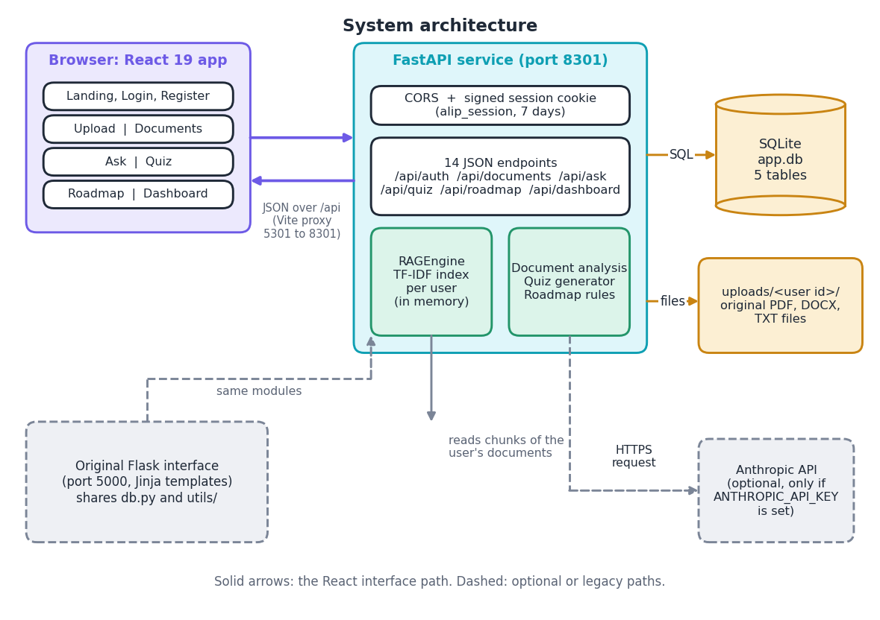
Figure 1: System architecture of the Adaptive Learning Intelligence Platform: browser, FastAPI service, SQLite and the file store.
The browser runs the React application; the FastAPI service on port 8301 applies a CORS rule and a signed session cookie (alip_session, seven days) and exposes 14 JSON endpoints; the stores are instance/app.db and uploads/<user id>/. The Anthropic call and the original Flask interface (port 5000, same db.py and utils/) are optional paths.
The contract between browser and server is narrow: JSON with a session cookie, allowed from localhost:5301 and 127.0.0.1:5301 only. There is no message queue, vector database or background worker; every request is synchronous, which is adequate at the measured median of 29.5 ms for an answer.

5.3 High-level workflow
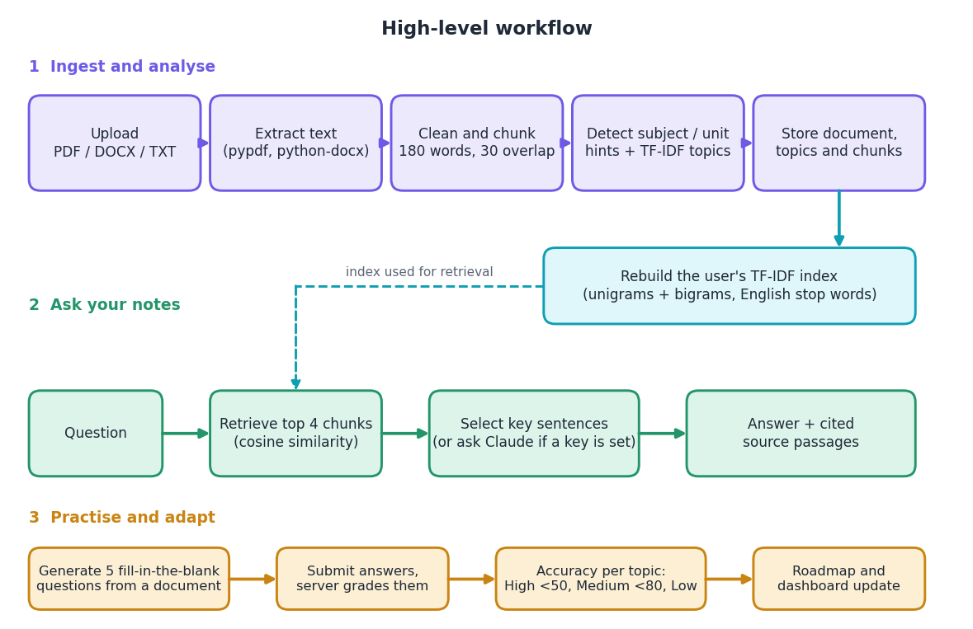
Figure 2: High-level workflow: ingest and analyse, ask, then practise and adapt.
Ingestion (parse, clean, chunk, detect headings, topics, store and re-index), asking (vectorise, retrieve four chunks, select sentences or call the model, show sources) and practice (five cloze questions, server-side grading, accuracy per topic, priority thresholds at 50 and 80 percent).

5.4 Data flow diagrams

5.4.1 Level 0
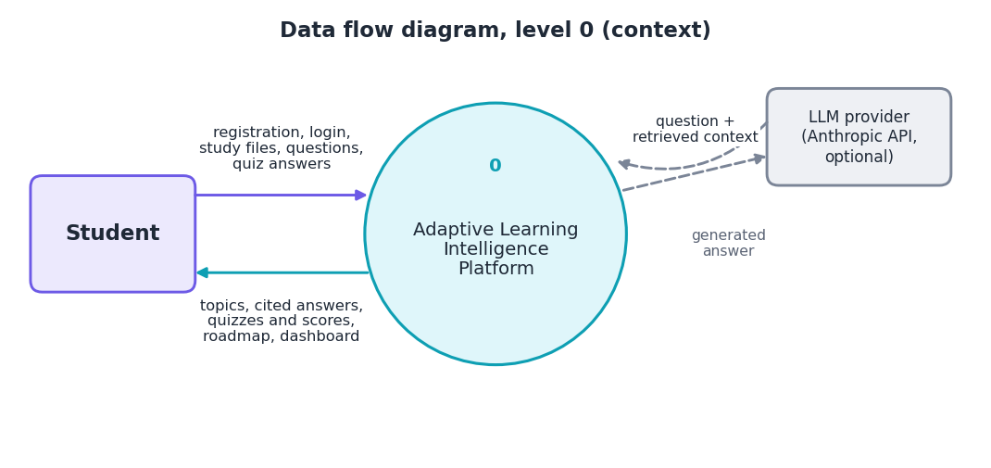
Figure 3: Level 0 data flow diagram (context diagram).
The platform is one process between the student and the optional language-model provider.

5.4.2 Level 1
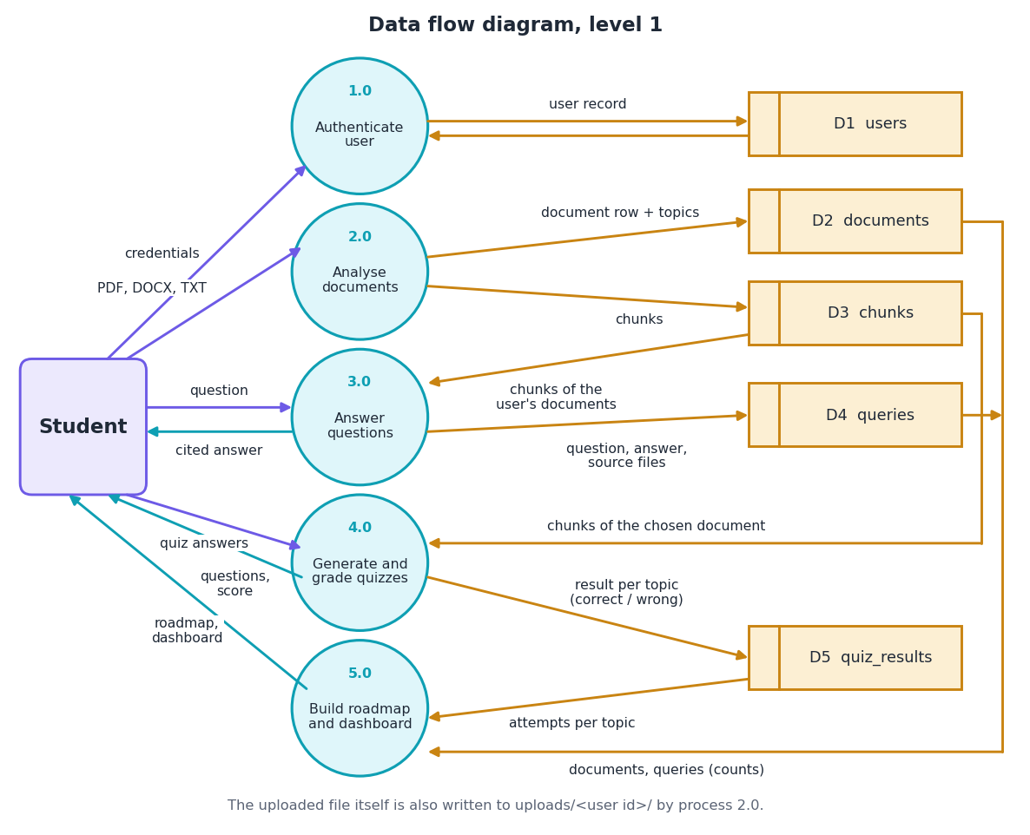
Figure 4: Level 1 data flow diagram with five processes and five data stores.
Five processes (authenticate, analyse documents, answer questions, generate and grade quizzes, build roadmap and dashboard) read and write five stores: users, documents, chunks, queries and quiz_results.

5.4.3 Level 2: document analysis
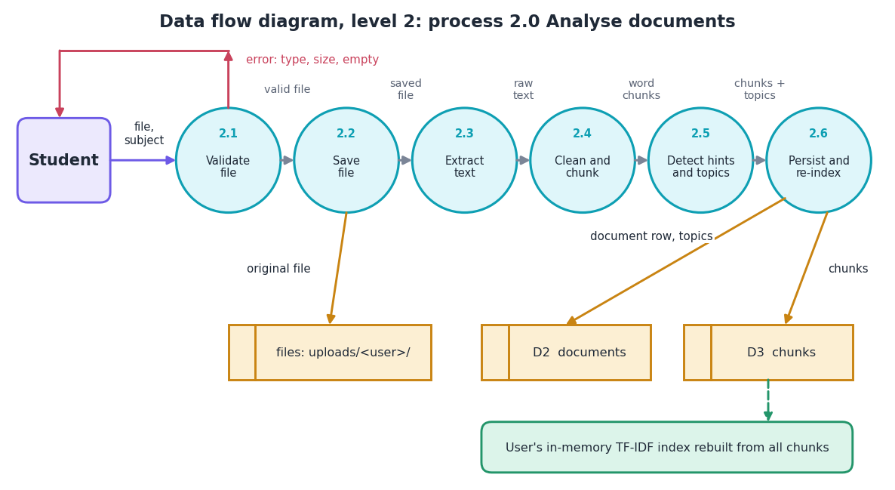
Figure 5: Level 2 data flow diagram of process 2.0, analyse documents.
Process 2.0 validates the file (type, 16 MB, safe name), saves it, extracts text, cleans and chunks it, detects headings and at most twelve topics, then stores rows and rebuilds the user's index.

5.4.4 Level 2: answering questions
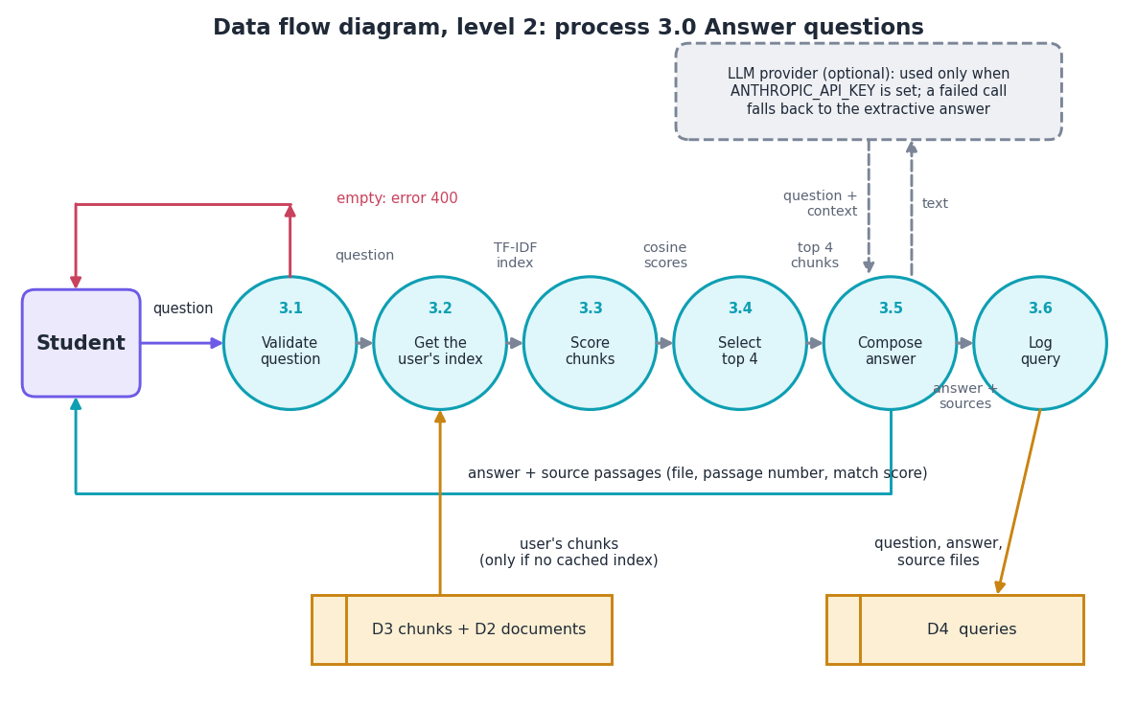
Figure 6: Level 2 data flow diagram of process 3.0, answer questions.
Process 3.0 rejects an empty question, obtains the cached or freshly built index, scores chunks by cosine similarity, keeps the top four with score above zero, composes the answer (extractive, or the optional model with fallback) and logs the query.

5.5 UML diagrams

5.5.1 Class diagram
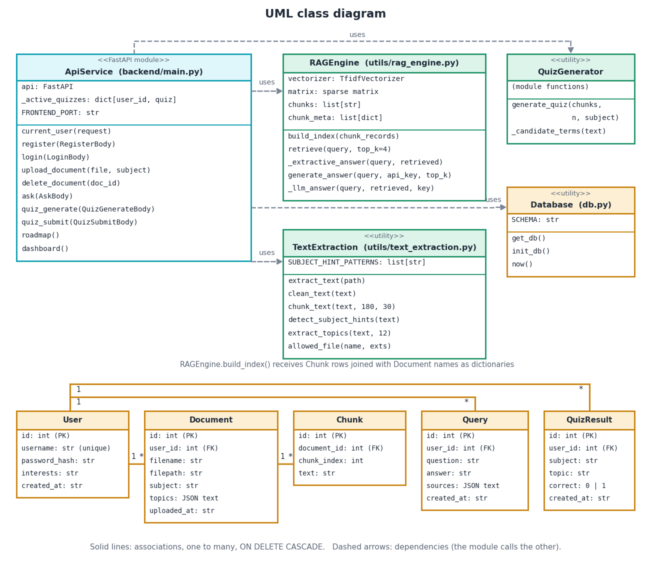
Figure 7: UML class diagram of the service modules and the five entities.
ApiService uses RAGEngine, TextExtraction, QuizGenerator and Database; the five entities hold the same relationships as the ER diagram (a user has many documents, queries and quiz results; a document has many chunks).

5.5.2 Sequence diagrams
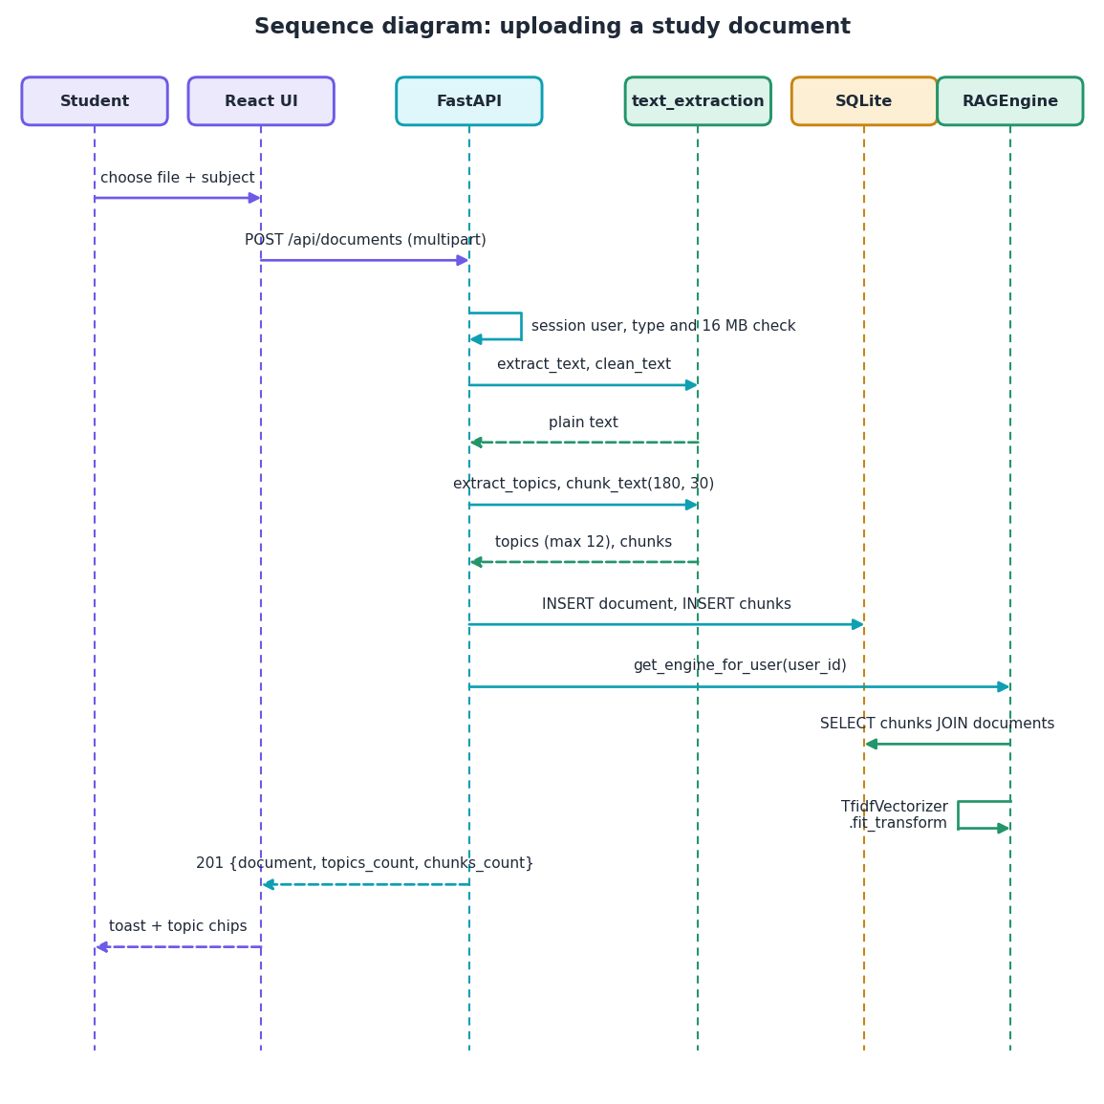
Figure 8: Sequence diagram of uploading a study document.
The upload request passes the session and file checks, the extraction helpers produce text, topics and chunks, SQLite stores them and the user's TF-IDF engine is rebuilt before the 201 response.
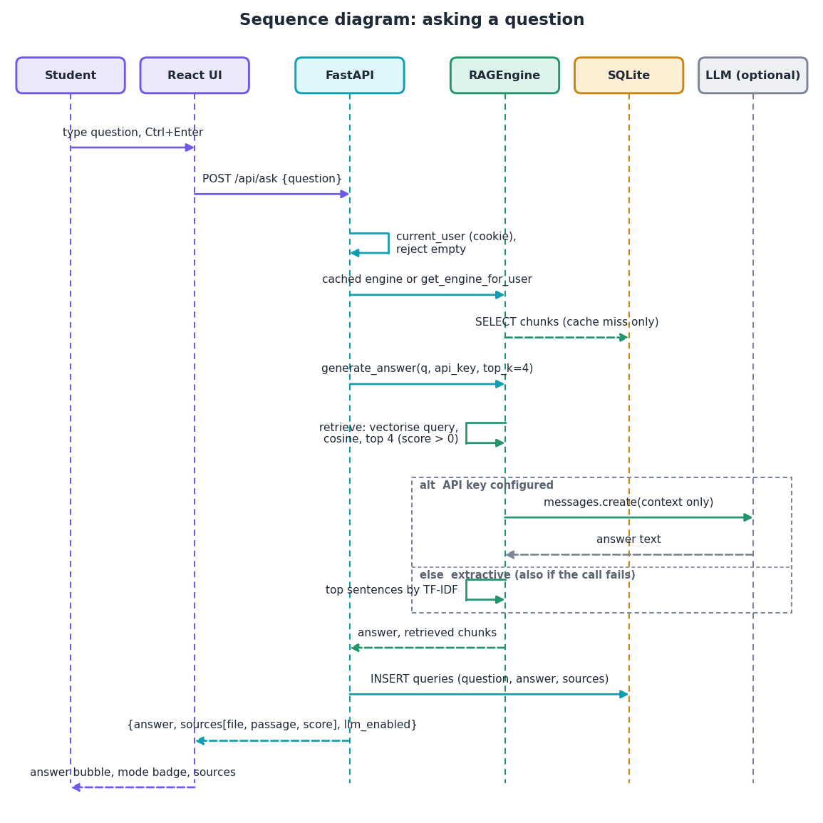
Figure 9: Sequence diagram of asking a question.
The question reaches the cached engine, the four best chunks are retrieved, the answer comes from the model (if a key is configured) or from sentence selection (also on failure), and the result is stored and returned with sources.

5.5.3 Use case diagram
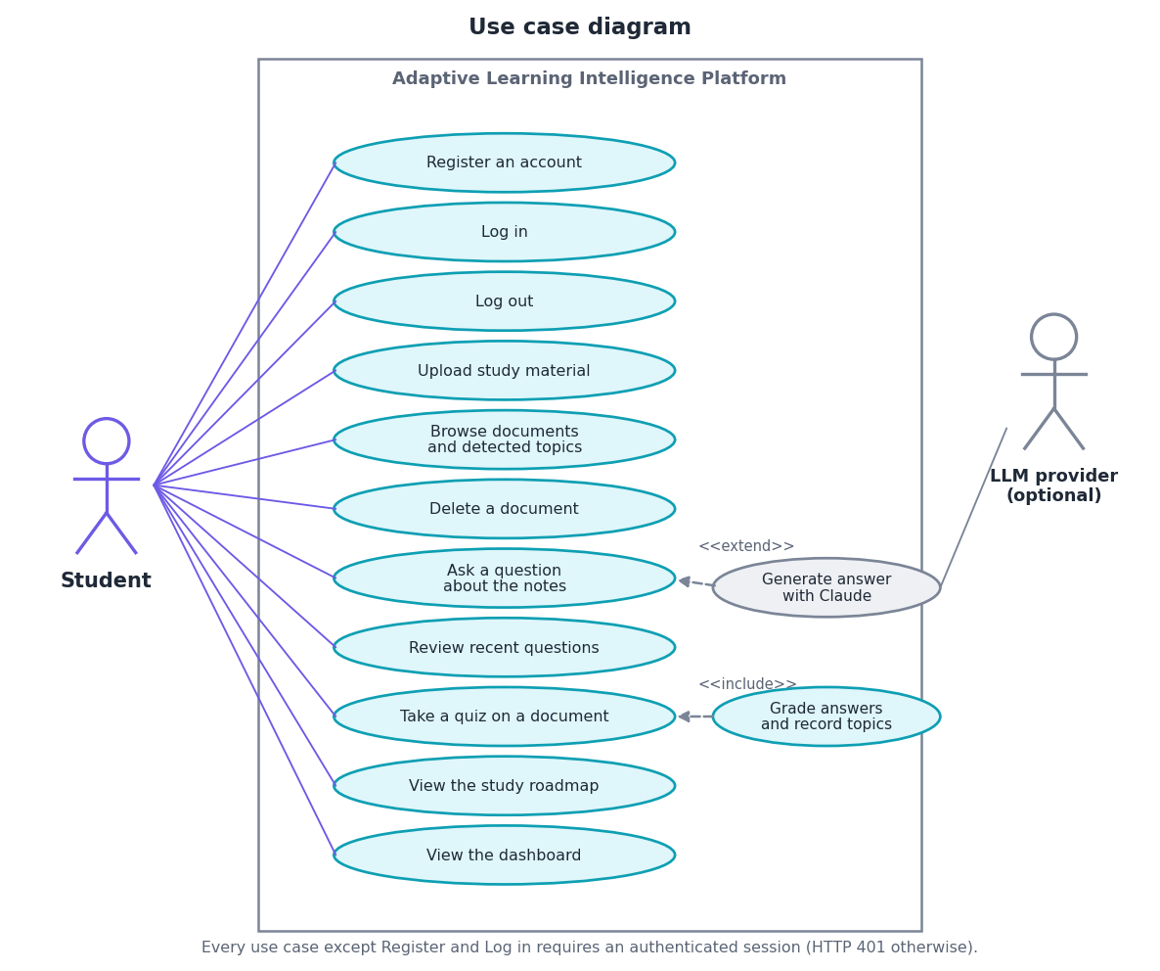
Figure 10: Use case diagram: one actor, eleven use cases and one optional external actor.
The student is the only actor; asking can be extended by the optional model, and taking a quiz includes grading. All use cases except registration and login need a session (HTTP 401 otherwise).

5.6 Database design
The data model has five tables in instance/app.db, created by db.init_db() with CREATE TABLE IF NOT EXISTS. Foreign-key checking is enabled for every connection (PRAGMA foreign_keys = ON) and every foreign key cascades on delete. The table gives the columns as defined in db.py.
Table 18: Tables and columns of the database
Table | Columns | Type and constraint | Meaning
users | id | INTEGER, primary key | Autoincrement identifier
 | username | TEXT, unique, not null | Login name, trimmed
 | password_hash | TEXT, not null | Werkzeug scrypt or PBKDF2 hash, never the password
 | interests, created_at | TEXT | Free text from registration; UTC ISO timestamp
documents | id, user_id | INTEGER, primary key; foreign key | Document identifier; owner (ON DELETE CASCADE)
 | filename, filepath | TEXT, not null | Secured file name; path under uploads/<user id>/
 | subject, topics | TEXT (topics: JSON list) | Subject typed at upload (default 'General'); up to twelve hints and keywords
 | uploaded_at | TEXT, not null | UTC ISO timestamp
chunks | id, document_id | INTEGER, primary key; foreign key | Chunk identifier; parent document (ON DELETE CASCADE)
 | chunk_index, text | INTEGER; TEXT, not null | Passage number shown as the source; about 180 words
queries | id, user_id | INTEGER, primary key; foreign key | Question identifier; asking user
 | question, answer, sources, created_at | TEXT (sources: JSON list) | As typed; answer returned; source file names; UTC ISO timestamp
quiz_results | id, user_id | INTEGER, primary key; foreign key | Result identifier; student
 | subject, topic, correct, created_at | TEXT; TEXT; INTEGER; TEXT | Subject of the document; blanked term used as topic; 1 if correct, 0 if wrong or blank; UTC ISO timestamp

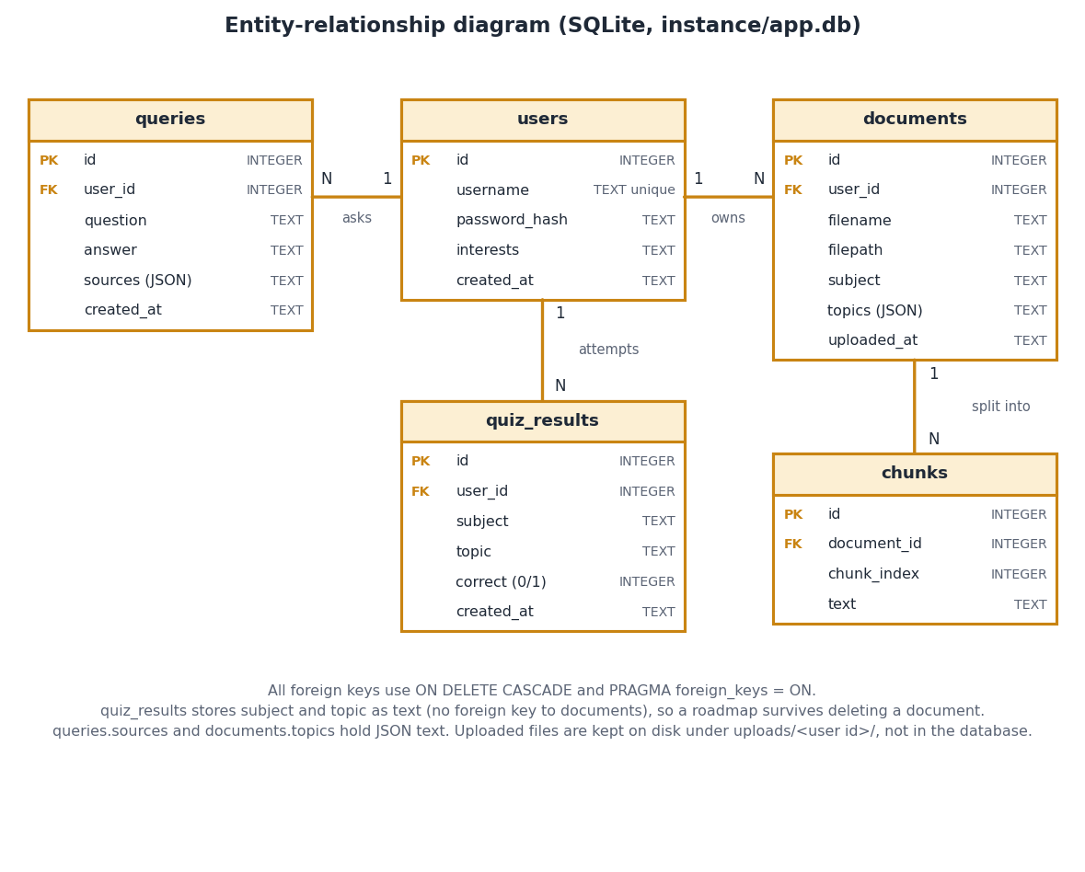
Figure 11: Entity-relationship diagram of the SQLite database.
users parents documents, queries and quiz_results; documents parents chunks; all foreign keys cascade on delete. quiz_results keeps subject and topic as text, so a roadmap survives deleting its document.
Two choices in the schema have consequences. quiz_results records subject and topic as text, so a roadmap survives the deletion of a document, but a topic name such as "data" is shared by every document that yields it and its accuracy mixes attempts from all of them. And the original file is written to uploads/<user id>/<secured name>, so two uploads with the same name share one path: deleting one removes the file of the other while its chunks stay in the database. This is recorded by a test (Chapter 7) and listed among the limitations.

5.7 Module design
The retrieval and quiz logic is small: 331 lines in three files under utils/. The API layer is 430 lines, the original Flask application 402 lines with ten templates, and the React interface 4,867 lines of TypeScript.
Table 19: Module breakdown
Module | Lines | Responsibility | Key names
backend/main.py | 430 | FastAPI application: 14 endpoints, Pydantic bodies, CORS, session middleware, helpers | ask, upload_document, quiz_submit, roadmap
app.py | 402 | Original Flask interface and the per-user index cache _rag_cache, get_engine_for_user | get_engine_for_user
db.py | 74 | SQLite connection, five-table schema, init_db, timestamp helper | get_db, SCHEMA
config.py | 15 | Secret key, database path, upload folder, allowed types, 16 MB limit, optional API key | Config
utils/text_extraction.py | 127 | Extraction for PDF, DOCX, TXT; cleaning; chunking; heading hints; TF-IDF topics | extract_text, chunk_text, extract_topics
utils/rag_engine.py | 120 | TF-IDF index, retrieval, extractive answer, optional Claude call | RAGEngine
utils/quiz_generator.py | 84 | Cloze question generation from TF-IDF terms | generate_quiz
frontend/src | 4,867 | Ten pages, interface kit, theme, motion, charts, API client and auth context | Ask.tsx, api.ts, AppShell.tsx
tests/ | 631 | 84 pytest tests with a temporary database | conftest.py, test_api.py
scripts/ | 2,160 | Corpus builder, questions, experiments, API timing, screenshots, figures, diagrams | run_experiments.py
run.bat | 23 | Creates the virtual environment, installs packages, starts both servers | -

Dependencies run one way: the interfaces call utils/ and db.py; utils/ imports only scikit-learn, pypdf, python-docx and the standard library. RAGEngine receives chunk records as plain dictionaries, so the test suite exercises it without a database (nine tests).

5.8 Algorithm design

5.8.1 Retrieval and answering
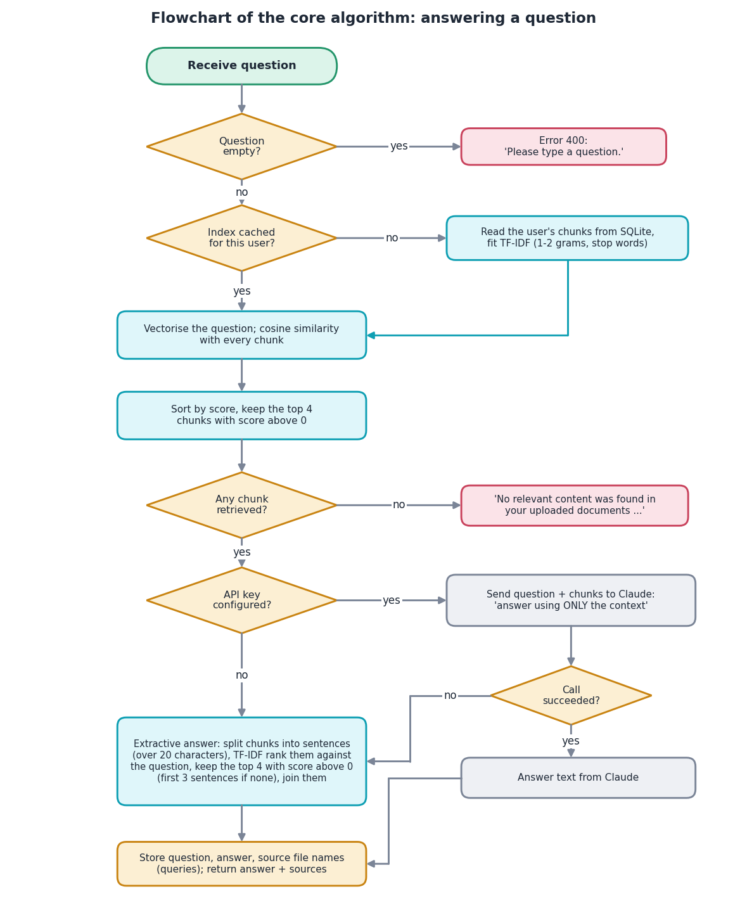
Figure 12: Flowchart of the core algorithm: retrieval and answer generation.
Empty question gives error 400; otherwise the index is taken from the cache or built, four chunks are retrieved, an empty result returns the fixed no-content message, and the answer is produced by the model or by sentence selection.
Retrieval is lexical (TF-IDF with unigrams and bigrams) because it needs no model download, GPU or network and the index rebuilds in a fraction of a second [6], [7]. The cost is quality: the shipped retriever reaches Hit@4 of 0.792, below BM25 (0.833) and a BM25 plus dense hybrid (0.889), the kinds of retriever used by the base paper [1], [5], [9]. The top_k is four so that the context stays near 720 words. The extractive answer guarantees that every word comes from the passages; the price is a loss of answer-key recall from 0.861 in the passages to 0.667 in the answer (Chapter 8). Unlike the base paper, there is no question classifier, sub-question decomposition, reranker or model-based compression [1], [11], [15].

5.8.2 Quiz generation and roadmap
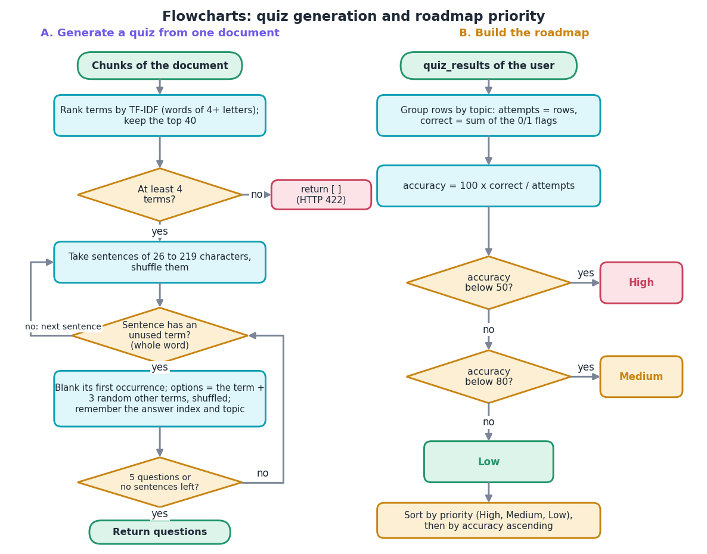
Figure 13: Flowcharts of quiz generation (left) and the roadmap priority rule (right).
Quiz: top 40 TF-IDF terms, shuffled sentences of 26 to 219 characters, first unused whole-word term blanked, three distractors, five questions or until sentences run out. Roadmap: accuracy per topic, High below 50, Medium below 80, otherwise Low.
The quiz generator needs no language model, but only the first occurrence of a blanked term is removed, a distractor may fit the sentence as well, and a sentence may begin in the middle of a thought. The roadmap uses fixed thresholds of 50 and 80 percent on one signal, the share of correct answers per topic: a transparent rule, not a learner model such as knowledge tracing [17] used by tutoring systems [2].

5.9 API design
Request bodies are Pydantic models (RegisterBody, LoginBody, AskBody, QuizGenerateBody, QuizSubmitBody), so a missing or mistyped field is reported with status 422 before any code runs. Every route except health, register, login, logout and me depends on current_user, which answers 401 when the session has no user. Interactive documentation is generated at /api/docs.
Table 20: Endpoints of backend/main.py
Method | Path | Request and response | Errors
GET | /api/health | {status, llm_enabled} | -
POST | /api/auth/register | In: username, password, interests. Out: message (201) | 400 empty, 409 duplicate
POST | /api/auth/login | In: username, password. Out: id, username, interests; sets the session cookie | 401
POST | /api/auth/logout | Clears the session | -
GET | /api/auth/me | Signed-in user, or null with HTTP 200 when nobody is signed in | -
GET | /api/dashboard | doc_count, query_count, quiz_attempts, performance[subject, accuracy, attempts], five latest documents | 401
GET | /api/documents | Documents with topics and chunk_count, newest first | 401
POST | /api/documents | In: multipart document and subject. Out: document, topics_count, chunks_count, warning (201) | 400 type, 413 over 16 MB
DELETE | /api/documents/{id} | Deletes chunks, row and file; refreshes the index | 404
POST | /api/ask | In: question. Out: answer, sources[text, score, doc_name, chunk_index], llm_enabled | 400 empty
GET | /api/ask/history | The last ten questions with answer and source names | 401
POST | /api/quiz/generate | In: doc_id. Out: five questions with options and topic (answers withheld) | 404, 422 too little text
POST | /api/quiz/submit | In: answers (index or null per question). Out: correct, total, score_pct, per-question results | 409 no active quiz
GET | /api/roadmap | Topics with subject, accuracy, attempts, priority, sorted weakest first | 401

Errors use the standard detail field, which the front end turns into a sentence; a network failure produces "Can't reach the server. Check that the backend is running on port 8301". The client sends cookies with every request, and a 401 on a protected page sends the user to the login page and back after sign-in.

5.10 User interface design
The React interface follows the Aurora Glass design kit: translucent glass cards over a soft gradient backdrop, violet and cyan accents, a sidebar that becomes a drawer on small screens, and a light and a dark theme sharing one set of colour tokens (stored under alip-theme, defaulting to the system preference).
Table 21: Pages of the React application
Page | Route | Content
Landing | / | Hero, how it works, example answer, statistics strip, light and dark theme switch
Login, Register | /login, /register | Credential forms with validation messages; registered users are redirected to the app
Dashboard | /app | Counters for documents, questions and quiz questions, subject-wise accuracy chart, recent documents
Upload | /app/upload | File drop area, subject field, processing result with topic chips and a link to a quiz
Documents | /app/documents | Searchable table with subject, topics, chunks, upload time, quiz and delete buttons
Ask your notes | /app/ask | Question box, answer, mode badge, expandable sources with match score, last ten questions
Quiz | /app/quiz | Document picker, five questions with four options, result with per-question review
Study roadmap | /app/roadmap | Counters per priority, filter tabs, sortable table with accuracy bar and attempts

• States and feedback. Every data page has loading, empty and error states, and a 401 redirects to login. Toasts confirm uploads ("12 topics detected, 4 chunks indexed"), quiz submissions and errors; a badge tells whether an answer came from the offline mode or from Claude.
• Charts and layout. Subject accuracy is a bar chart in three colours (below 50, 50 to 79, 80 and above). The layout was captured at 1440, 768 and 360 pixels in both themes with no console error and no horizontal overflow (Chapter 7), and every page is a lazy chunk (the largest, the landing page, is 18.5 kB before compression).
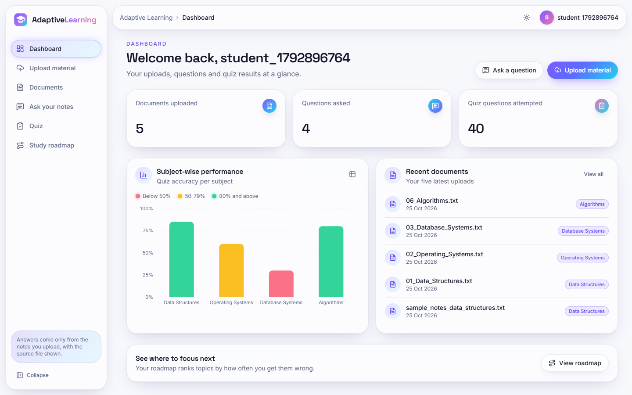  Figure 14: Dashboard with counters, subject accuracy and recent documents. | 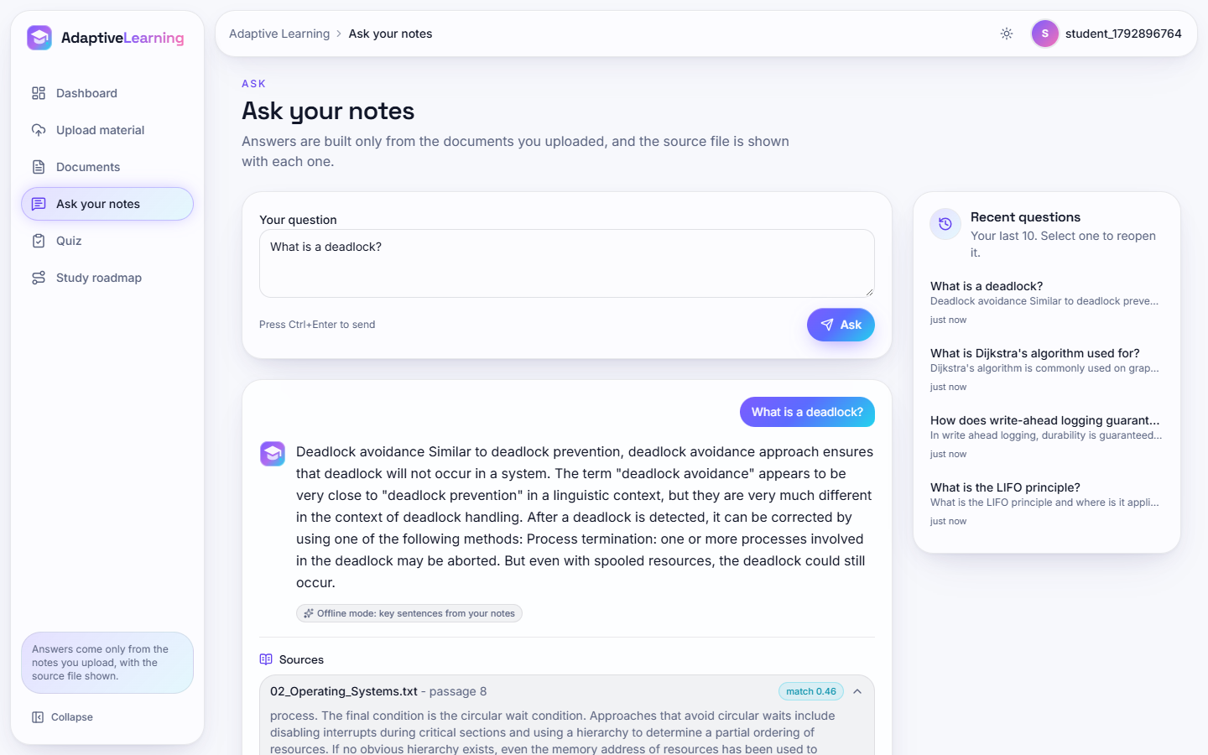  Figure 15: Ask your notes: answer, offline-mode badge and sources.

There is no administrator interface, teacher view, notification or revision calendar; these are listed as future work in Chapter 10.

CHAPTER 6: METHODOLOGY AND SOFTWARE IMPLEMENTATION

6.1 Overall methodology
The platform is a document-analysis and retrieval pipeline followed by two small adaptive components, a quiz generator and a roadmap builder. The design follows the retrieve-then-generate idea of retrieval-augmented generation [4] and adopts from the base paper [1] the view that retrieval and context compression are separate stages whose joint effect on answer quality and context size must be measured. It does not adopt the base paper's learned components (an LLM question classifier, dense retrieval with a cross-encoder reranker, an LLM compressor), for the reasons given in Section 6.4. The steps are:
1. Ingest. Accept a PDF, DOCX or TXT file of at most 16 MB, store the original under uploads/<user id>/, and extract plain text (Section 6.3).
2. Analyse. Clean the text, detect subject and unit headings with regular expressions, and rank keywords by TF-IDF to obtain at most twelve topics per document.
3. Chunk and index. Cut the text into windows of 180 words with an overlap of 30 words, store them in SQLite and rebuild the user's in-memory TF-IDF index.
4. Retrieve. Vectorise the question, compute the cosine similarity with every chunk and keep the four best chunks with a positive score.
5. Answer. Select the four sentences of the retrieved chunks that are most similar to the question (extractive mode), or, when an API key is configured, send the question and the chunks to an LLM with the instruction to use only the context.
6. Practise. Build five fill-in-the-blank questions from a document, grade the submission on the server and store one result row per question.
7. Adapt. Group the results by topic, compute the accuracy of each topic and label it High, Medium or Low priority.
To judge the pipeline, and not only to describe it, an experimental protocol was run on a six-subject corpus with 72 hand-written questions (Sections 6.2 and 6.6); it is the source of every number in Chapters 7 and 8.

6.2 Dataset
The product itself needs no training data: TF-IDF is fitted on the user's own documents at run time. The project therefore has no training, validation and test split in the machine-learning sense. Two document sets are used.
Bundled sample notes. sample_data/sample_notes_data_structures.txt is a 619-word note on data structures written for the project (a Subject: line, five Unit n: headings and a list of important questions; 4 chunks). It is used for the demonstration and most unit tests.
Evaluation corpus. To measure retrieval and answering at realistic volume, scripts/fetch_corpus.py builds six subject files from 36 English Wikipedia articles (CC BY-SA 4.0 [18]). Each file starts with Subject: ... and each article becomes a Unit n: <title> section, the layout that the document analyser recognises. Articles are pinned to revision identifiers in experiments/corpus_manifest.json, mathematical markup is removed and each is cut at 3,200 words, so the corpus can be rebuilt exactly. Wikipedia is better organised than typical lecture notes, which probably makes retrieval easier than on real material.
Table 22: Evaluation corpus
File (subject) | Articles | Words | Chunks (180/30)
Data Structures | 6 | 15,072 | 101
Operating Systems | 6 | 16,797 | 112
Database Systems | 6 | 15,504 | 104
Computer Networks | 6 | 17,618 | 118
Machine Learning | 6 | 18,346 | 123
Algorithms | 6 | 17,107 | 114
Total | 36 | 100,444 | 672

Questions. Seventy-two questions were written by hand, twelve per subject and twenty-four for each of three types that follow the taxonomy of the base paper [1]: fact (When, Which, How many), definition (What is, Define) and reasoning (Why, How). The type is assigned from the wording of the question. For each question the gold evidence is a sentence fragment copied from the corpus; a script confirms that every fragment occurs exactly once in its subject file, and that each lies wholly inside at least one chunk (72 of 72). A retrieved chunk counts as a hit when it contains the evidence after whitespace and case normalisation. Each question also carries one to three short answer strings, used to test whether a generated answer contains the expected fact. In addition 12 off-topic questions (sport, cooking, geography and similar) test whether the system refuses to answer when nothing relevant has been uploaded.
All seventy-two questions are test questions: nothing is trained and the shipped parameters were fixed before the questions were written; the sweeps of Chapter 8 are sensitivity analyses, not tuning. With 72 questions the confidence intervals are wide, so the bootstrap interval is stated wherever the shipped scores are quoted.

6.3 Pre-processing
utils/text_extraction.py holds all pre-processing. Each step is a small, separately tested function.
Table 23: Pre-processing steps
Step | Function | Behaviour
Text extraction | extract_text | PDF: pypdf.PdfReader, text of every page (a page that fails is skipped). DOCX: text of every paragraph (table cells are not read). TXT: UTF-8, undecodable bytes ignored. Any exception returns the string [Could not extract text: ...].
Chunking | chunk_text | Splits on whitespace and forms windows of 180 words that advance by 150 words (overlap 30). The last window may be shorter.
Heading detection | detect_subject_hints | Four case-insensitive patterns: Subject:, Course:, Unit <digits> :|-, Chapter <digits> :|-. Hints longer than 120 characters are dropped, duplicates removed, at most 15 kept.
Topic extraction | extract_topics | TF-IDF (unigrams and bigrams, English stop words, at most 500 features) over the sentences longer than 15 characters; terms ranked by summed weight; headings first, keywords after; at most 12 topics.
File validation | allowed_file | The extension must be pdf, docx or txt (case-insensitive); the size must not exceed 16 MB.

Chunking by word count is deliberately naive: a window can begin or end in the middle of a sentence. The overlap limits the damage for retrieval: with the shipped setting all 72 gold evidence fragments lie wholly inside at least one chunk, whereas with 60-word windows 2 are split. Heading detection recognises only Arabic numerals (Unit 1:, Unit 1 -, Chapter 1:); UNIT-I, Unit I:, Module 1: and 1. Title are not found (5 of 5 units for the first style, 0 of 5 for the second). On the evaluation corpus all 36 unit headings are found because the corpus uses the recognised layout.

6.4 Algorithm choice and justification
The project brief asks for semantic retrieval and context compression in the manner of the base paper [1]. The implemented algorithms are simpler, and the choice was made on four criteria: the system must run on an ordinary laptop with no GPU and no download; it must be free to run (no API cost); every answer must be traceable to a passage the student can read; and the code must be small enough for a four-student team to test completely. The table below lists each decision and the alternative that was not taken.
Table 24: Algorithm decisions
Component | Chosen | Reason | Not chosen and why
Retrieval | TF-IDF (1-2 grams) with cosine similarity, scikit-learn [16] | Offline, no model download, fits in milliseconds, scores are inspectable (the interface shows the match score) | Dense embeddings [5], [9]: need a model download and more memory; measured in Chapter 8 as a reference and not shipped. BM25 [6]: better in the measurements, not adopted in the product (Section 6.6)
Answer | Extractive: top four sentences by TF-IDF similarity to the question | Cannot invent text; the answer is made only of the student's own sentences | Abstractive generation: needs an LLM and a key. It exists as an optional branch (Anthropic API) but was not measured
Compression | The sentence selection itself | Reduces the context shown or sent to the generator without a second model | LLM compression as in SAC-RAG [1], LLMLingua [10], RECOMP [15]: cost, latency and a key
Question types | None: one strategy for every question | Keeps the pipeline linear and easy to test | Question-type routing as in SAC-RAG [1] and Adaptive-RAG [11]: needs a classifier; per-type results are only reported, not used
Quiz | Cloze questions on TF-IDF terms with random distractors from the same document | Works offline on any document and needs no answer key | LLM-written multiple-choice questions: cost and unverifiable quality
Roadmap | Per-topic accuracy with fixed thresholds 50 and 80 | Transparent rule a student can understand | Knowledge tracing [17] as in TutorLLM [2]: needs response sequences and a trained model

Two of these choices are weaker than the stated objectives. Retrieval is lexical, so a question that shares no word with the passage cannot find it; the brief's phrase 'searched semantically rather than by keyword' is therefore not satisfied by the shipped code. And the compression is extractive and unconditioned on the question type, so it has no counterpart to the adaptive behaviour that is the main contribution of the base paper. These gaps are measured, not hidden, in Chapters 8 and 9.
The index is rebuilt from all of the user's chunks after every upload or deletion and is kept in a dictionary keyed by user, _rag_cache, inside the Python process. It is not persisted: after a restart it is rebuilt on the first question.

6.5 Mathematical formulation

6.5.1 TF-IDF and cosine similarity
Let the index contain n chunks and let df(t) be the number of chunks that contain term t, where a term is a unigram or bigram after stop-word removal. scikit-learn [16] uses the smoothed inverse document frequency and L2-normalised vectors:
idf(t) = ln((1 + n) / (1 + df(t))) + 1; w(t, d) = tf(t, d) x idf(t); v_d = w(., d) / ||w(., d)|| (1)
The query q is transformed with the same vocabulary and idf, giving v_q. Because both vectors have unit length, the cosine similarity is a dot product, and chunks are ranked by it:
score(q, d) = cos(v_q, v_d) = v_q . v_d, 0 <= score <= 1 (2)
The four chunks with the highest positive score form the retrieved set R. A term that is absent from the vocabulary does not contribute, so a question whose terms all fall outside the vocabulary has score zero for every chunk and returns no result.

6.5.2 Extractive answer
Let S be the sentences (longer than 20 characters) of the chunks in R. A second TF-IDF model is fitted on the list [q] + S, and the answer is made of the four sentences with the largest positive cosine similarity to q:
answer(q) = join( top4{ s in S : cos(v_q, v_s) > 0 } ) (3)
If no sentence scores above zero the first three sentences are returned; if there are none, the first 500 characters of the best chunk. The answer contains no word that is absent from R (verified in Chapter 8) and is about 90 words long whatever the question, because four sentences are always selected.

6.5.3 Evaluation measures
For question i let r_i be the rank of the first retrieved chunk that contains the gold evidence, or infinity if none of the first ten does. With N = 72 questions:
Hit@k = (1 / N) x #{ i : r_i <= k }; MRR@10 = (1 / N) x sum_i (1 / r_i) with 1 / r_i = 0 if r_i > 10 (4)
Answer-key recall is the share of questions whose generated answer (or retrieved context) contains at least one answer string; the word reduction is 1 minus the mean answer length over the mean context length. A 95 percent bootstrap interval (2,000 resamples, fixed seed) is given for the shipped retriever.

6.5.4 Retrievers used for comparison
To place the shipped retriever against the alternatives the base paper builds on, four more scorers were evaluated on the same chunks. BM25 [6] with k1 = 1.5 and b = 0.75 scores a chunk d by
BM25(q, d) = sum over t in q of idf(t) x f(t, d) (k1 + 1) / ( f(t, d) + k1 (1 - b + b |d| / avgdl) ), idf(t) = ln((n - df(t) + 0.5) / (df(t) + 0.5) + 1) (5)
LSA [8] projects the TF-IDF matrix to 200 dimensions (truncated SVD). The dense retriever embeds chunks and questions with BAAI/bge-small-en-v1.5 [9] (quantised ONNX model, 384 dimensions, fastembed, CPU). The hybrids add 0.5 times the min-max-normalised BM25 score to 0.5 times the normalised score of a second scorer, a simplified form of the fact-type retrieval of the base paper [1] without its cross-encoder reranking.

6.5.5 Quiz generation and roadmap rule
For a document with chunks C the quiz generator ranks terms of four or more letters by TF-IDF over the whole text and keeps the best 40. Sentences of 26 to 219 characters are shuffled; for each sentence the first term (in rank order) not yet used that occurs in it as a whole word is blanked at its first occurrence, three other terms are drawn at random as distractors, and the four options are shuffled; the process stops after five questions. The roadmap rule for a topic with a correct answers in m attempts is
acc = 100 a / m; priority = High if acc < 50; Medium if 50 <= acc < 80; Low otherwise (6)

6.6 Experiment configuration
scripts/run_experiments.py runs the protocol on the project's own code (utils.text_extraction, utils.rag_engine, utils.quiz_generator) and writes experiments/results.json. Hardware and software were: Intel Core i5-12500 (6 cores, 12 threads), 15.7 GB RAM, Windows 11 Pro, none (CPU only); Python 3.11.9, scikit-learn 1.5.1, NumPy 1.26.4. The machine was shared with other jobs, so timings are medians of repeated runs.
Table 25: Experiment protocol
Experiment | Configuration | Measures
Retriever comparison | Seven retrievers (shipped TF-IDF, unigram TF-IDF, BM25, TF-IDF + LSA, BM25 + LSA, dense BGE-small, BM25 + dense) on the same 672 chunks, 72 questions | Hit@1, 3, 4, 10, MRR@10, bootstrap interval, by question type
Chunk size | 60/15, 100/20, 180/30 (shipped), 300/50 and 450/75 words, shipped retriever | Chunks, evidence intact, Hit@k, MRR
Compression | Top k of 1, 2, 4, 6 and 8 chunks; shipped extractive answer step, offline mode | Words in context and answer, answer-key recall, evidence retention, answer words found in context
Abstention | 12 off-topic questions; top-1 score thresholds from 0 to 0.30 | Share of off-topic questions refused, share of in-scope questions still answered
Document analysis | Six corpus files; synthetic five-unit syllabus in seven heading styles | Unit recall, topics per file, units found per style
Quiz generation | 30 seeds x 6 files x 5 requested questions; manual review of 30 questions | Yield, structural validity, ambiguity, answer repeated in the stem, reviewer label

The shipped design was fixed first and the other retrievers were compared afterwards; no product parameter changed after the measurements. The dense baseline needed a separate environment (ONNX runtime); the product's requirements are unchanged.
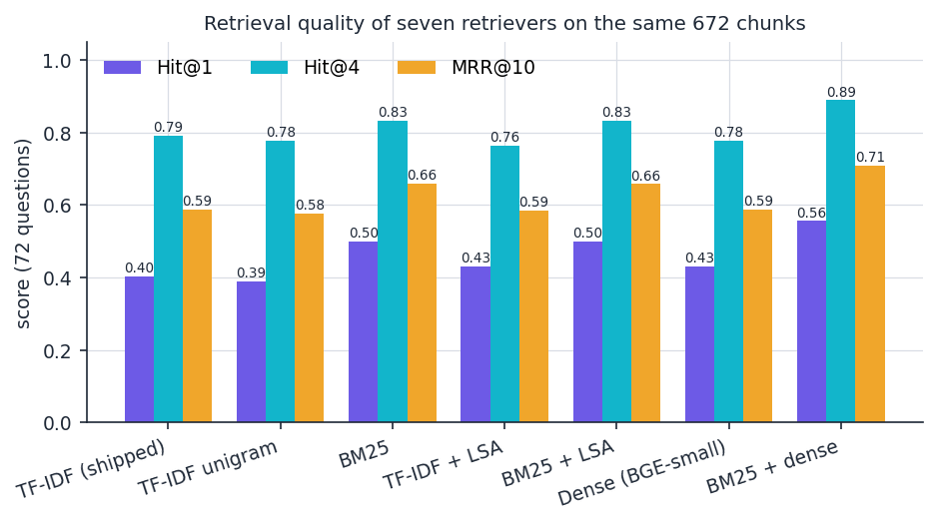
Figure 16: Retrieval quality of the seven retrievers evaluated on the same 672 chunks and 72 questions.

6.7 Application architecture
A request travels from a React page, through the Vite development proxy (port 5301 to 8301), to the FastAPI application in backend/main.py. The module does not reimplement the pipeline: it imports db.py, config.py and utils/* and the index cache from the original Flask module app.py (import app as legacy), so both interfaces use identical logic and the same SQLite file. Middleware adds CORS for the two frontend origins and a signed session cookie.
Document upload is the longest path. After validating the extension and size, the handler writes the file, extracts and cleans the text, derives the topics, cuts the chunks, inserts one documents row and one chunks row per window, and calls get_engine_for_user, which reads all of the user's chunks and fits a new TF-IDF model. A question then needs only the cached engine (legacy._rag_cache): it calls generate_answer(question, api_key) and logs the exchange in queries.
Rebuilding the index after each upload keeps the code simple and the index consistent, but its cost grows with the user's total number of chunks: uploading the six corpus files one by one took between 201 and 2501 ms per file in the measured run (Chapter 7). Retrieval itself takes a median of 2.0 ms at 672 chunks and 17.6 ms at 5,376 chunks, so one student's notes are served comfortably; the design is not meant for shared collections of many users in one process.
The quiz endpoints keep the generated questions, including the correct answer index, in a Python dictionary _active_quizzes keyed by user, so that the browser never receives the answers before grading. This state lives in the process: a restart or a second worker loses it, and the next submission then receives HTTP 409. The Flask interface keeps the same data in its cookie session instead.
The roadmap is computed on every request from the quiz_results rows, grouped by topic and compared with the thresholds 50 and 80; nothing is cached.
Grouping is by topic string only, so two subjects that produce the same keyword (for example 'data' in Data Structures and in Database Systems) share one roadmap row, and the subject shown is the one of the latest result.

6.8 API design
The API has fourteen JSON endpoints under /api. Request bodies are Pydantic models (RegisterBody, LoginBody, AskBody, QuizGenerateBody, QuizSubmitBody); the upload is multipart. Errors use FastAPI's {"detail": ...} form, which the React client shows as a message.
Table 26: API endpoints
Method | Path | Purpose | Status codes
GET | /api/health | Status and whether an LLM key is configured | 200
POST | /api/auth/register | Create a user from username, password, interests | 201; 400 empty field; 409 duplicate
POST | /api/auth/login | Check the password hash and set the session cookie | 200; 401
POST | /api/auth/logout | Clear the session | 200
GET | /api/auth/me | Current user, or null when signed out | 200
GET | /api/dashboard | Counts, accuracy per subject, five latest documents | 200; 401
GET | /api/documents | Documents with chunk counts | 200; 401
POST | /api/documents | Upload a file (multipart: document, subject) | 201; 400 type; 413 over 16 MB; 401
DELETE | /api/documents/{id} | Delete document, chunks and file; rebuild the index | 200; 404
POST | /api/ask | Answer a question with sources | 200; 400 empty; 401
GET | /api/ask/history | The ten latest questions | 200; 401
POST | /api/quiz/generate | Five cloze questions from one document (answers withheld) | 200; 404; 422 too little text
POST | /api/quiz/submit | Grade the active quiz and store results | 200; 409 no active quiz
GET | /api/roadmap | Topics with accuracy, attempts and priority | 200; 401

Authentication is a signed cookie (alip_session, seven days, SameSite Lax) set by login; every endpoint except health, register, login, logout and me returns 401 without it, which the test suite checks for nine routes. Passwords are hashed with Werkzeug before storage. The sample screens of Chapter 8 show the API in use.

6.9 Security and error handling
Security was tested as a feature (Chapter 7). The table lists the situations that are handled.
Table 27: Input validation and errors
Situation | Behaviour | HTTP
Empty username or password at registration | Rejected with a message | 400
Wrong password or unknown user | Same message for both, so existence of a user is not revealed | 401
Protected route without a valid session (including a tampered cookie) | Rejected; the cookie signature is checked | 401
Extension other than pdf, docx, txt (including notes.txt.exe) | Rejected before anything is stored | 400
Filename with path parts (../../evil.txt) or only dots | secure_filename keeps the file inside the user's folder; a name that reduces to nothing is rejected | 201 / 400
Corrupt PDF or file without text | No exception; zero chunks and a warning in the response | 201
Another user's document id (delete, quiz) | Reported as not found; documents and sources of one user never appear for another | 404
SQL-injection text in names or questions | Parameterised queries; the text is stored literally | 200 / 401
Foreign browser origin | No CORS header is returned | -

The posture is that of a local teaching prototype. The session cookie is not marked Secure and the server is plain HTTP, so credentials travel unencrypted without a TLS proxy; there is no rate limiting, account lock-out, password-strength rule or CSRF token (SameSite Lax is the only mitigation); the signing secret defaults to a development value if SECRET_KEY is not set; and the upload body is read fully into memory before the size check. Two uploads of the same file name by one user share one path on disk, so deleting one removes the file the other still lists (its chunks remain, so questions are unaffected); this is a recorded limitation with a test that asserts the current behaviour.
The optional LLM branch falls back silently to the extractive answer on any exception; only the badge in the answer card tells the student which mode produced the answer.

6.10 Installation and execution
Table 28: Software environment used for this work
Component | Version
Operating system / hardware | Windows 11 Pro; Intel Core i5-12500 (6 cores, 12 threads); 15.7 GB RAM; none (CPU only)
Python and packages | Python 3.11.9; scikit-learn 1.5.1; numpy 1.26.4; pypdf 4.3.1; python-docx 1.1.2
Back end | FastAPI 0.115.0; uvicorn 0.30.6; Flask 3.0.3 (original interface); SQLite (Python standard library)
Front end | Node 24.19.0; React 19; Vite 8.3; Tailwind CSS 4; TanStack Query, axios, Recharts, framer-motion, GSAP

One-command start. Python 3.11 or newer and Node.js 20 or newer are required. Running run.bat in 8.ProjectCode (i) creates the virtual environment venv and installs backend/requirements.txt on the first run, (ii) runs npm install in frontend/ if node_modules is missing, and (iii) opens two windows, one for uvicorn backend.main:app --host 127.0.0.1 --port 8301 and one for npm run dev (Vite on 5301). The SQLite database instance/app.db is created on first use; no model has to be trained because the index is built from the user's own uploads. Ports and the cookie-signing secret are read from .env (copied from .env.example); setting ANTHROPIC_API_KEY there, and installing the anthropic package, enables Claude-written answers.
python -m venv venv
venv\Scripts\python -m pip install -r backend\requirements.txt
venv\Scripts\python -m uvicorn backend.main:app --port 8301 # API, docs at /api/docs
cd frontend && npm install && npm run dev # http://localhost:5301
venv\Scripts\python app.py # original Flask UI, port 5000

Checks: python -m pytest -q (84 tests) and python scripts/smoke_test.py (24 checks). scripts/capture_screens.py --rich --responsive records the screens with Playwright; scripts/fetch_corpus.py, run_experiments.py and measure_api.py reproduce the experiments, and serve_scratch.py runs the backend on a throw-away database. A demonstration account (demo, password Demo@1234) exists in the project's own database.

CHAPTER 7: SYSTEM TESTING

7.1 Testing strategy
Before this documentation work the project contained a single end-to-end script, scripts/smoke_test.py, and no automated tests. The suite described here was written to measure the product as it is, not to confirm it: where the code has a limitation, a test records the current behaviour and the limitation is listed in Section 7.9 and in Chapter 9. The suite checks behaviour (does an upload create the right rows, is another user's document invisible, is a quiz graded on the server); retrieval and answer quality are measured on a corpus and reported in Chapter 8.
Testing has five layers: small functions tested directly with pytest; every API endpoint called through FastAPI's TestClient against a temporary SQLite database and upload folder (the suite never touches instance/app.db); a separate group of security tests; a scripted browser walk through the real interface; and response times measured on a running server. The whole pytest run takes 15.2 seconds on the development machine (Intel Core i5-12500 (6 cores, 12 threads), 15.7 GB RAM).
Table 29: Test layers and results
Layer | What it covers | How | Result
Unit | Text extraction, chunking, heading and topic detection, file-type check, retrieval engine, quiz generator | pytest, direct import of utils/ | 28 tests pass
Integration and functional | Every endpoint: authentication, upload, documents, ask, quiz, roadmap, dashboard | pytest, TestClient, temporary database | 45 tests pass
Security | Hashing, injection strings, path traversal, cookie flags, tampered cookie, CORS, isolation between users | pytest | 11 tests pass
End-to-end smoke test | Register, login, upload, ask, quiz, roadmap, dashboard, delete, logout against the running API | scripts/smoke_test.py | 24 of 24 checks pass
Front end | Type check, production build, console errors and layout overflow on 1440, 768 and 360 pixel screens, light and dark | npm run build, Playwright | Build succeeds; console clean
Performance | Response time of each endpoint; retrieval time against index size | scripts/measure_api.py, scripts/run_experiments.py | Measured (Section 7.8)

In total 84 pytest tests ran: 84 passed, 0 failed, 0 errored and 0 were skipped, and all 24 smoke checks passed. Line coverage was not measured, so no coverage figure is claimed. The first run exposed one error, in the test itself (the expected length of the last chunk of a 500-word text was 80 instead of 50); the code under test was correct.

7.2 Unit testing
The unit tests import the real modules and mock only the LLM call. Text files are created in a temporary folder, Word files with python-docx, and PDF files by a small helper that writes a minimal valid one-page PDF, with or without a text layer, so that no binary fixture is stored.
Table 30: Unit test cases (tests/test_text_extraction.py, test_rag_engine.py, test_quiz_generator.py)
ID | Test function | Checks | Result
U1 | test_extract_txt, test_extract_docx_paragraphs, test_extract_pdf_text_layer | Text is recovered from TXT, DOCX paragraphs and a PDF with a text layer | Pass
U2 | test_extract_docx_ignores_table_cells | Known limitation: text inside Word tables is not extracted | Pass (records the limitation)
U3 | test_extract_pdf_without_text_layer_is_empty, test_extract_corrupt_pdf_does_not_raise | A scan-like PDF gives empty text; a corrupt PDF gives [Could not extract text ...] and no exception | Pass
U5 | test_chunk_text_size_and_overlap | 500 words give windows of 180, 180, 180 and 50 words; the last 30 words of one window open the next | Pass
U7 | test_detect_subject_hints_standard_headings, _deduplicates_and_caps | Subject, course, unit and chapter headings are found; duplicates removed; at most 15 returned | Pass
U8 | test_detect_subject_hints_roman_numerals_not_recognised | Known limitation: UNIT-I, Unit I: and Module 1: give no hints | Pass (records the limitation)
U9 | test_extract_topics_prefers_hints_then_keywords, _short_text_falls_back | The sample notes give 12 topics starting with the subject; a tiny text gives none | Pass
U11 | test_retrieves_the_right_chunk, test_scores_are_sorted_descending | The LIFO chunk is ranked first for a LIFO question; scores are positive, at most 1 and sorted | Pass
U12 | test_empty_index_returns_nothing, test_query_without_shared_terms_has_no_results | No index or no shared term returns an empty list and the message No relevant content ... | Pass
U14 | test_extractive_answer_is_taken_from_retrieved_text | Every word of the answer occurs in the retrieved chunks | Pass
U16 | test_quiz_has_requested_number_and_valid_structure, test_terms_are_not_reused_within_one_quiz | Five questions, four distinct options, answer index consistent, each term used once | Pass
U17 | test_too_little_text_returns_empty | Fewer than four candidate terms gives no quiz | Pass

Together the unit tests cover every public function of utils/text_extraction.py, utils/rag_engine.py and utils/quiz_generator.py. The LLM call itself (_llm_answer) is not exercised against the real service.

7.3 Integration testing
The 45 API tests (tests/test_api.py) run the real FastAPI application, the real SQLite schema and the real pipeline in one process, with a fresh user per test so that tests do not depend on one another. They check the contract between the layers: rows created by an upload are visible through the documents list and the dashboard, the index rebuilt after an upload or deletion changes what a question can find, and quiz results written at submission appear in the roadmap and the subject chart.
Table 31: Integration test cases (tests/test_api.py)
ID | Test function | Scenario and expected result | Result
I1 | test_register_login_me_logout | Register, log in, read the user, log out; me returns null afterwards | Pass
I2 | test_upload_txt_creates_document_topics_and_chunks | The sample notes give 4 chunks and 12 topics; the list shows the chunk count and hides the file path | Pass
I3 | test_ask_answers_from_the_upload_with_sources_and_history | The LIFO question returns an answer containing Last In First Out, the source file name, and an entry in the history | Pass
I4 | test_deleting_a_document_removes_it_from_answers | After deletion the same question has no sources | Pass
I6 | test_quiz_flow_grades_and_feeds_roadmap_and_dashboard | Five questions without answer keys; an empty submission scores 0; the roadmap has five High rows; the dashboard counts one document and five attempts | Pass
I7 | test_quiz_submit_with_correct_answers_scores_100 | Submitting the stored answer indexes scores 100 percent and every roadmap row becomes Low | Pass
I9 | test_upload_docx | A Word file is accepted and indexed | Pass

7.4 Functional testing
Functional tests express the requirements as observable behaviour of the running API. Several apply to the three user stories that matter most: upload and analyse, ask with a cited answer, and practise with a roadmap.
Table 32: Functional test cases
ID | Requirement | Test function | Result
F1 | Only PDF, DOCX and TXT files are accepted | test_upload_rejects_unsupported_type | Pass
F2 | Files above 16 MB are refused | test_upload_rejects_files_over_16_mb (an 18 MB body gives 413) | Pass
F3 | A document with no extractable text is accepted with a warning and no chunks | test_upload_empty_text_gives_warning | Pass
F5 | A question must contain text | test_ask_requires_text | Pass
F7 | A quiz cannot be submitted twice or without being generated | test_quiz_cannot_be_submitted_twice, test_quiz_submit_without_active_quiz_conflicts (409) | Pass
F8 | A document with too little text cannot produce a quiz | test_quiz_on_tiny_document_is_refused (422) | Pass
F10 | A new user sees a zero dashboard | test_dashboard_for_new_user_is_zero | Pass

7.5 Validation and edge cases
The roadmap rule is the only piece of adaptive logic and was tested at its boundaries. test_roadmap_priority_thresholds is parametrised with ten combinations and passes for all of them: 0/1, 1/3 and 49/100 give High; 1/2, 2/4, 7/9 and 79/100 give Medium; 4/5, 80/100 and 5/5 give Low. test_roadmap_is_sorted_high_first_then_by_accuracy checks the order of the list.
Edge cases outside the unit tests were measured on the corpus and are reported in Chapter 8: heading styles that are not recognised, off-topic questions that still receive an answer, and quiz questions that repeat their own answer. They are not defects of the code against its specification; they are cases where the behaviour falls short of what the objectives ask for.

7.6 Security testing
The 11 tests of tests/test_security.py, together with the nine parametrised authentication checks of test_api.py, were written from a list of ordinary web risks.
Table 33: Security test cases
ID | Risk | Test function | Observed behaviour
S1 | Unauthenticated access | test_protected_routes_need_login (9 routes) | 401 on every protected route
S2 | Password disclosure | test_passwords_are_stored_hashed | Stored value is a scrypt or pbkdf2 hash that does not contain the password
S3 | SQL injection | test_sql_injection_in_login_and_register_is_inert, test_sql_injection_in_question_is_stored_literally | Login with ' OR '1'='1' -- fails; the string is stored as text; tables remain
S4 | Path traversal | test_path_traversal_in_filename_stays_inside_user_folder, test_filename_with_only_dots_is_rejected | ../../evil.txt becomes evil.txt inside the user's folder; .. is rejected
S6 | Session cookie | test_session_cookie_flags | HttpOnly and SameSite Lax present; Secure absent (recorded limitation)
S8 | Cross-site scripting | test_script_in_subject_is_returned_as_plain_json_text | A script tag in a subject is stored verbatim and returned as JSON, so React escapes it
S10 | Access to other users' data | test_users_cannot_see_or_delete_each_others_documents | Another user's documents are not listed, deletion and quiz return 404, and the search finds no source
S11 | File-name collision | test_known_limitation_same_filename_shares_one_file_on_disk | Two uploads of one name share a path; deleting one removes the file of the other (documented)

These tests establish that the common attacks do not succeed. They do not amount to a penetration test: rate limiting, CSRF protection, TLS and secret management are absent from the design and were not tested, and no external scanner was used.

7.7 End-to-end smoke test and browser run
scripts/smoke_test.py drives a running backend with the standard library and checks 24 points in order, from health and anonymous rejection through registration, login, upload, question, quiz, roadmap and dashboard to deletion and logout; all 24 pass against the scratch backend used for the measurements.
npm run build runs the TypeScript compiler and the production bundler without errors. scripts/capture_screens.py --rich --responsive then drives the real interface in Chrome through Playwright (five uploads, four questions, eight quizzes, every page in light and dark themes at 1440, 768 and 360 pixels) and records console errors, page errors, failed requests and horizontal overflow; the final run reported none. This checks stability and layout, not usability.

7.8 Performance testing
Latency was measured against a running backend on 127.0.0.1 (the host name localhost added about two seconds per call on this machine through an IPv6 fallback) with one user whose six corpus files (672 chunks) were indexed. Each endpoint was called 30 times. The table gives the second of two runs; the first run agreed on every median.
Table 34: HTTP response time (milliseconds)
Endpoint | Calls | Median | 95th percentile | Maximum
GET /api/health | 30 | 2.0 | 2.8 | 3.4
POST /api/auth/login (password hashing) | 10 | 127.6 | 137.0 | 177.5
GET /api/dashboard | 30 | 4.2 | 5.8 | 6.4
GET /api/documents | 30 | 5.8 | 6.9 | 8.7
GET /api/ask/history | 30 | 4.1 | 10.6 | 29.0
GET /api/roadmap | 30 | 7.0 | 10.0 | 10.4
POST /api/ask | 30 | 29.5 | 35.3 | 135.6
POST /api/quiz/generate | 30 | 23.1 | 28.2 | 34.7
POST /api/quiz/submit | 30 | 24.5 | 2172.4 | 2436.0

Most endpoints answer within a few milliseconds and a question within about 30 ms. Login takes about 128 ms because the password hash is computed on purpose. Quiz submission has a normal median of 24.5 ms but a 95th percentile of 2,172 ms: one or two of the 30 calls in each run took one to two seconds. The call writes five rows and commits to SQLite; slow commits are the likely explanation, but the cause was not isolated and the outliers are reported as measured.
Uploading is the slow path because each upload re-indexes all of the user's chunks: one file of 88 to 110 kB took between 201 and 2501 ms in the tabulated run and 120 to 811 ms in the earlier run, and deleting a document with re-indexing took 248 and 683 ms. The spread comes from load of other jobs on the shared machine, so these figures are an order of magnitude only.
Table 35: Retrieval time against index size (in-process, 72 queries)
Chunks in index | Words | Index build (ms) | Retrieve, median / p95 (ms) | Retrieve + extractive answer, median / p95 (ms)
672 | 120,424 | 197 | 2.0 / 3.3 | 4.8 / 6.3
1,344 | 240,848 | 316 | 4.6 / 6.0 | 7.9 / 9.6
2,688 | 481,696 | 540 | 9.7 / 12.9 | 13.0 / 17.0
5,376 | 963,392 | 964 | 17.6 / 20.9 | 20.7 / 25.7

Retrieval time grows roughly in proportion to the number of chunks, because the query is compared with every chunk; one student's notes are served in tens of milliseconds. The dense reference needed 52 seconds to embed the 672 chunks and 4.4 ms per query on the same CPU, which is why it is kept outside the product.
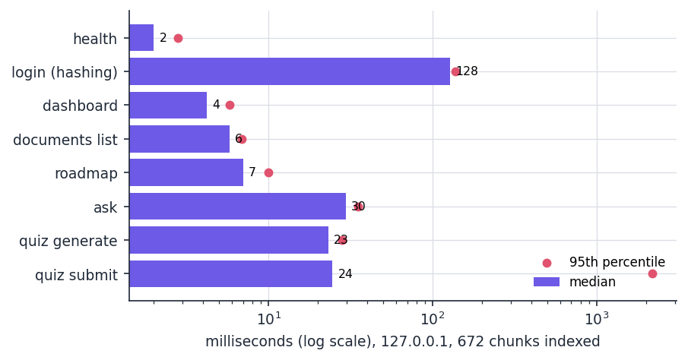
Figure 17: Median and 95th-percentile response time of the API endpoints (logarithmic scale).

7.9 Behaviours observed rather than asserted
The following findings come from the experiments of Chapter 8 and from the characterisation tests. None is a failed test; each is a gap between behaviour and objective, repeated in the limitations of Chapter 9.
• Off-topic questions are answered. 9 of 12 questions unrelated to the notes still received an extractive answer, because the engine refuses only when no query term overlaps any chunk. The 'strictly from the uploaded material' objective is satisfied for what is returned (every answer word comes from the chunks) but not for whether it should be returned.
• Heading styles. UNIT-I, Unit I:, Module 1: and 1. Title yield no hints (0 of 5 units), so a syllabus in those styles gets keyword topics only.
• Quiz quality. Every generated question is structurally valid, but in 18.2% of 900 the answer term still appears in the question and in 9.4% another option appears there too; a manual review of 30 questions rated 17 acceptable, 5 ambiguous and 8 poor.
• Process-local state. The index cache and the active-quiz dictionary live in one Python process; two server workers would not share them, and a restart discards an open quiz. This was not tested because it needs a multi-process deployment.
• Roadmap topics. Topics are single TF-IDF keywords, so some are generic words, and a keyword shared by two subjects merges their results.

7.10 User acceptance
No user study was carried out. No student other than the project team used the system, so no satisfaction, usability or learning-gain result exists and none is claimed. What was done is a scripted acceptance walk-through against the six objectives of the project, executed by capture_screens.py with real uploads in the real interface. The script plays a student who answers a chosen number of quiz questions correctly by selecting the option that restores the sentence from the notes and a wrong option for the rest. The resulting accuracies (Data Structures 85 percent, Algorithms 80, Operating Systems 60, Database Systems 30) are therefore simulated and demonstrate the roadmap logic, not the learning of a real student.
Table 36: Acceptance walk-through against the objectives
No. | Objective | Evidence in the walk-through | Verdict
1 | Ingest syllabi, notes and question banks and extract subjects, units and topics | Five documents uploaded; topics shown as chips (12 per file); heading hints found for Subject: and Unit n: layouts only | Partly met
2 | Store content so that it can be searched semantically | Content stored as chunks and searched by TF-IDF; no embeddings in the product | Not met
3 | Answer strictly from the material and cite the source | Answers made of the student's own sentences, with file, passage number and match score; off-topic questions are not refused | Mostly met
4 | Compress retrieved context within the model's limit | Extractive sentence selection shortens the context; not learned and not question-aware | Partly met
5 | Generate personalised roadmaps and revision schedules | Roadmap ranks topics by quiz accuracy; no schedule | Partly met
6 | Show coverage, study velocity and engagement on a dashboard | Counts of documents, questions and quiz attempts and a subject accuracy chart; no coverage or velocity | Partly met

7.11 The limits of the testing done
• No user study and no real student documents. The corpus is Wikipedia text; real notes, scanned syllabi and tables inside documents were not measured.
• Scanned PDFs. A PDF without a text layer is handled gracefully (empty text, warning), but optical character recognition is outside the system and was not tried.
• LLM mode. No API key was available, so the optional Claude branch was tested only with the call mocked. Its answer quality, cost and latency are unknown.
• Scale and concurrency. All timings are for one user on one machine that was shared with other jobs. Concurrent users, long-running sessions and multi-process deployment were not tested.
• Statistical power. The retrieval measurements use 72 questions; the 95 percent bootstrap interval for the shipped retriever's Hit@4 is 0.694 to 0.875, so differences of a few points between retrievers are within noise.
• Accessibility and cross-browser. Only Chrome was driven; no screen-reader or colour-contrast audit was done.

CHAPTER 8: RESULTS AND OUTPUT SCREENS

8.1 Experimental setup and protocol
The product has no trained model, so there is no accuracy to report in the usual sense. Its own code was therefore run on a purpose-built evaluation corpus: six subject files (Data Structures, Operating Systems, Database Systems, Computer Networks, Machine Learning, Algorithms) assembled from 36 English Wikipedia articles [18] under CC BY-SA 4.0, 100,444 words in all, laid out with a "Subject:" line and six "Unit n:" sections. Chunked by the platform (180 words, 30 overlap) the corpus gives 672 chunks of 179.2 words on average. Every article is pinned to a revision identifier in experiments/corpus_manifest.json, so scripts/fetch_corpus.py rebuilds it exactly.
The evaluation set has 72 hand-written questions, 12 per subject and 24 each of the three question types of the base paper [1] (fact, definition, reasoning, typed by wording). The gold answer of a question is a sentence fragment copied from the corpus; a retrieved chunk is a hit when it contains it. All 72 fragments lie wholly inside at least one chunk. A further 12 off-topic questions test whether the system refuses what its notes cannot answer. Measurements were made on Intel Core i5-12500 (6 cores, 12 threads) with 15.7 GB of memory and no GPU (Python 3.11.9, scikit-learn 1.5.1) on 25 October 2026; the machine was shared, so timings are medians of repeated runs. The measures are Hit@k, mean reciprocal rank over ten chunks (MRR@10), answer-key recall (a short key string of the gold answer occurs in the text), words passed on, and milliseconds.
What this protocol does not show. The corpus is encyclopaedic text and not a student's scanned notes; the questions were written by the project team; with only 72 of them the 95 % interval of the shipped retriever's Hit@4 is wide (0.694 to 0.875); and the generator under test is the offline extractive one, because no API key for the Claude mode was available. The numbers describe how the shipped components behave on this corpus, not real classroom use.

8.2 Output screens
All screens are real captures (1440 x 900 pixels) of the React application running against the FastAPI backend, taken by scripts/capture_screens.py --rich on a scratch database. The user has five uploaded documents (the bundled sample notes and four corpus files), four questions asked and eight quizzes taken. The quiz answers were scripted: the capture script picks the option that restores the sentence from the notes for a chosen number of questions out of five, which simulates a student with different mastery in each subject. The scores on the dashboard and the roadmap therefore illustrate the screens and are not results of a user study. The landing, login, registration, picker and dark-theme screens are in Appendix C.

8.2.1 Upload, documents, dashboard and roadmap
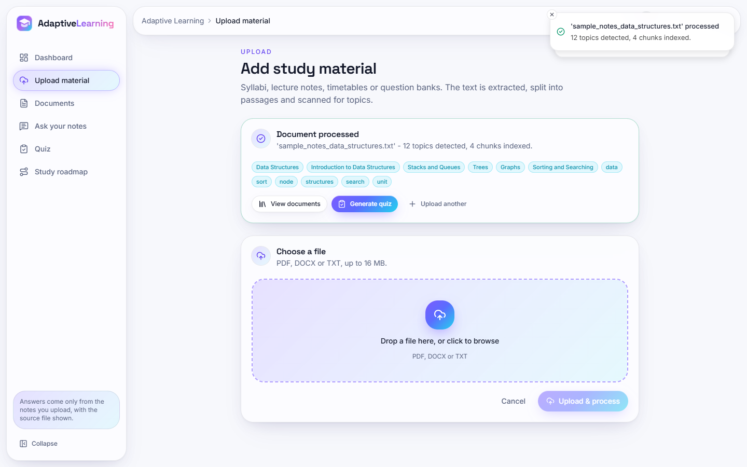  Figure 18: Upload after processing the sample notes: "12 topics detected, 4 chunks indexed" and the topic chips. | 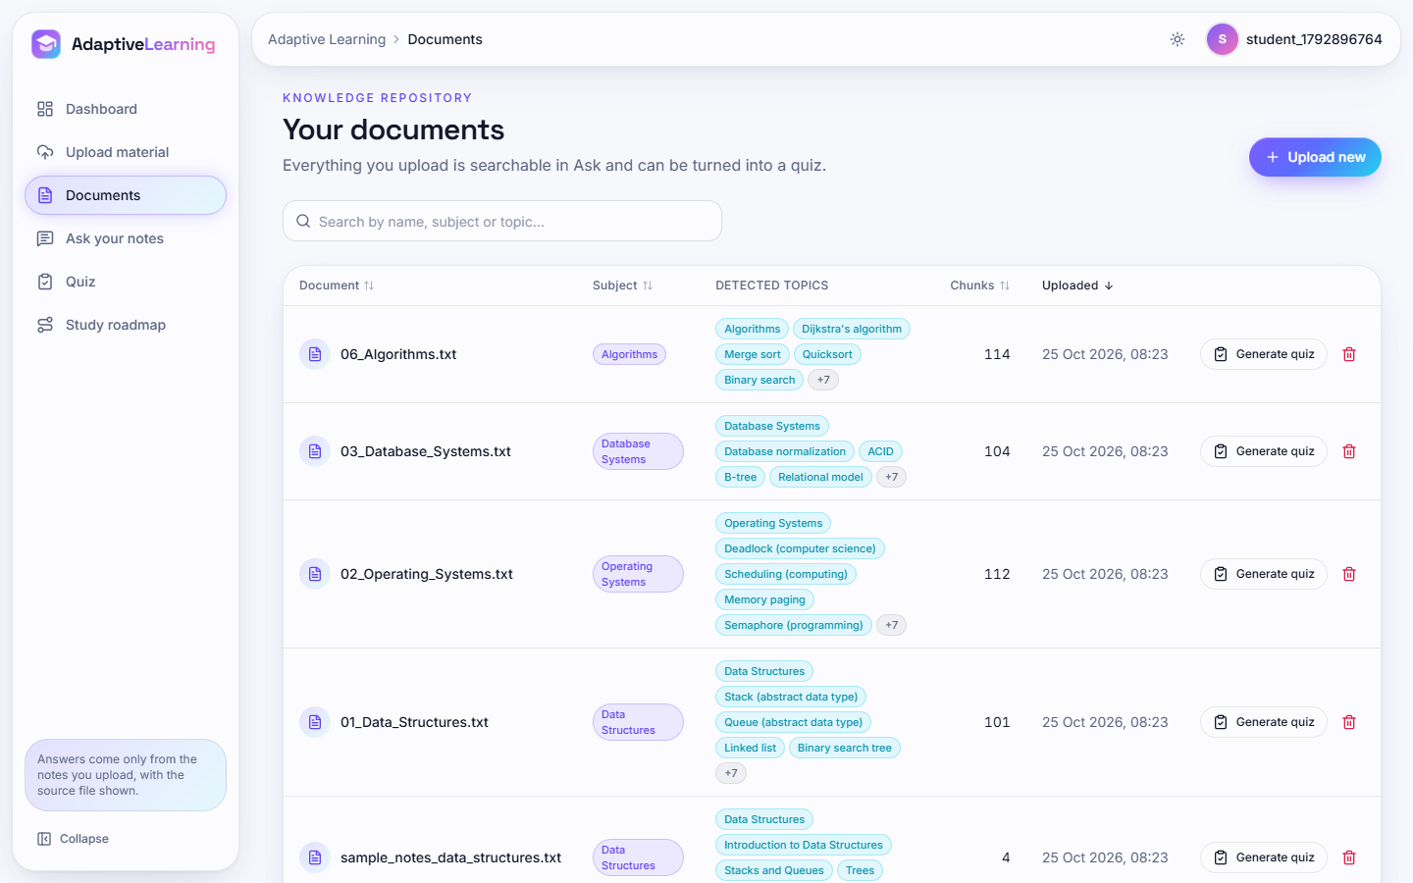  Figure 19: Documents: five documents with subject, detected topics, chunk counts (114, 104, 112, 101, 4), quiz and delete buttons.

The first six chips are the subject and unit headings found by the heading rules; the last six are TF-IDF keywords that fill the list up to twelve. The generic words "data", "unit" and "structures" show why keyword topics are a weak basis for a roadmap (Section 8.12).
Figure 20: Dashboard: 5 documents, 4 questions, 40 quiz questions; accuracy per subject (Data Structures 85 %, Algorithms 80 %, Operating Systems 60 %, Database Systems 30 %). | 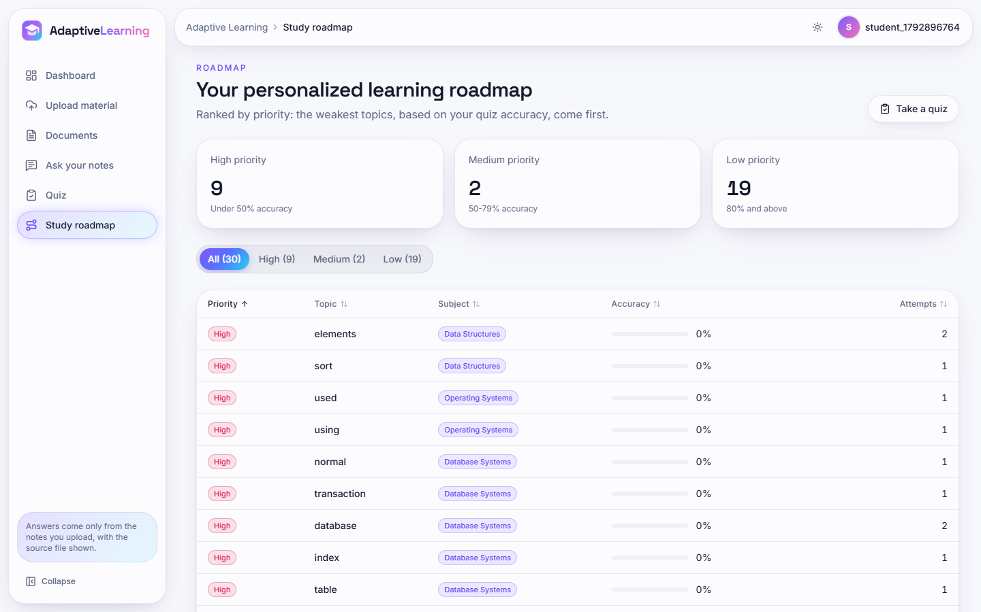  Figure 21: Roadmap: 30 topics (High 9, Medium 2, Low 19); the first rows are generic keywords such as "elements", "used" and "using".

The bars use the same thresholds as the roadmap, so the red bar for Database Systems (30 %) and the amber bar for Operating Systems (60 %) mark the subjects to revise first. The scores come from the scripted answers.

8.2.2 Asking questions and taking a quiz
Figure 22: Ask screen: "What is a deadlock?" answered from 02_Operating_Systems.txt (passage 8, match 0.46), with the badge "Offline mode: key sentences from your notes", recent questions and expandable sources.
The answer is made of sentences of the notes, so nothing is invented and the source passage is named. The sentences chosen, however, describe deadlock avoidance and recovery and not the definition, which lies in the first passage of the document (Section 8.12).
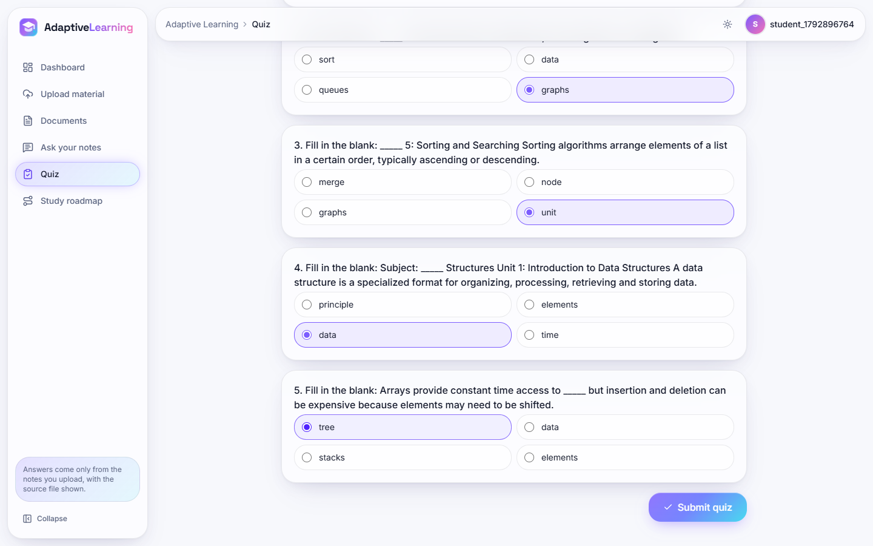  Figure 23: Quiz in progress: fill-in-the-blank questions with four options. | 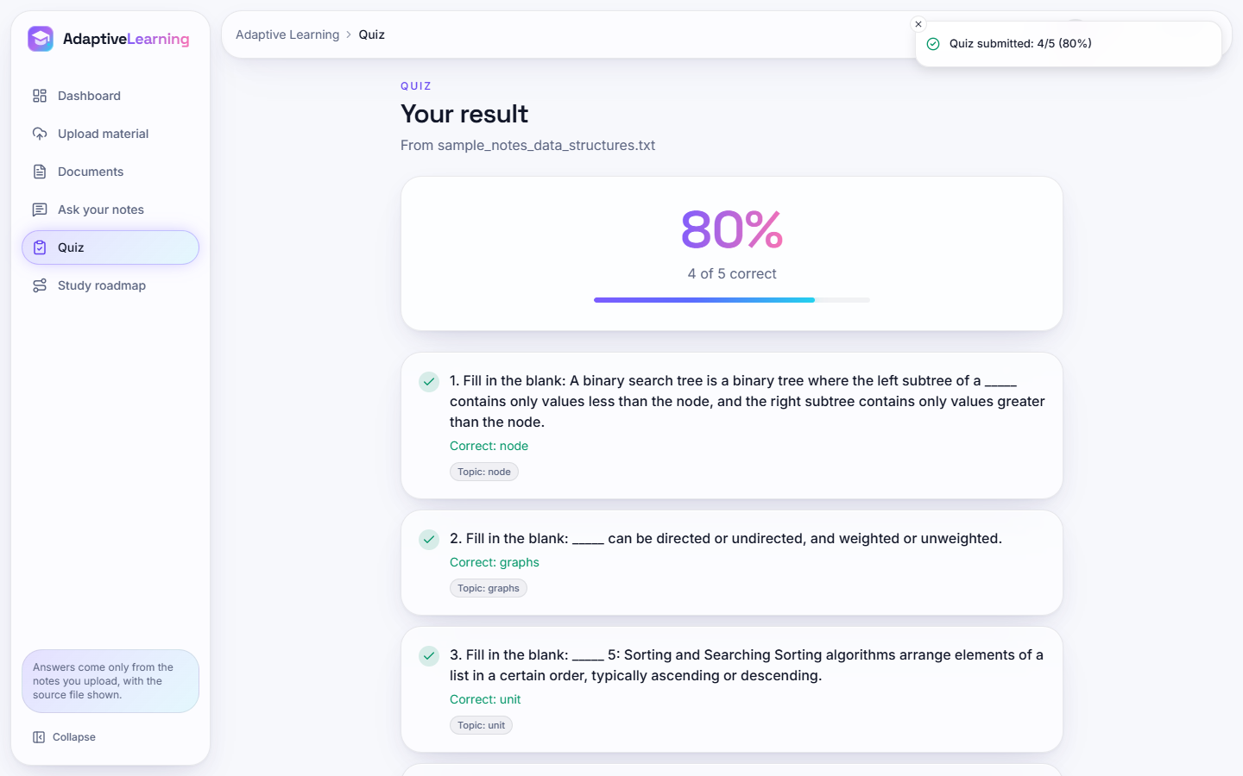  Figure 24: Quiz result: 80 % (4 of 5) with the correct term and topic per question.

Question 3 of this quiz ("____ 2: Stacks and Queues A stack is") is built from a heading line and illustrates the poor questions counted in Section 8.7. The correct answers stay on the server until the quiz is graded.

8.3 Retrieval quality
Seven retrievers were run on the same 672 chunks and 72 questions: the shipped TF-IDF retriever (unigrams and bigrams), a unigram variant, BM25 [6] (k1 = 1.5, b = 0.75), latent semantic analysis [8] with 200 dimensions, a weighted sum of BM25 and LSA, the dense BGE-small model [9] (quantised ONNX through fastembed, 384 dimensions) and a weighted sum of BM25 and the dense scores. The last four are reference points outside the product.
Table 37: Retrieval quality, 72 questions, 672 chunks (the shipped retriever is the first row)
Retriever | Hit@1 | Hit@3 | Hit@4 | Hit@10 | MRR@10
TF-IDF 1-2 gram (shipped) | 0.403 | 0.736 | 0.792 | 0.931 | 0.588
TF-IDF unigram | 0.389 | 0.694 | 0.778 | 0.944 | 0.577
BM25 | 0.500 | 0.792 | 0.833 | 0.944 | 0.659
TF-IDF + LSA (200) | 0.431 | 0.681 | 0.764 | 0.958 | 0.585
BM25 + LSA | 0.500 | 0.819 | 0.833 | 0.944 | 0.658
Dense BGE-small | 0.431 | 0.750 | 0.778 | 0.917 | 0.588
BM25 + dense BGE-small | 0.556 | 0.833 | 0.889 | 0.958 | 0.709

Figure 25: Hit@1, Hit@4 and MRR@10 of the seven retrievers on the same chunks and questions.
The shipped retriever puts the evidence in the top four chunks for 79.2% of the questions and in the first chunk for 40.3%. Bootstrap intervals (2,000 resamples) are 0.292 to 0.514 for Hit@1, 0.694 to 0.875 for Hit@4 and 0.505 to 0.673 for MRR@10, so differences of a few points between retrievers are within noise. Two signals are larger: BM25 ranks the evidence first more often than TF-IDF (0.500 against 0.403), and the sum of BM25 and dense scores is best on every measure (Hit@1 0.556, Hit@4 0.889, MRR@10 0.709). The dense model alone is no better than TF-IDF (Hit@4 0.778 against 0.792); its value lies in being complementary to a lexical score, in line with the hybrid design of [1]. Embedding the 672 chunks took 52.3 s on the CPU and each query 4.4 ms.

8.3.1 By question type, number of chunks and chunk size
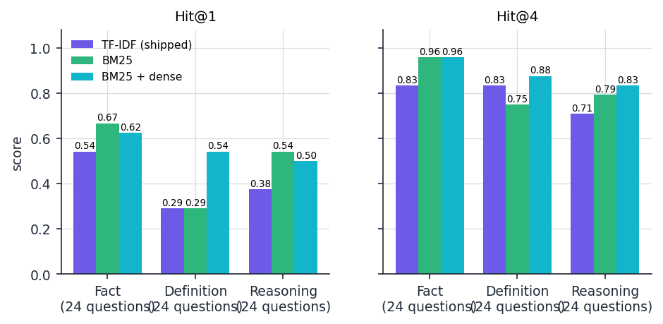  Figure 26: Hit@1 and Hit@4 by question type for the shipped retriever, BM25 and BM25 plus dense. | 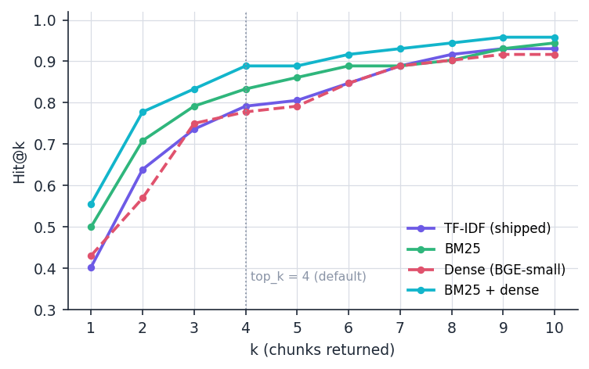  Figure 27: Hit@k for k = 1 to 10; the dotted line marks the default of four chunks.

For the shipped retriever, fact and definition questions reach the same Hit@4 (0.833) but definitions are rarely ranked first (Hit@1 0.292, against 0.542 for facts), because a definition question such as "What is routing?" contains words that occur in dozens of chunks of the same subject. Reasoning questions are hardest at four chunks (0.708) because their wording differs from the sentence that holds the answer. BM25 gains most on facts (Hit@4 0.958); the hybrid is the only retriever strong on all three types (Hit@4 0.958, 0.875 and 0.833). The curve is steep up to four chunks and flat after ten: with TF-IDF, 0.736 of the questions are covered by three chunks, 0.792 by four and 0.931 by ten.
Table 38: Effect of the chunk size (words / overlap) on the shipped TF-IDF retriever
Size / overlap | Chunks | Mean words | Evidence intact | Hit@1 | Hit@4 | Hit@10 | MRR@10
60/15 | 2,233 | 60 | 70/72 | 0.306 | 0.611 | 0.694 | 0.446
100/20 | 1,257 | 100 | 72/72 | 0.417 | 0.708 | 0.903 | 0.568
180/30 (shipped) | 672 | 179 | 72/72 | 0.403 | 0.792 | 0.931 | 0.588
300/50 | 404 | 298 | 72/72 | 0.556 | 0.847 | 0.986 | 0.688
450/75 | 269 | 447 | 72/72 | 0.486 | 0.944 | 1.000 | 0.676

Very small chunks (60 words) split 2 of the 72 evidence fragments across boundaries and score lowest (Hit@4 0.611). Larger chunks score higher, but not like for like: a 450-word chunk is more likely to contain the evidence by chance, and four such chunks pass on about 1,800 words. The shipped 180 words keep every fragment intact and the context short; the table does not show that it is the best.

8.4 Context compression and answer quality
Objective 4 asks for context compression. The only compression in the product is the extractive answer step: the retrieved chunks are split into sentences, ranked by TF-IDF similarity to the question, and the best four are joined. "Answer key" is a short string of the gold answer (for example "coffman"); a question counts as answered when the key occurs in the text. This is the kind of trade-off that [1] measures for its LLM compressor.
Table 39: Words passed on and answer-key recall against the number of retrieved chunks (72 questions)
Chunks retrieved | Words in chunks | Words in answer | Words removed | Key in chunks | Key in answer | Evidence sentence in answer
1 | 180 | 88.0 | 51.1 % | 0.625 | 0.514 | 0.361
2 | 360 | 94.4 | 73.8 % | 0.750 | 0.653 | 0.583
4 (default) | 720 | 89.8 | 87.5 % | 0.861 | 0.667 | 0.569
6 | 1080 | 87.3 | 91.9 % | 0.944 | 0.764 | 0.639
8 | 1438 | 84.2 | 94.1 % | 0.972 | 0.792 | 0.681

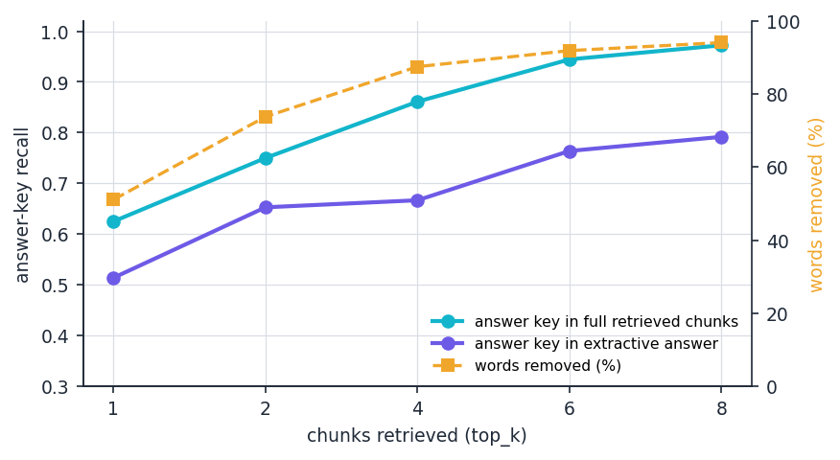
Figure 28: Answer-key recall in the full retrieved chunks and in the extractive answer, and the percentage of words removed, against the number of chunks retrieved.
At the default of four chunks the answer keeps 89.8 of 720 words (87.5 % fewer) and answer-key recall falls from 0.861 to 0.667, a loss of 19.4 percentage points. This is far more aggressive than [1], which reports 38 to 58 % fewer tokens for a drop of one to two points of exact match with a language model as compressor on different data. The extractive step always returns about 85 to 95 words, so the share removed grows with k while the key recall of the answer rises only from 0.514 to 0.792. When retrieval has found the evidence (57 of 72 questions), the answer contains the key in 82.5% of the cases and the evidence sentence in 71.9%. Every word of every answer occurs in the retrieved chunks (1.000), so the answers are grounded in the notes by construction. Definition questions suffer most: the key is in the retrieved chunks for 0.917 of them but in the answer for only 0.500 (facts 0.917 to 0.792, reasoning 0.750 to 0.708), because the answerer prefers sentences that repeat the words of the question and the defining sentence often does not.

8.5 Answering only from the notes: abstention
Objective 3 requires answers strictly from the uploaded material. The engine abstains only when no query word occurs in any chunk. Of the 12 off-topic questions, 9 still received an answer and 3 were refused (25% correct abstention). "What is the capital city of Australia?" returned a sentence about a phone book organised by city because the word "city" occurs in the notes (top-1 score 0.36), whereas "Who painted the Mona Lisa?" was refused.
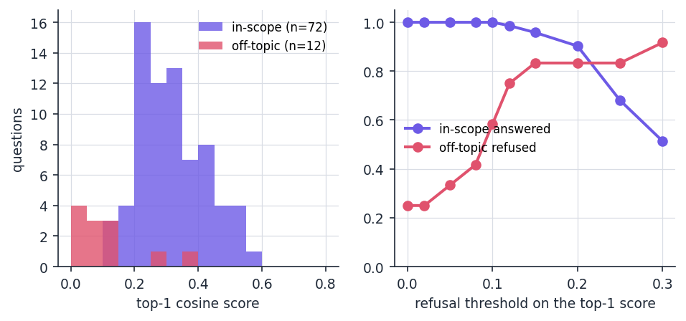
Figure 29: Left: top-1 cosine score of the 72 in-scope and 12 off-topic questions. Right: effect of a refusal threshold on the top-1 score.
In-scope top-1 scores have a mean of 0.320 (10th percentile 0.212, minimum 0.102); off-topic scores a mean of 0.107 (maximum 0.357). The distributions overlap only a little. The product has no threshold; the table is a suggestion, not an implemented feature.
Table 40: Effect of a refusal threshold on the top-1 score
Threshold | In-scope questions answered | Off-topic questions refused
0.00 (shipped behaviour) | 100.0% | 25.0%
0.10 | 100.0% | 58.3%
0.12 | 98.6% | 75.0%
0.15 | 95.8% | 83.3%
0.20 | 90.3% | 83.3%
0.30 | 51.4% | 91.7%

A threshold of 0.12 to 0.15 would refuse 75 to 83 % of the off-topic questions at a cost of 1.4 to 4.2 % of the in-scope questions. The 12 off-topic questions are few and clearly outside the notes, so the threshold would have to be re-checked on questions that are only partly covered.

8.6 Document analysis
Objective 1 asks the platform to extract subjects, units and topics. On the six corpus files the heading rules found all 36 of 36 "Unit n:" headings and the "Subject:" line of every file. Each file yields the maximum of twelve topics: seven headings plus five TF-IDF keywords such as "data", "node" and "unit"; the headings are the useful topics, the keywords are often generic. A synthetic five-unit syllabus written in seven common styles shows that only an Arabic numeral followed by a colon or hyphen is recognised.
Table 41: Units found in a five-unit syllabus, by heading style
Heading style | Units found | Of
Unit 1: Title | 5 | 5
Unit 1 - Title | 5 | 5
UNIT-I Title | 0 | 5
Unit I: Title | 0 | 5
Module 1: Title | 0 | 5
Chapter 1: Title | 5 | 5
1. Title | 0 | 5

Roman numerals ("UNIT-I", "Unit I:"), "Module 1:" and numbered lists ("1. Title"), which Indian university syllabi use widely, are not recognised, so such a syllabus yields keywords but no unit list. Tests confirmed that plain text, DOCX paragraphs and PDFs with a text layer are extracted; text inside DOCX tables is lost; a scanned PDF returns no text and the upload reports that nothing readable was found; a corrupt PDF returns a short error string without stopping the request.

8.7 Quiz generation and the roadmap
Quizzes were generated from each corpus file with 30 random seeds (five questions requested each time), 900 questions in all. Every request produced five questions (yield 1.000) and every question was structurally valid (1.000); generation takes a median of 14.17 ms. Structure is not quality: another option also occurs as a word inside the question in 9.4% of the questions, and the answer term itself is still visible in the question in 18.2% (only its first occurrence is blanked). A manual review of 30 questions (seed 0, one reviewer) judged 17 acceptable (56.7%), 5 ambiguous and 8 poor.
Table 42: Three of the 30 reviewed questions (the blank is shown as _____)
Question | Answer | Review
SQL uses a Null value to indicate missing data, which has no analog in the _____ model. | relational | acceptable
_____ pools A popular programming pattern involving threads is that of thread pools where a set number of t... | thread | poor: answer "thread" is repeated in the stem ("thread pools")
That means dist[w] + _____.Edges[w,u] < dist[u]. | graph | poor: pseudo-code fragment

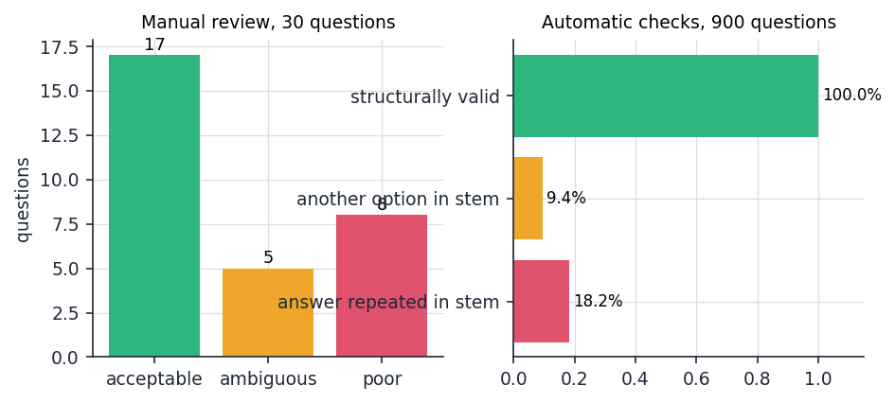
Figure 30: Left: manual review of 30 questions. Right: automatic checks over 900 questions.
The poor questions share three causes: sentences that begin mid-thought or contain formulas and code, terms repeated in the question, and blanks on very general words. The roadmap inherits the weakness, because the topic of a question is the blanked term; "using", "used", "normal" and "elements" appear on the roadmap screen as items to revise. The roadmap rule was tested at its boundaries: 0 of 1 and 49 of 100 correct give High, 1 of 2 and 79 of 100 give Medium, 4 of 5 and 80 of 100 give Low.

8.8 Performance
Two sets of timings were taken: the retriever in process for four index sizes (the corpus repeated one, two, four and eight times), and the running HTTP API on 127.0.0.1 (one user, 672 chunks, 30 calls per endpoint). The address 127.0.0.1 matters: on this machine the name localhost added about two seconds to every Python request.
Table 43: In-process retrieval time against index size (72 queries, milliseconds)
Chunks | Words | Index build | Retrieve median / 95th | Retrieve + answer median / 95th
672 | 120,424 | 197 | 2.0 / 3.3 | 4.8 / 6.3
1,344 | 240,848 | 316 | 4.6 / 6.0 | 7.9 / 9.6
2,688 | 481,696 | 540 | 9.7 / 12.9 | 13.0 / 17.0
5,376 | 963,392 | 964 | 17.6 / 20.9 | 20.7 / 25.7

Table 44: HTTP API latency on 127.0.0.1, 30 calls each (milliseconds)
Endpoint | Median | 95th percentile
health | 2.0 | 2.8
login (password hashing) | 127.6 | 137.0
dashboard | 4.2 | 5.8
documents list | 5.8 | 6.9
roadmap | 7.0 | 10.0
ask history | 4.1 | 10.6
ask (retrieve + extractive answer) | 29.5 | 35.3
quiz generate | 23.1 | 28.2
quiz submit | 24.5 | 2172.4

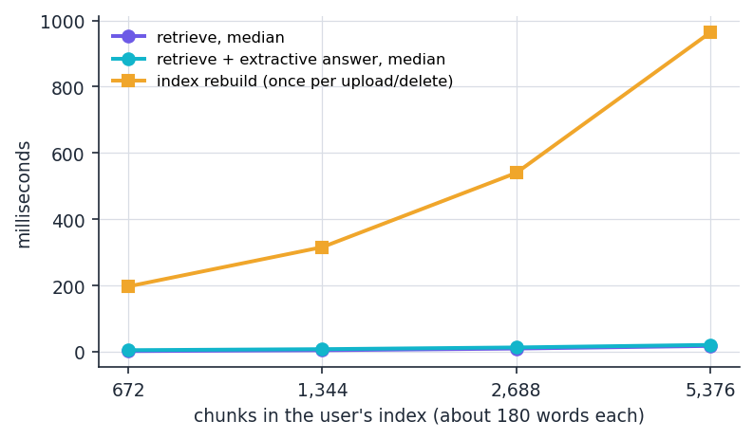  Figure 31: Retrieval and index-rebuild time against the number of chunks (log scale). | Figure 32: Median (bars) and 95th percentile (dots) of the API endpoints.

Retrieval time grows about linearly with the number of chunks: 2.5 ms at 672 chunks and 19.4 ms at 5,376 (about 963,000 words); rebuilding the index after an upload or delete takes 263 ms and 974 ms. A student with a few dozen documents is well inside this range. All endpoints except login answer in under 40 ms at the median; login takes about 128 ms because the password hash is computed on purpose. quiz submit showed a 95th percentile of 1.0 s and 2.2 s in two runs, caused by one or two slow database commits in 30 calls; the cause was not isolated and the median stayed at 24 ms. Uploading one corpus file (88 to 110 KB) with re-indexing took 201 to 2501 ms in the second run and 119 to 811 ms in the first, a spread that follows the load of the shared machine. The Claude mode would add the network latency of a model call, which was not measured.

8.9 Test results
The automated suite in tests/ has 84 tests in six files and all 84 passed in 15.2 s (0 failures, 0 errors, 0 skipped): test_api 45, test_text_extraction 15, test_security 11, test_rag_engine 9 and test_quiz_generator 4, on a temporary database. The smoke script scripts/smoke_test.py ran 24 checks against a live server and all passed. The frontend builds (tsc --noEmit and vite build, 8.7 s), and a Playwright walk through every screen at 1440, 768 and 360 pixels in both themes reported no console errors, page errors, failed requests or horizontal overflow. Four behaviours are recorded by the tests as known limitations: two uploads with the same file name share one file on disk; text in DOCX tables is not read; headings such as "UNIT-I" are not recognised; the session cookie is HttpOnly and SameSite=Lax but not Secure. Chapter 7 describes the tests in detail.

8.10 Comparison with the base paper
The base paper [1] evaluates a pipeline for multi-hop question answering. Its data, models and measures differ from those of this project, so its numbers cannot be compared with the numbers in this chapter; only the direction of effects can.
Table 45: SAC-RAG [1] and this project
Aspect | SAC-RAG [1] | This project
Data | HotpotQA [13], 2WikiMultiHopQA and MuSiQue, 1,000 questions each | Six-subject notes corpus, 100,444 words, 72 hand-written questions
Retrieval | Fact: BM25 + dense with BGE reranker; definition: dense; reasoning: sub-question decomposition | TF-IDF cosine (Hit@4 0.792); BM25 + dense only as a reference (Hit@4 0.889)
Question type | LLM classifier, 92.0 % accuracy on 300 labelled questions | Not implemented; typed by hand for analysis only
Compression | LLM extracts evidence; 38 to 58 % fewer tokens for 1 to 2 points of exact match | Extractive; 87.5 % fewer words, answer-key recall 0.861 to 0.667
Generator, measures | gpt-5-mini; exact match, F1, Recall@10, tokens | None in the measured mode (Claude mode not measured); Hit@k, MRR@10, answer-key recall
Latency | About 27.8 s against 9.6 s per question (extra LLM calls) | 30 ms median per question, no model call

Three patterns agree in direction with [1]. Combining a lexical and a dense score beats either alone (Hit@4 0.889 against 0.833 for BM25 and 0.778 for dense). Compression trades answer quality for fewer words, and here the loss is larger because the compressor is extractive and unaware of the answer. And the paper reports a latency cost for its extra LLM calls, which the offline mode of this project does not have, and it has no quality gain from them either. The paper's Recall@10 (0.787 to 0.880 on HotpotQA) counts gold documents among ten retrieved, whereas Hit@10 here asks whether one fragment appears in ten chunks, so the two must not be read against each other. What is not achieved. The question classifier, the type-specific retrieval and the LLM compression module of [1] are not implemented; the project adopts the retrieve, compress and generate structure and the evaluation vocabulary, not the method. Chapter 9 states this as a finding and Chapter 10 describes how the gap could be closed.

8.11 Sample inputs and outputs
Real outputs of the shipped engine (offline extractive mode) on the corpus, shortened to the first sentences. The score is the cosine similarity of the best chunk.
Table 46: Sample questions and the engine's answers
Question | Answer (start) | Top source (score) | Evidence in top 4?
Which stack operation removes the most recently added element? | "Additionally, a peek operation can ... return the value of the last element added ... Push ... and Pop, which removes the mo..." | 01_Data_Structures, passage 0 (0.33) | Yes, rank 1
Which layer of the TCP/IP suite does TCP belong to? | "Therefore, the entire suite is commonly referred to as TCP/IP. ... TCP, which is part of the transport layer of the TCP/IP suite." | 04_Computer_Networks, passage 0 (0.32) | Yes, rank 1
Why is regularization used to prevent overfitting? | "Regularization is a technique used to prevent overfitting by adding a penalty term to the loss function ..." | 05_Machine_Learning, passage 14 (0.28) | Yes, rank 1
What is a binary search tree? | "The binary search tree and B-tree data structures are based on binary search. Balanced binary search trees ..." | 01_Data_Structures, passage 57 (0.50) | Yes, not rank 1
Who painted the Mona Lisa? | "No relevant content was found in your uploaded documents for this question. ..." | none | Correct refusal

The first three answers contain the key but are stitched from neighbouring sentences; the fourth starts with a sentence about binary search and reaches the definition only later. The answer length is nearly constant at about 90 words, more than a short factual question needs.

8.12 Success and failure analysis
Where it works. The shipped retriever finds the evidence in the top four chunks for 57 of 72 questions. It is reliable when the question repeats distinctive words of the evidence, such as names, years and unusual terms (who coined the acronym ACID, write-ahead logging, the laboratory that developed the support vector machine and the year the OSI model was published all rank the evidence first). Where it fails. 15 questions are missed at four chunks; four real misses show the typical causes.
Table 47: Four real failures of the shipped retriever
Question | Type | Rank TF-IDF | Rank BM25 | Rank BM25 + dense | Cause
Why can a binary search tree become as slow as a linked list? | reasoning | not in top 10 | 8 | not in top 10 | The question says "slow", the notes say "degenerate"; the top chunks share only the words "binary search tree" and "linked list".
What is routing? | definition | not in top 10 | not in top 10 | not in top 10 | "Routing" occurs in many chunks and the lead sentence sits in passage 63, while passages 67 and 64 repeat the word more often. No retriever in the table finds it in the top ten.
How can gradient descent get stuck? | reasoning | not in top 10 | not in top 10 | not in top 10 | The evidence is an analogy sentence ("get stuck in some hole"); the words "gradient descent" match the passages that define the method. No retriever in the table finds it in the top ten.
What is a deadlock? | definition | 6 | 6 | 1 | Passage 0 holds the definition of a deadlock; passages 7 and 4 about avoidance and recovery repeat "deadlock" more often (0.48 and 0.42), so the answer on the Ask screen describes avoidance.

Lexical mismatch is the main limit of any keyword retriever and is the case dense embeddings are meant to repair; the hybrid repairs some cases ("What does each node in a basic linked list contain?" moves from rank 7 to rank 2) but not the first one in the table. Frequency effects hit definition questions, and chunk-level scoring gives no weight to the first sentence of a section, which usually defines the concept. A fourth failure lies in the answer step: even when the right chunk is retrieved, the answer omits the key for about one question in six. Other components fail too: a DOCX table is silently dropped, a syllabus with "UNIT-I" headings yields no unit list, a quiz may contain a fragment or a formula, a roadmap may list "using" as a topic, and an off-topic question that shares a word with the notes is answered.

8.13 Limitations of the evaluation
• Corpus. Wikipedia articles are well written and self-contained; lecture notes, scanned slides and mixed-language material are harder. The 36 articles are in English and cover six computer-science subjects.
• Questions. Seventy-two questions written by the project team after reading the articles are few and favour lexical overlap; the intervals in Section 8.3 are wide.
• Measures. Hit@k and answer-key recall are proxies for answer quality. No human judged the answers, and no exact match or F1 against reference answers was computed.
• Claude mode. No API key was available, so the generation mode that uses a language model was not measured.
• Screens and load. The quiz answers in the screenshots were scripted. One user was simulated; concurrent users and multi-process deployment were not tested, since the quiz state and the index cache live in the memory of one process.
• Dense reference. The dense and hybrid retrievers are experiments run outside the product with a quantised model; their numbers show potential, not delivered behaviour.

8.14 Objectives against outcomes
Table 48: The six objectives of the batch against what was measured
No. | Objective | Status | Evidence
1 | Build a document ingestion module that parses syllabi, lecture notes and question banks and extracts subjects, units and topics. | Partly met | PDF, DOCX and TXT are parsed; subjects and units are recognised from "Subject:", "Course:", "Unit n:" and "Chapter n:" headings (36 of 36 units on the corpus) but not from "UNIT-I", "Module 1" or numbered lists (0 of 5 each); DOCX tables and scanned pages are not read.
2 | Store the extracted content as vector embeddings so the material can be searched semantically rather than by keyword. | Not met | The shipped retriever is TF-IDF with cosine similarity, which is lexical. A dense model was measured only as a reference (Hit@4 0.778, hybrid with BM25 0.889) and is not part of the product.
3 | Implement a RAG question-answering engine that answers strictly from the uploaded material and cites the source. | Met in extractive mode | Every answer word comes from the retrieved chunks (100 %) and each answer lists source file, passage and match score. Without a relevance threshold, 9 of 12 off-topic questions still received an answer. The Claude mode was not measured.
4 | Apply semantic context compression so retrieval stays accurate without exceeding the model context window. | Partly met | Extractive sentence selection removes 87.5 % of the words of four retrieved chunks, but answer-key recall falls from 0.861 to 0.667. There is no question-type routing and no learned compression as in [1].
5 | Generate personalised study roadmaps and revision schedules from topic coverage and performance. | Partly met | A priority roadmap (High below 50 %, Medium below 80 %, Low otherwise) is built from quiz accuracy per topic. There is no revision schedule, no spaced repetition and no coverage model; topics are single TF-IDF keywords.
6 | Present curriculum coverage, study velocity and engagement metrics on an interactive dashboard. | Partly met | The dashboard shows documents, questions asked, quiz questions attempted, subject-wise accuracy and recent documents. Curriculum coverage and study velocity over time are not computed.

One objective is met in the offline mode, four are met in part and one (semantic embeddings) is not met. The platform works end to end for a student on a laptop and each component was measured, but the semantic retrieval and the semantic compression of the title and of the base paper are the largest gap between what was planned and what was built.

CHAPTER 9: CONCLUSION

9.1 Summary
The Adaptive Learning Intelligence Platform lets a student upload syllabi, notes and question banks, analyses them into a searchable repository with detected subjects, units and topics, answers questions from the notes with the source shown, generates quizzes from the same documents and turns quiz accuracy into a priority roadmap and a dashboard. It is delivered as a FastAPI service with a React interface and, unchanged, as the original Flask application, and it runs offline on one CPU-only PC. The project follows the structure of the base paper [1] (retrieve, compress, generate) with simpler components, and the evaluation in this report measures how far those components go.

9.2 Objectives achieved
Of the six objectives, one was met in the offline mode (grounded answers with sources), one was not met (semantic embeddings) and four were met in part. The table gives the status and the basis of each.
Table 49: Objectives and their status
No. | Objective | Status | Basis
1 | Build a document ingestion module that parses syllabi, lecture notes and question banks and extracts subjects, units and topics. | Partly met | PDF, DOCX and TXT are parsed; subjects and units are recognised from "Subject:", "Course:", "Unit n:" and "Chapter n:" headings (36 of 36 units on the corpus) but not from "UNIT-I", "Module 1" or numbered lists (0 of 5 each); DOCX tables and scanned pages are not read.
2 | Store the extracted content as vector embeddings so the material can be searched semantically rather than by keyword. | Not met | The shipped retriever is TF-IDF with cosine similarity, which is lexical. A dense model was measured only as a reference (Hit@4 0.778, hybrid with BM25 0.889) and is not part of the product.
3 | Implement a RAG question-answering engine that answers strictly from the uploaded material and cites the source. | Met in extractive mode | Every answer word comes from the retrieved chunks (100 %) and each answer lists source file, passage and match score. Without a relevance threshold, 9 of 12 off-topic questions still received an answer. The Claude mode was not measured.
4 | Apply semantic context compression so retrieval stays accurate without exceeding the model context window. | Partly met | Extractive sentence selection removes 87.5 % of the words of four retrieved chunks, but answer-key recall falls from 0.861 to 0.667. There is no question-type routing and no learned compression as in [1].
5 | Generate personalised study roadmaps and revision schedules from topic coverage and performance. | Partly met | A priority roadmap (High below 50 %, Medium below 80 %, Low otherwise) is built from quiz accuracy per topic. There is no revision schedule, no spaced repetition and no coverage model; topics are single TF-IDF keywords.
6 | Present curriculum coverage, study velocity and engagement metrics on an interactive dashboard. | Partly met | The dashboard shows documents, questions asked, quiz questions attempted, subject-wise accuracy and recent documents. Curriculum coverage and study velocity over time are not computed.

9.3 Key findings
1. The shipped retriever is lexical. It finds the evidence in the top four chunks for 79.2% of 72 questions and ranks it first for 40.3%. BM25 reaches 0.500 at rank one, and BM25 plus a dense model reaches Hit@4 0.889; the semantic retrieval of objective 2 is therefore not delivered, and the dense and hybrid retrieval of [1] is better supported than the product's.
2. None of the SAC-RAG components (question classifier, adaptive retrieval, LLM compression) is implemented. The only compression is extractive sentence selection, which removes 87.5 % of the words and lowers answer-key recall from 0.861 to 0.667; [1] reports 38 to 58 % fewer tokens for one to two points of exact match, with a language model and different data.
3. Definition questions are the weak case for extractive answers: the key is in the retrieved chunks for 0.917 of them and in the answer for 0.500. The answer favours sentences that repeat the question's words, not the defining sentence.
4. There is no relevance threshold: 9 of 12 off-topic questions received an unrelated answer. A threshold near 0.12 to 0.15 would refuse 75 to 83 % of them at a cost of 1 to 4 % of in-scope questions.
5. The quiz and roadmap work end to end but their content is shallow: 17 of 30 reviewed questions were acceptable, the answer term is visible in the question in 18.2% of 900 generated questions, and roadmap topics are single keywords.
6. The roadmap and dashboard adapt only to quiz accuracy; there is no knowledge-tracing model, revision schedule, coverage or study-velocity measure.
7. The software is sound for its purpose: 84 of 84 automated tests and 24 of 24 smoke checks pass, endpoints answer in 4 to 30 ms (login 128 ms), and hostile inputs are refused or stored as plain text. These results are on a Wikipedia corpus of 72 questions with an extractive answerer; they are not comparable with the datasets of the base paper.

9.4 Practical applications
The platform can serve as a personal study assistant that keeps a semester's notes in one searchable place and shows the source of every answer, as a revision planner whose ranked weak topics tell a student what to revise first (once topics are made more meaningful), and as a teaching case for the whole cycle of ingestion, retrieval, answering, quiz generation and honest measurement. With BM25 plus dense retrieval, a relevance threshold and real syllabi it could serve a class (Chapter 10).

9.5 Known limitations and lessons
The platform was evaluated on encyclopaedic text and not on student notes; answers were scored by key strings and not by people; the Claude mode was not measured. Retrieval is lexical, definitions are answered poorly, off-topic questions are answered, Roman-numeral headings, DOCX tables and scans are not handled, quiz questions are of uneven quality, and security is suited to local use (limitations L1 to L13 in the scope and limitations document). Two lessons follow. Each stage must be measured separately: the screens looked convincing, but retrieval ranks the evidence first in only two of five questions and the answer step then drops the key in about one case in six. And grounding is not relevance: an answer made only of sentences from the notes can still answer a different question, so a relevance check is a separate requirement. With 72 questions the interval of Hit@4 is about 0.18 wide, so small differences between retrievers must not be reported as improvements.

CHAPTER 10: FUTURE SCOPE

10.1 Improvements to retrieval and answering
• Replace TF-IDF with BM25 or a BM25 plus dense hybrid. In the experiments BM25 raised Hit@1 from 0.403 to 0.500, and the hybrid raised Hit@4 from 0.792 to 0.889 with a small quantised model [9] that embeds a query in 4.4 ms on the CPU. The cost is a one-time embedding of each upload (52 s for 672 chunks on this PC) and one more model to ship.
• Add a relevance threshold. Refuse to answer when the best score is below a value between 0.12 and 0.15, and say so on the Ask screen. The measured effect is 75 to 83 % of off-topic questions refused for a 1 to 4 % cost; the value should be re-tuned on real notes.
• Select the answer sentence with the answer in mind. Mix question similarity with position in the chunk so that the defining sentence is favoured; this targets the drop of definition answers from 0.917 to 0.500 key recall.
• Question-type routing in the style of [1] and [11]. Classify a question as fact, definition or reasoning by rules and route facts to BM25, definitions to dense retrieval and reasoning questions to decomposition; the by-type results show different best retrievers for each type.
• LLM compression and generation. Use a language model to extract evidence [10], [15] and write the answer from it when a key is available, and measure it on the same 72 questions to see whether the loss of answer-key recall disappears.

10.2 Improvements to document analysis
• More heading patterns. Recognise "UNIT-I", "Unit I:", "Module 1" and numbered lists; this closes the 0 of 5 results of Section 8.6.
• Read DOCX tables and slides, which hold many syllabi, and add OCR for scanned pages, which currently give no text and a warning.
• Unique file names. Store each upload under its document identifier so that two files with the same name cannot share a path (limitation L6).
• Better topics. Use units, section headings or noun phrases instead of single TF-IDF keywords and remove generic words; this makes the roadmap meaningful.

10.3 Improvements to quizzes, roadmap and dashboard
• Cloze quality filters. Blank every occurrence of the term, reject sentences that start mid-clause or contain formulas or code, and choose distractors of similar frequency; the review accepted 17 of 30 questions today.
• Knowledge tracing and spaced repetition. Replace the two fixed thresholds by a model of mastery per topic over time, as in [2] and [17], and schedule revisions; this addresses objective 5.
• Coverage and study velocity. Track which units of a document have been asked about or quizzed and show progress over time on the dashboard (objective 6).
• Key the roadmap by subject and topic, so that the same word in two subjects is not merged.

10.4 Scalability, security and deployment
• Per-subject retrieval. Let the student restrict a question to one subject or document, removing cross-subject distractors.
• Persistent and incremental indexes. Rebuilding the whole index after each upload took 197 ms at 672 chunks and 964 ms at 5,376; an incremental index and stored quiz state also remove the dependence on one process.
• HTTPS, a secret from the environment, a Secure cookie, rate limiting and CSRF protection before the application is reachable from a network.
• Continuous testing. Run the 84 tests and the experiments script in a pipeline and add browser tests.

10.5 Further research and evaluation
• Collect real notes and student questions and repeat the evaluation, with human judgement of correctness and usefulness and exact match or F1 against reference answers.
• A user study to learn whether the quizzes and the roadmap change how students revise.
• Measure the Claude mode and compare cost, latency and quality with the extractive mode on the same questions.
• Study abstention and compression jointly: whether a relevance threshold plus answer-aware compression restores the quality that extractive selection loses.

10.6 Suggested order
A sensible order is: first the relevance threshold, unique file names, more heading patterns and a subject-keyed roadmap (days); then BM25 or hybrid retrieval and answer-aware sentence selection; then cloze filters, better topics and coverage tracking; then the measured Claude mode, question-type routing and LLM compression, which realise the structure of the base paper [1]; and last knowledge tracing, spaced repetition, accounts, HTTPS and a pilot with real notes and a user study.

REFERENCES
[1] D. Zhang, H. Yu, J. Huo and M. Su, "SAC-RAG: Semantic Adaptive Context Compression for Retrieval-Augmented Generation," IEEE Access, vol. 14, pp. 117406-117418, 2026, doi: 10.1109/ACCESS.2026.3718025.
[2] Z. Li, V. Yazdanpanah, J. Wang, W. Gu, L. Shi, A. I. Cristea, S. Kiden and S. Stein, "TutorLLM: Customizing learning recommendations with knowledge tracing and retrieval-augmented generation," in Proc. 18th ACM Conf. Recommender Syst. (RecSys 2024), Bari, Italy, Oct. 2024; arXiv:2502.15709.
[3] R. Vatankhah Barenji, N. Salimi and S. Khoshgoftar, "An LLM-powered assessment retrieval-augmented generation (RAG) for higher education," arXiv:2601.06141, Jan. 2026.
[4] P. Lewis et al., "Retrieval-augmented generation for knowledge-intensive NLP tasks," in Advances in Neural Information Processing Systems, vol. 33, 2020, pp. 9459-9474.
[5] V. Karpukhin, B. Oguz, S. Min, P. Lewis, L. Wu, S. Edunov, D. Chen and W.-T. Yih, "Dense passage retrieval for open-domain question answering," in Proc. Conf. Empirical Methods Natural Lang. Process. (EMNLP), 2020, pp. 6769-6781.
[6] S. Robertson and H. Zaragoza, "The probabilistic relevance framework: BM25 and beyond," Found. Trends Inf. Retr., vol. 3, no. 4, pp. 333-389, 2009.
[7] G. Salton and C. Buckley, "Term-weighting approaches in automatic text retrieval," Inf. Process. Manage., vol. 24, no. 5, pp. 513-523, 1988.
[8] S. Deerwester, S. T. Dumais, G. W. Furnas, T. K. Landauer and R. Harshman, "Indexing by latent semantic analysis," J. Amer. Soc. Inf. Sci., vol. 41, no. 6, pp. 391-407, 1990.
[9] S. Xiao, Z. Liu, P. Zhang and N. Muennighoff, "C-Pack: Packaged resources to advance general Chinese embedding," arXiv:2309.07597, 2023 (BGE embedding models, including BAAI/bge-small-en-v1.5).
[10] H. Jiang, Q. Wu, C.-Y. Lin, Y. Yang and L. Qiu, "LLMLingua: Compressing prompts for accelerated inference of large language models," in Proc. Conf. Empirical Methods Natural Lang. Process. (EMNLP), 2023, pp. 13358-13376.
[11] S. Jeong, J. Baek, S. Cho, S. J. Hwang and J. Park, "Adaptive-RAG: Learning to adapt retrieval-augmented large language models through question complexity," in Proc. Conf. North Amer. Chapter Assoc. Comput. Linguistics: Hum. Lang. Technol. (NAACL-HLT), 2024, pp. 7036-7050.
[12] N. F. Liu, K. Lin, J. Hewitt, A. Paranjape, M. Bevilacqua, F. Petroni and P. Liang, "Lost in the middle: How language models use long contexts," Trans. Assoc. Comput. Linguistics, vol. 12, pp. 157-173, Feb. 2024.
[13] Z. Yang, P. Qi, S. Zhang, Y. Bengio, W. Cohen, R. Salakhutdinov and C. D. Manning, "HotpotQA: A dataset for diverse, explainable multi-hop question answering," in Proc. Conf. Empirical Methods Natural Lang. Process. (EMNLP), 2018, pp. 2369-2380.
[14] A. Asai, Z. Wu, Y. Wang, A. Sil and H. Hajishirzi, "Self-RAG: Learning to retrieve, generate, and critique through self-reflection," in Proc. 12th Int. Conf. Learn. Represent. (ICLR), 2024.
[15] F. Xu, W. Shi and E. Choi, "RECOMP: Improving retrieval-augmented LMs with compression and selective augmentation," in Proc. 12th Int. Conf. Learn. Represent. (ICLR), 2024.
[16] F. Pedregosa et al., "Scikit-learn: Machine learning in Python," J. Mach. Learn. Res., vol. 12, pp. 2825-2830, Oct. 2011.
[17] A. T. Corbett and J. R. Anderson, "Knowledge tracing: Modeling the acquisition of procedural knowledge," User Model. User-Adapt. Interact., vol. 4, no. 4, pp. 253-278, 1994.
[18] Wikimedia Foundation, "English Wikipedia," https://en.wikipedia.org (text licensed CC BY-SA 4.0; the 36 articles and revision identifiers used for the evaluation corpus are listed in experiments/corpus_manifest.json).
[19] J. Kaczmarek, J. Pokrywka, K. Biedalak, G. Kurzyp and L. Grzybowski, "Optimizing retrieval-augmented generation of medical content for spaced repetition learning," in Proc. 17th Int. Conf. Comput. Supported Educ. (CSEDU), 2025, pp. 174-186, doi: 10.5220/0013477700003932; arXiv:2503.01859.
[20] R. Gokhman, J. Li and Y. Zhang, "Automatic teaching platform on vision language retrieval augmented generation," presented at the 2025 IEEE Integrated STEM Education Conf. (ISEC), Princeton, NJ, USA, Mar. 2025; arXiv:2503.05464.
[21] D. S. Eleuterio, P. F. Oliveira and P. Matos, "Democratizing financial education: An API-driven platform powered by retrieval-augmented generation," in Proc. 2025 17th Int. Conf. Educ. Technol. Comput. (ICETC), 2025, pp. 108-112, doi: 10.1109/ICETC66579.2025.11387160.
[22] "Student-designed educational resources for Lean: exploring ChatGPT and Retrieval-Augmented Generation," ZDM - Mathematics Education, 2026 (title, year and venue as listed in the batch literature survey; authors and pagination not verified).
[23] Z. Jiang, F. F. Xu, L. Gao, Z. Sun, Q. Liu, J. Dwivedi-Yu, Y. Yang, J. Callan and G. Neubig, "Active retrieval augmented generation," in Proc. Conf. Empirical Methods Natural Lang. Process. (EMNLP), 2023, pp. 7969-7992.
[24] W. Shi, S. Min, M. Yasunaga, M. Seo, R. James, M. Lewis, L. Zettlemoyer and W.-T. Yih, "REPLUG: Retrieval-augmented black-box language models," Trans. Assoc. Comput. Linguistics, vol. 12, pp. 1-19, Jun. 2024.
[25] H. Jiang, Q. Wu, X. Luo, D. Li, C.-Y. Lin, Y. Yang and L. Qiu, "LongLLMLingua: Accelerating and enhancing LLMs in long context scenarios via prompt compression," in Proc. 62nd Annu. Meeting Assoc. Comput. Linguistics (ACL), 2024, pp. 1658-1677.
[26] Z. Pan et al., "LLMLingua-2: Data distillation for efficient and faithful task-agnostic prompt compression," in Findings Assoc. Comput. Linguistics: ACL 2024, pp. 963-981.
[27] Y. Gao et al., "Retrieval-augmented generation for large language models: A survey," arXiv:2312.10997, 2023 (revised 2024).
[28] X. Ho, A.-K. Duong Nguyen, S. Sugawara and A. Aizawa, "Constructing a multi-hop QA dataset for comprehensive evaluation of reasoning steps," in Proc. 28th Int. Conf. Comput. Linguistics (COLING), 2020, pp. 6609-6625.
[29] H. Trivedi, N. Balasubramanian, T. Khot and A. Sabharwal, "MuSiQue: Multihop questions via single-hop question composition," Trans. Assoc. Comput. Linguistics, vol. 10, pp. 539-554, May 2022.
[30] G. Izacard et al., "Atlas: Few-shot learning with retrieval augmented language models," J. Mach. Learn. Res., vol. 24, no. 251, pp. 1-43, 2023.

APPENDIX A: IMPORTANT CODE
The listings are copied from the repository (8.ProjectCode) in the state in which the results of this report were measured and are read from the files when this document is built. Only the most important functions are shown; the quiz generator and the database schema are described in Chapters 5 and 6.

A.1 Chunking (`utils/text_extraction.py`, lines 58-74)
def chunk_text(text, chunk_size=180, overlap=30):
"""Split text into overlapping word-based chunks for retrieval."""
words = text.split()
if not words:
return []
chunks = []
start = 0
while start < len(words):
end = start + chunk_size
chunk = " ".join(words[start:end])
if chunk.strip():
chunks.append(chunk.strip())
if end >= len(words):
break
start = end - overlap
return chunks

A.2 Index and retrieval (`utils/rag_engine.py`, lines 26-57)
build_index fits the TF-IDF vectoriser on the chunks of one user; retrieve scores a query by cosine similarity and drops zero scores.
def build_index(self, chunk_records):
"""
chunk_records: list of dicts with keys 'text', 'doc_id', 'doc_name', 'chunk_index'
"""
self.chunks = [c["text"] for c in chunk_records]
self.chunk_meta = chunk_records
if not self.chunks:
self.vectorizer = None
self.matrix = None
return
self.vectorizer = TfidfVectorizer(stop_words="english", ngram_range=(1, 2))
self.matrix = self.vectorizer.fit_transform(self.chunks)

def retrieve(self, query, top_k=4):
if not self.chunks or self.vectorizer is None:
return []
query_vec = self.vectorizer.transform([query])
sims = cosine_similarity(query_vec, self.matrix).flatten()
top_indices = np.argsort(sims)[::-1][:top_k]
results = []
for idx in top_indices:
if sims[idx] <= 0:
continue
meta = self.chunk_meta[idx]
results.append({
"text": self.chunks[idx],
"score": float(sims[idx]),
"doc_id": meta.get("doc_id"),
"doc_name": meta.get("doc_name"),
"chunk_index": meta.get("chunk_index"),
})
return results

A.3 Extractive answer and generation (`utils/rag_engine.py`, lines 59-101)
_extractive_answer selects the best sentences; generate_answer calls the language model first when a key is given and falls back to the extractive answer.
def _extractive_answer(self, query, retrieved):
"""Pick the sentences most relevant to the query from retrieved chunks."""
if not retrieved:
return "No relevant content was found in your uploaded documents for this question. Try uploading related notes first."

sentences = []
for r in retrieved:
for s in re.split(r"(?<=[.!?])\s+", r["text"]):
s = s.strip()
if len(s) > 20:
sentences.append((s, r["doc_name"]))

if not sentences:
return retrieved[0]["text"][:500]

vectorizer = TfidfVectorizer(stop_words="english")
try:
all_texts = [query] + [s for s, _ in sentences]
mat = vectorizer.fit_transform(all_texts)
sims = cosine_similarity(mat[0:1], mat[1:]).flatten()
ranked = sorted(zip(sentences, sims), key=lambda x: x[1], reverse=True)
top_sents = [s for (s, _doc), score in ranked[:4] if score > 0]
except ValueError:
top_sents = [s for s, _ in sentences[:3]]

if not top_sents:
top_sents = [s for s, _ in sentences[:3]]

answer = " ".join(top_sents)
return answer

def generate_answer(self, query, api_key=None, top_k=4):
retrieved = self.retrieve(query, top_k=top_k)

if api_key:
try:
answer = self._llm_answer(query, retrieved, api_key)
return answer, retrieved
except Exception:
# Silently fall back to extractive mode if the API call fails
pass

return self._extractive_answer(query, retrieved), retrieved

A.4 The ask and roadmap endpoints (`backend/main.py`, lines 297-321 and 400-430)
@api.post("/api/ask")
def ask(body: AskBody, user=Depends(current_user)):
question = body.question.strip()
if not question:
raise HTTPException(status_code=400, detail="Please type a question.")
engine = legacy._rag_cache.get(user["id"]) or legacy.get_engine_for_user(user["id"])
answer, sources = engine.generate_answer(question, api_key=Config.ANTHROPIC_API_KEY or None)

conn = get_db()
cur = conn.execute(
"INSERT INTO queries (user_id, question, answer, sources, created_at) VALUES (?, ?, ?, ?, ?)",
(user["id"], question, answer, json.dumps([s["doc_name"] for s in sources]), now()),
)
conn.commit()
created = conn.execute("SELECT created_at FROM queries WHERE id=?", (cur.lastrowid,)).fetchone()
conn.close()
return {
"id": cur.lastrowid,
"question": question,
"answer": answer,
"sources": sources,
"created_at": created["created_at"],
"llm_enabled": bool(Config.ANTHROPIC_API_KEY),
}

@api.get("/api/roadmap")
def roadmap(user=Depends(current_user)):
conn = get_db()
rows = conn.execute(
"SELECT subject, topic, correct FROM quiz_results WHERE user_id=?", (user["id"],)
).fetchall()
conn.close()

topic_stats = defaultdict(lambda: {"correct": 0, "total": 0, "subject": "General"})
for r in rows:
stats = topic_stats[r["topic"]]
stats["total"] += 1
stats["correct"] += r["correct"]
stats["subject"] = r["subject"]

items = []
for topic, stats in topic_stats.items():
accuracy = 100 * stats["correct"] / stats["total"]
priority = "High" if accuracy < 50 else "Medium" if accuracy < 80 else "Low"
items.append(
{
"topic": topic,
"subject": stats["subject"],
"accuracy": round(accuracy, 1),
"attempts": stats["total"],
"priority": priority,
}
)
order = {"High": 0, "Medium": 1, "Low": 2}
items.sort(key=lambda x: (order[x["priority"]], x["accuracy"]))
return items

APPENDIX B: INSTALLATION AND USER GUIDE

B.1 Requirements
• A Windows PC (the build machine was an Intel Core i5-12500 (6 cores, 12 threads) with 15.7 GB and no GPU; these are not stated minimums), Python 3.11 or newer (built with 3.11.9), Node.js 20 or newer (24.19 was used) and a current browser (Chrome was used).
• An internet connection for the first installation only. No other service is needed: the default answer mode is offline.

B.2 Installation and start
1. Open the folder 8.ProjectCode and double-click run.bat. On the first run it creates the virtual environment venv, installs backend\requirements.txt (which includes the root requirements.txt: Flask, scikit-learn, NumPy, pypdf, python-docx, FastAPI, uvicorn, python-multipart and itsdangerous) and runs npm install in frontend.
2. It then opens two windows: the backend (uvicorn backend.main:app on 127.0.0.1:8301, health check at http://localhost:8301/api/health, interactive API documentation at /api/docs) and the frontend (Vite on http://localhost:5301).
3. Open http://localhost:5301 in the browser. Register an account (or use the demo account below) and start with the Upload screen.
4. To stop, close the two server windows. Ports and the cookie-signing secret are read from .env (copy .env.example; .env is not stored in version control).
Manual start: venv\Scripts\python -m uvicorn backend.main:app --port 8301 in 8.ProjectCode, and npm install then npm run dev in frontend (npm run build runs the type check and the production build). The original Flask interface starts with venv\Scripts\python app.py at http://127.0.0.1:5000; both interfaces share instance/app.db.
Table 50: Settings in .env and the demo account
Key or field | Meaning or value
BACKEND_PORT, FRONTEND_PORT | 8301 and 5301 by default; the Vite proxy sends /api from the frontend port to the backend port
SECRET_KEY | Signs the session cookie; change it for any use beyond a local demo
ANTHROPIC_API_KEY | Optional. When set (and pip install anthropic has been run) answers are written by Claude from the retrieved passages; if a call fails the extractive answer is used
Demo account | URL http://localhost:5301, username demo, password Demo@1234. It exists in the local instance/app.db; with a fresh database register it again or register any account (there is no administrator).

B.3 Using the screens
Table 51: User guide
Screen (route) | How to use it
Landing, Login, Register (/, /login, /register) | Register with a username, a password and optional interests, then log in; the application opens on the Upload screen.
Upload (/app/upload) | Drop or choose a PDF, DOCX or TXT file (up to 16 MB), type a subject and press Upload & process. The result card lists the detected topics and chunks indexed. Try sample_data/sample_notes_data_structures.txt first.
Documents (/app/documents) | Lists every upload with subject, topics, chunks and date; search by name, subject or topic; Generate quiz starts a quiz and the bin button deletes the document.
Ask (/app/ask) | Type a question and press Ask or Ctrl+Enter. The answer is shown with the sources (file, passage, match score); the right panel keeps the last ten questions.
Quiz (/app/quiz) | Choose a document, answer five fill-in-the-blank questions and press Submit quiz; the result page shows the score and the correct term and topic of every question.
Roadmap and Dashboard (/app/roadmap, /app) | The roadmap ranks topics by quiz accuracy: High below 50 %, Medium below 80 %, Low otherwise. The dashboard shows counts, accuracy per subject and the latest documents; the sun and moon button switches theme.

B.4 Running the tests, measurements and screenshots
venv\Scripts\python -m pip install pytest==8.3.3 httpx==0.27.2 :: once
venv\Scripts\python -m pytest -q :: 84 tests, temporary database
venv\Scripts\python scripts\smoke_test.py :: 24 live API checks (backend running)
python scripts\fetch_corpus.py ; venv\Scripts\python scripts\run_experiments.py :: corpus, experiments\results.json
venv\Scripts\python scripts\serve_scratch.py --data <folder> --port 8301 ; ... scripts\measure_api.py
python scripts\capture_screens.py --rich --responsive ; python scripts\make_figures.py ; python scripts\make_diagrams.py

Use serve_scratch.py for measurements and screenshots so that instance/app.db is not changed. scripts/dense_baseline.py (optional, separate environment with fastembed) writes the dense similarity matrix for the reference rows.

B.5 Troubleshooting
Table 52: Common problems
Symptom | Cause and fix
The page shows an error or loads nothing after login | The backend is not running on port 8301. Start it (B.2) and check http://localhost:8301/api/health.
Upload is refused, or a quiz says there is not enough content, or submit says there is no active quiz | Only PDF, DOCX and TXT up to 16 MB are accepted; a quiz needs a longer document; after a restart generate a new quiz.
Upload succeeds but reports that no readable text could be extracted | The PDF has no text layer (a scan) or is empty. The platform has no OCR; use a text version of the file.
Answers look unrelated to the question | The question shares only a general word with the notes (there is no relevance threshold). Rephrase with words used in the notes.
Port already in use; scripts slow on localhost | Change the port in .env and restart. Use 127.0.0.1 in scripts: on the test machine localhost added about two seconds per request.

APPENDIX C: ADDITIONAL SCREENS
These captures complement Chapter 8. Desktop screens are 1440 x 900 pixels; the responsive screens are 360 x 780 and 768 x 1024 pixels. All were taken from the running application against a scratch database; the quiz answers behind the dashboard and roadmap were scripted (Section 8.2).
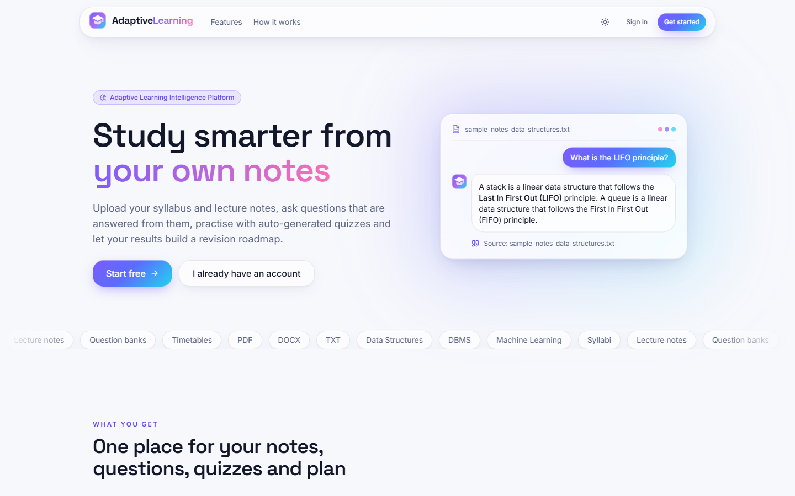  Figure 33: Landing page, light theme. | 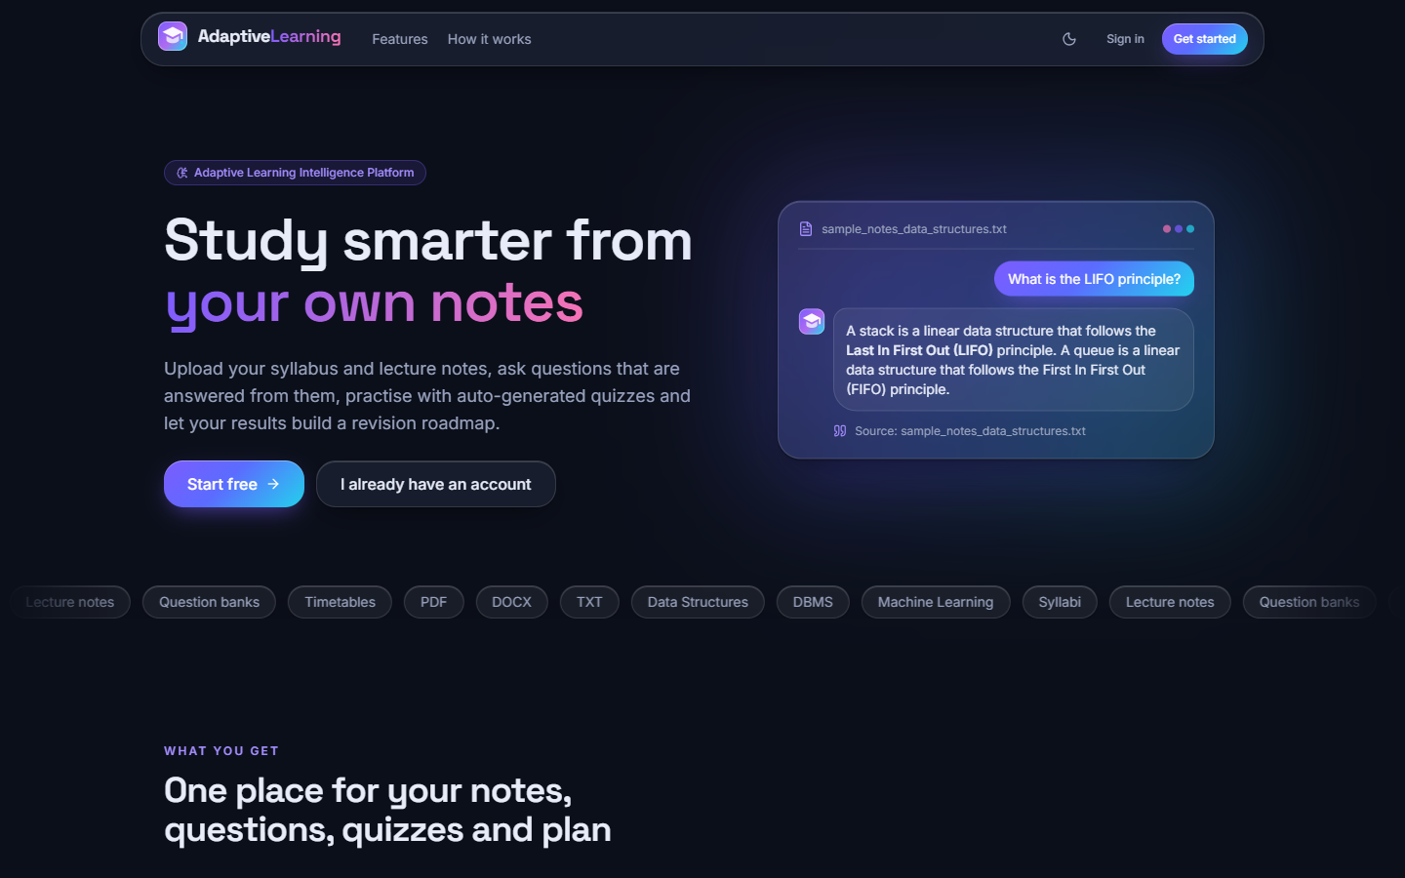  Figure 34: Landing page, dark theme.

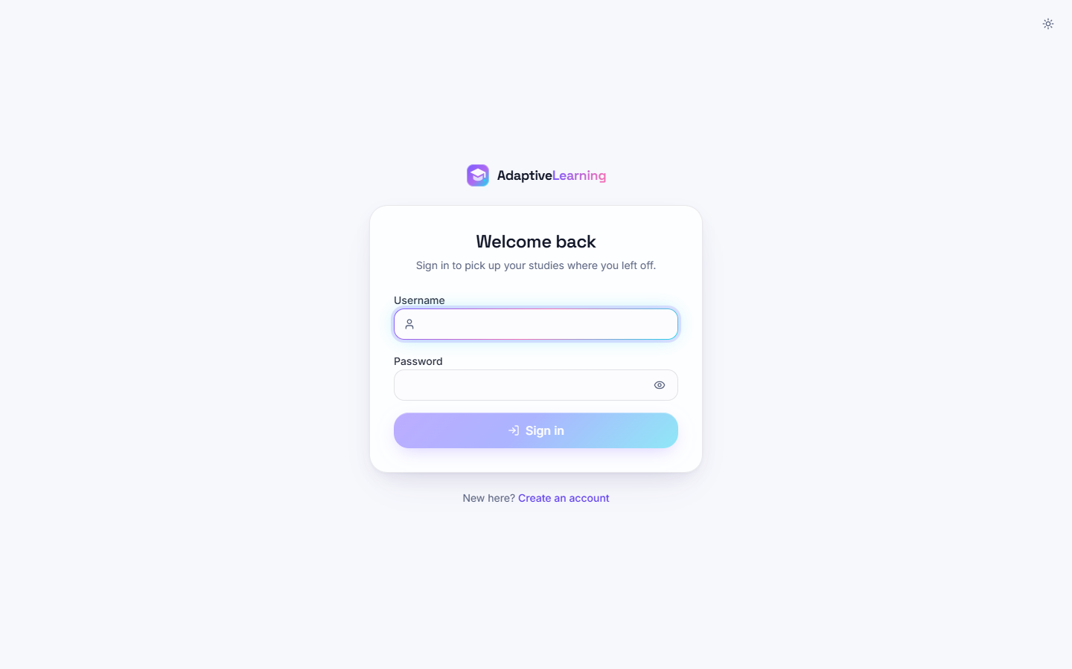  Figure 35: Login screen. | 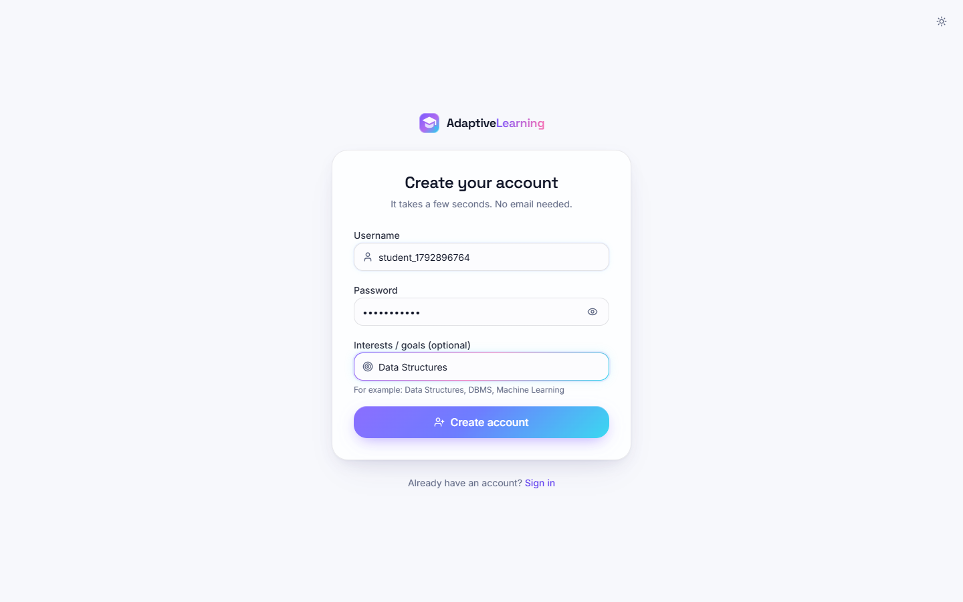  Figure 36: Registration screen with the form filled.

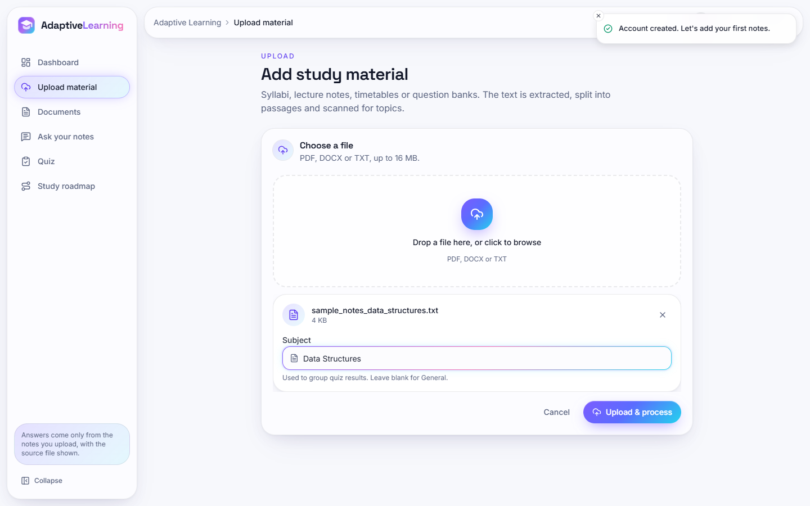  Figure 37: Upload screen with the sample notes chosen, before pressing Upload & process. | 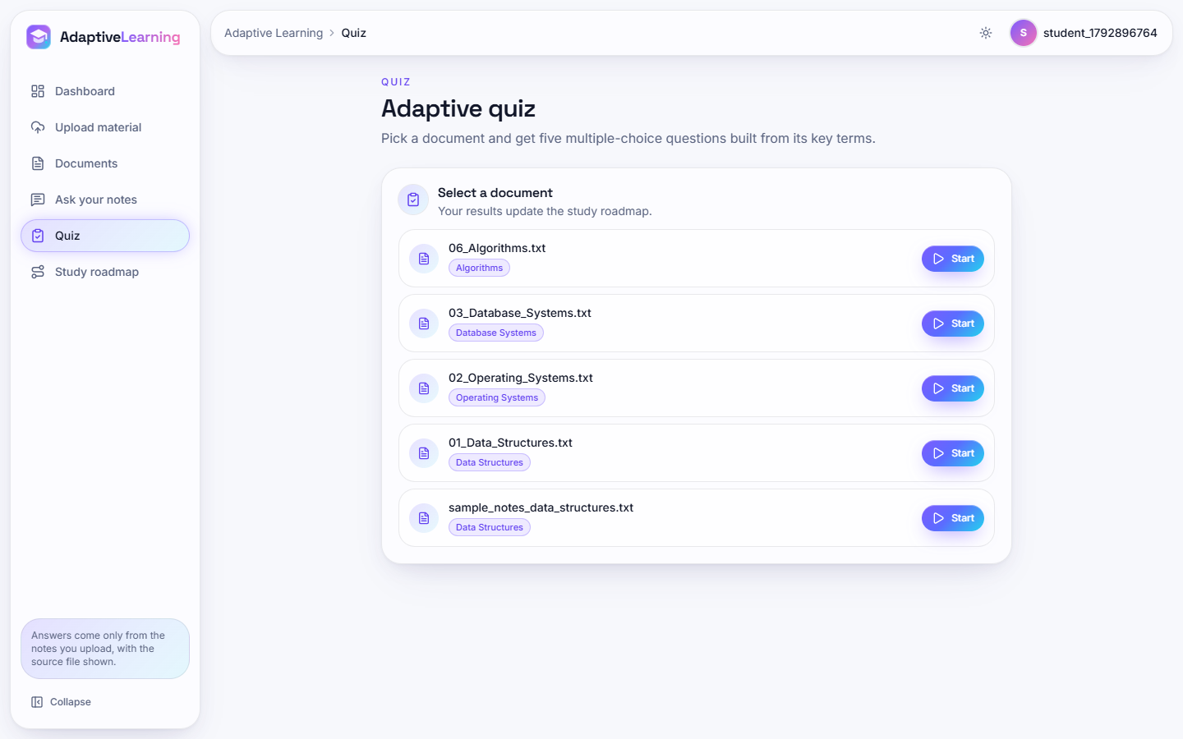  Figure 38: Quiz screen: a button to start a quiz on each document.

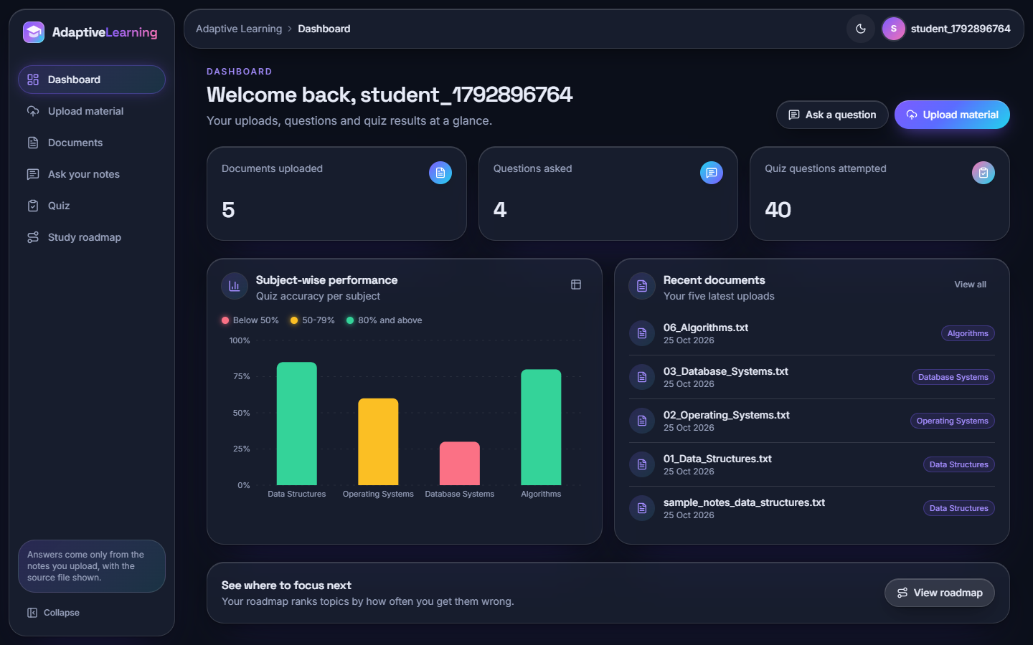
Figure 39: Dashboard in the dark theme.
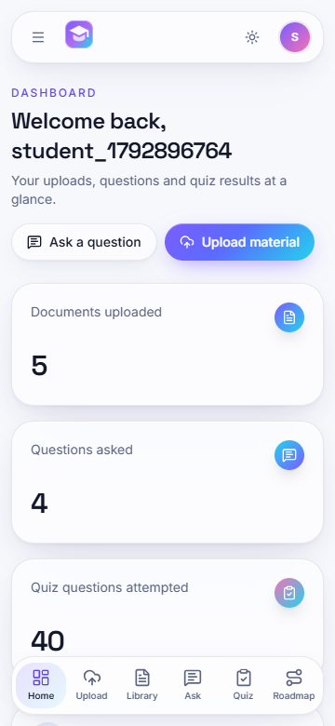  Figure 40: Dashboard on a 360 x 780 phone. | 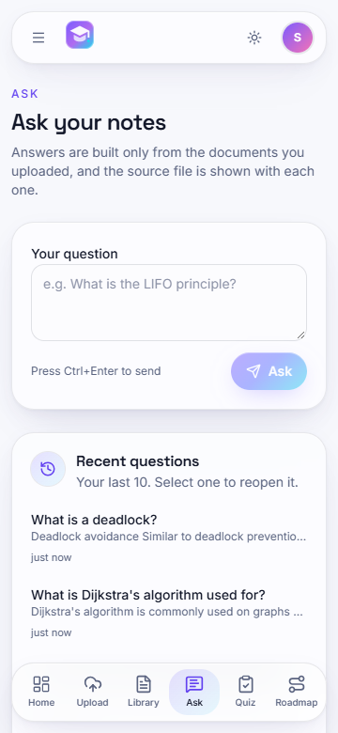  Figure 41: Ask screen on a phone. | 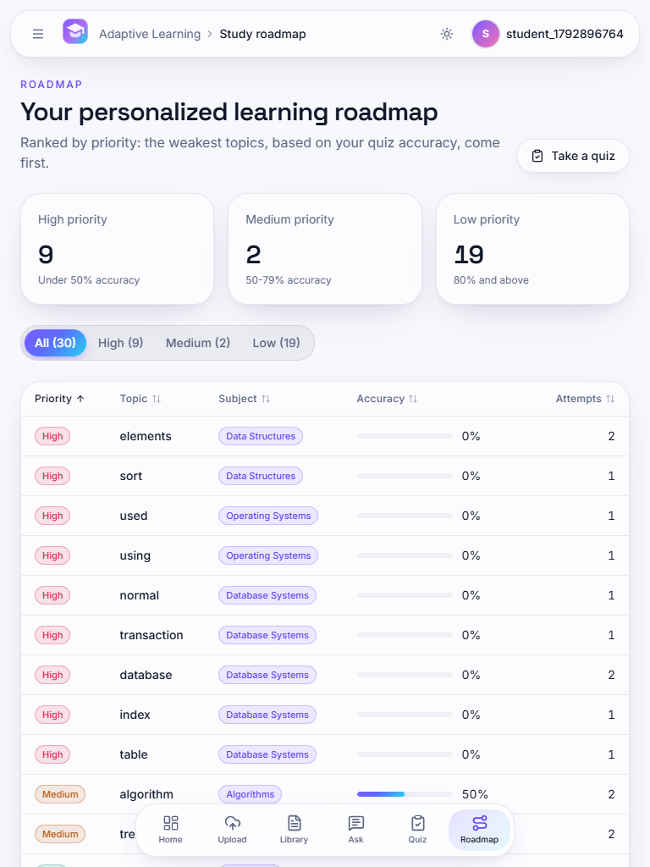  Figure 42: Roadmap on a 768 x 1024 tablet. | 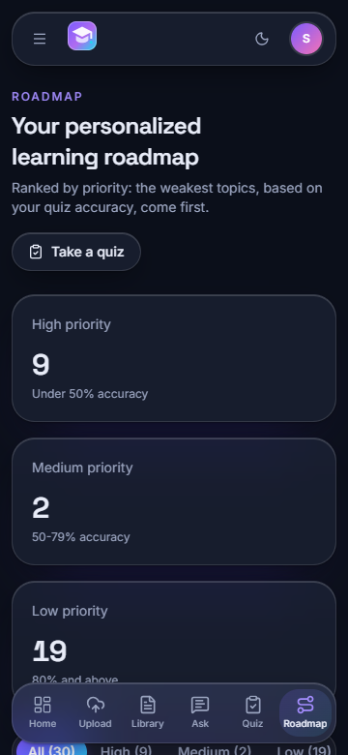  Figure 43: Roadmap on a phone, dark theme.

